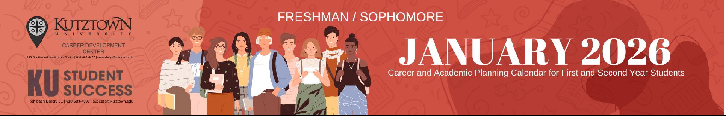

Monday | Tuesday | Wednesday | Thursday | Friday
  26 |   27  Whoopie Pies & Hot Chocolate  1-3 OM Lobby | 28  Choosing a Major  3-3:50 OM 23 | 29 | 30    It’s syllabus week! Take some time to review your syllabi and record test dates and assignments on a calendar or planner.
Concerned about your class schedule or courses? See your department advisor this week (during drop/add) to discuss adjustments or changes.

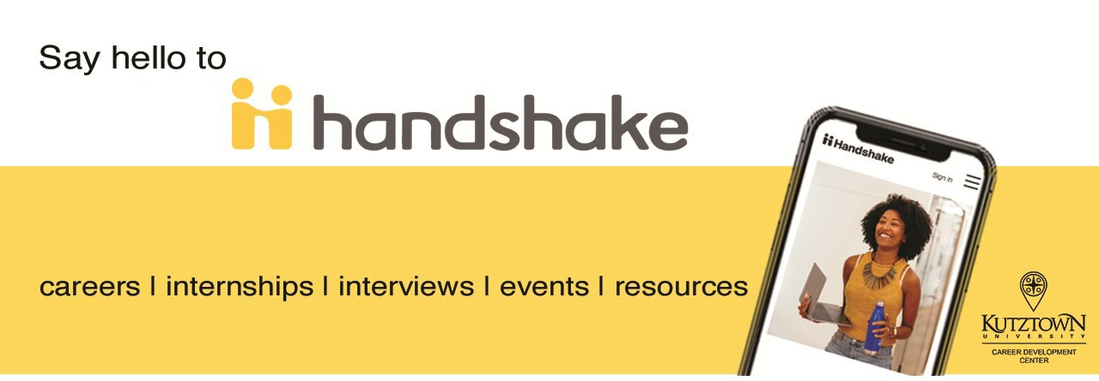

Academic Success Workshops - All held at 11am in AF 203

If you do not sign into a
workshop with-in 5 minutes of it starting, your attend-
ance will not be counted. Thank you.
Become a more confident, and successful student & future employee by participating in the
FREE Career Exploration Certificate Program
Learn more at www.kutztown.edu/CDCcertificate
Start Off Strong: Planner Party & Syllabus, Tue. Feb. 3rd
Bear Bytes: KU Technology & Tutoring, Tue. Feb. 10th Bear-y Efficient: Time Management:, Thur. Feb. 12th Golden Goals: Plan, Prioritize, Succeed, Tue. Feb. 17th
Read to Succeed: Text book Strategies That Work, Tue. Feb. 24th Note Taking Made Easy: From Lecture to Learning, Tue. Mar. 3rd Plan to Win: Mid-Term Planner Party, Tue. Mar. 10th
Chart Your Course: Advisement 101 w/Dr. Fares Tue. Mar. 24th
Test Like the Best: Golden Strategies for Exam Success, Tue. Mar. 31st Polish Your Presence: Golden Bear Guide to Professionalism, Tue. Apr. 7th Bearly Any Stress? Find Your Motivation Mode! Tue. Apr. 14th
Bear Necessities with Student Assistance, Tue. Apr. 21st
Embrace the Paw-sibilities: Growth Mindset & Imposter Phenomenon, Tue. Apr. 28th
Save that Money, Financial Literacy with PSECU, Thur. Apr. 30th
The Golden Game Plan: Conquer Finals with Confidence, Tue. May 5th

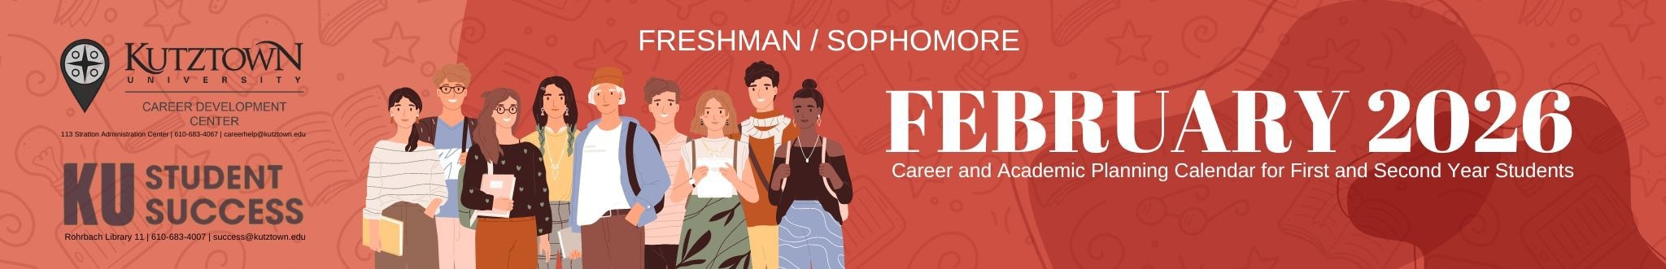

Monday | Tuesday |  | Wednesday |  | Thursday | Friday
Zoom IDs for virtual career workshops  at: www.kutztown.edu/careercenter |  | If you do not sign into a workshop within 5 minutes of it starting, your attendance will not be counted. Thank you. |  | Check your KU email and D2L accounts frequently. It is the means by which your advisors, professors, and staff will communicate with you.
2 | 3 |  | 4 |  | 5  Designing Your Career Path  11-11:50 OM 138  Writing Your Resume & Cover Letter  2-2:50 AF 200 | 6
9 | 10  Internship & Job Search Strategies  11-11:50 Virtual |  | 11 |  | 12
This Sun 2/15 JC Penney Suit Up!
4-7pm
Lehigh Valley Mall
16  Choosing a Major  2-2:50 Virtual | 17  GoinGlobal  Searching in the U.S. & Abroad  11-11:50 Virtual |  | 18  Designing Your Career Path  1-1:50 Virtual  The Washington Center Info Session  Intern in D.C.!  2-2:50 Virtual |  | 19  Disney College Program Info Session  Intern in Orlando!  11-11:50 MSU 250  Career Readiness: What Employers Wants 1-1:50 AF 103  Mini Workshop Marathon  Writing Your Resume & Cover Letter 6pm  Virtual | 20
23 | 24 |  | 25 |  | 26 | 27
Internship & Job | Career Readiness: |  |  |  | Writing Your Resume & Cover Letter  11-11:50 OM 138
Search Strategies | What Employers Wants |  |  |  | Choosing a Major
2-2:50 OM 138 | 11-11:50 Virtual |  |  |  | 2-2:50 AF 200
 |  |  |  |  | Mini Workshop Marathon
 |  |  |  |  | Career Readiness: What Employers Want 5pm
 |  |  |  |  | Choosing a Major 5:30pm
 |  |  |  |  | Designing Your Career Path 6pm
 |  |  |  |  | Virtual
Career Development Center ● 113 Stratton Admin ● 610-683-4067

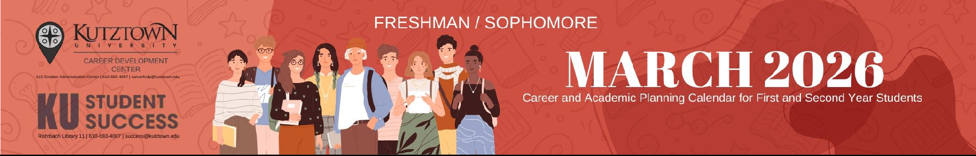

Monday | Tuesday | Wednesday |  | Thursday | Friday
2 | 3  Peace Corps Info Session  11-11:50 Virtual | 4    Prepare for the Fair Table Whoopie Pies, Iced Coffee & Resume Reviews  11-1 RL Lobby  Mini Workshop Marathon  Writing Your Resume & Cover Letter 5pm Designing Your Career Path, 6pm  Virtual | 5  Designing Your Career Path  11-11:50 OM 138  Internship & Job Search Strategies  11-11:50 Virtual |  | 6
9 | 10 | 11  Spring Internship & Job Fair  70+ employers! | 12  Writing Your Resume & Cover Letter  11-11:50 OM 138 |  | 13
 |  | 12-3pm MSU 218  Free Headshots too! | The Washington Center Info Session
 |  |  | Intern in D.C.!
 |  |  | 11-11:50 Virtual
16  Spring Break >>> | 17  >>> | 18  >>> | 19  >>> |  | 20
16  Spring Break >>> | 17  >>> | 18  >>> |  | >>  Next month you will select your Fall 2026 courses making this an ideal time to consider your career/ major direction. Questioning your choices?  Call the Career Development Center to make an appointment with a Career Coach. |  | >
23 | 24    Coffee, Cookies & Resume Reviews  11-1 Library Lobby | 25  GoinGlobal  Searching in the U.S. & Abroad  2-2:50 Virtual  Designing Your Career Path  6pm Virtual | 26  Career Readiness: What Employers Want  11-11:50 Virtual |  | 27  Uline Site  Visit  Visit, tour and network with Uline personnel at their Trexlertown location. Spots are limited.
 |  |  |  |  | Sign up on Handshake
30 | 31

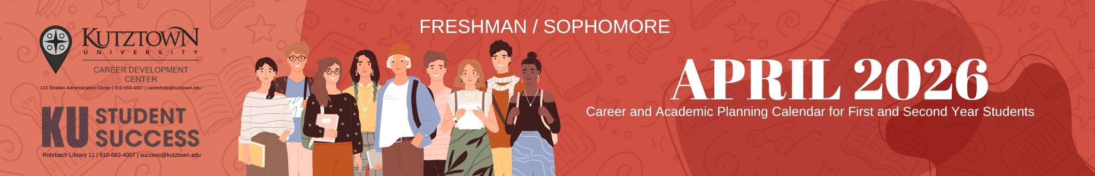

Monday | Tuesday | Wednesday | Thursday | Friday
 |  | 1 | 2 | 3
 |  |  | Writing Your Resume
 |  |  | & Cover Letter
 |  |  | 11-11:50 AF 103
 |  |  | Designing Your Career Path
 |  |  | 11-11:50 AF 102
6 | 7  Internship & Job Search Strategies  11-11:50 AF 101 | 8  Disney College Program Info Session  Intern in Orlando!  1-1:50 Stratton 116 | 9  Career Readiness: What Employers Want  11-11:50 AF 103 | Sunday the 12th  Mini Workshop Marathon  Choosing a Major 5pm Designing Your Career Path 5:30pm Writing Your Resume & Cover Letter 6pm  virtual
13 | 14 | 15  Choosing a Major  10-10:50 AF 202  Designing Your Career Path  1-1:50 AF 202 | 16  Writing Your Resume & Cover Letter  11-11:50 AF 103 | Sunday the 19th  Mini Workshop Marathon  Career Readiness: What Employers Want 5pm Designing Your Career Path 5:30pm virtual
20 | 21 | 22 | 23 | 24
Internship & Job Search Strategies 1-1:50 AF 103 |  | Career Readiness: What Employers Want  2-2:50 AF 103 | Designing Your Career Path  11-11:50 AF 102  Career Readiness:  What Employers Want
 |  |  | 11-11:50 AF 103
27 | 28 | 29 | 30 | May 1
May 4 | May 5 | May 6 | May 7 | May 8  Last Day for Certificate Items to be completed
May 11 Finals Week >>> | May 12  >>> | May 13  >>> | May 14  >>> | May 15  >>>

