Mon Tue Wed Thu Fri

26 27 28 29 30

Whoopie Pies & Hot Chocolate
1-3pm OM Lobby

Load the App: Handshake Jobs and Careers or go to: www.kutztown.edu/handshake

Become a more confident and successful student & future
employee by earning a FREE Career Success Certificate!
Learn more at www.kutztown.edu/CDCcertificate
Resume Reviews M-F 2-4pm
Stratton 113
Zoom IDs for all virtual workshops at: www.kutztown.edu/careercenter


Be on time! If you don’t sign in to the workshop within the first 5 minutes your attendance will not be counted. Thank you.

Login to www.kutztown.edu/biginterview using your KU Single Sign-on ID to practice interviewing!


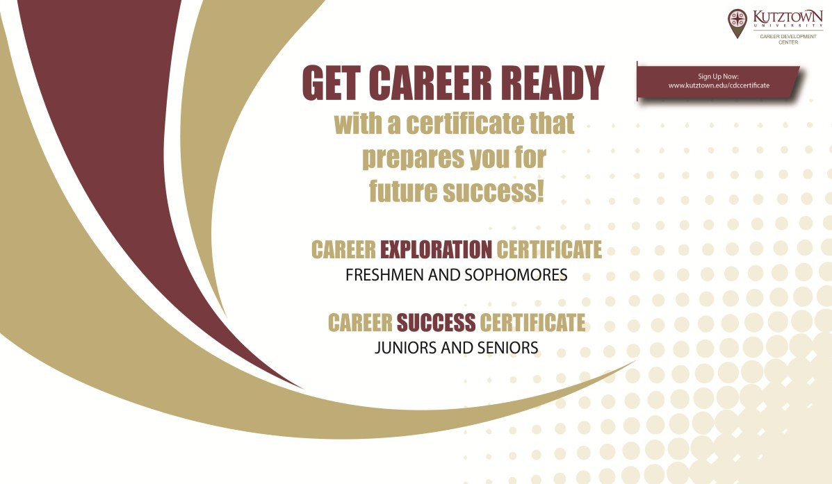
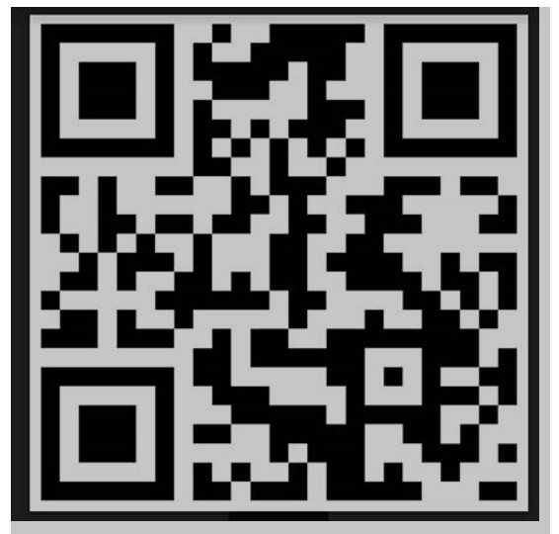
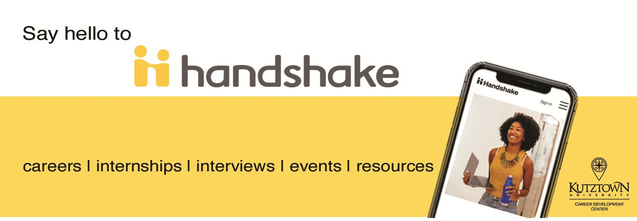
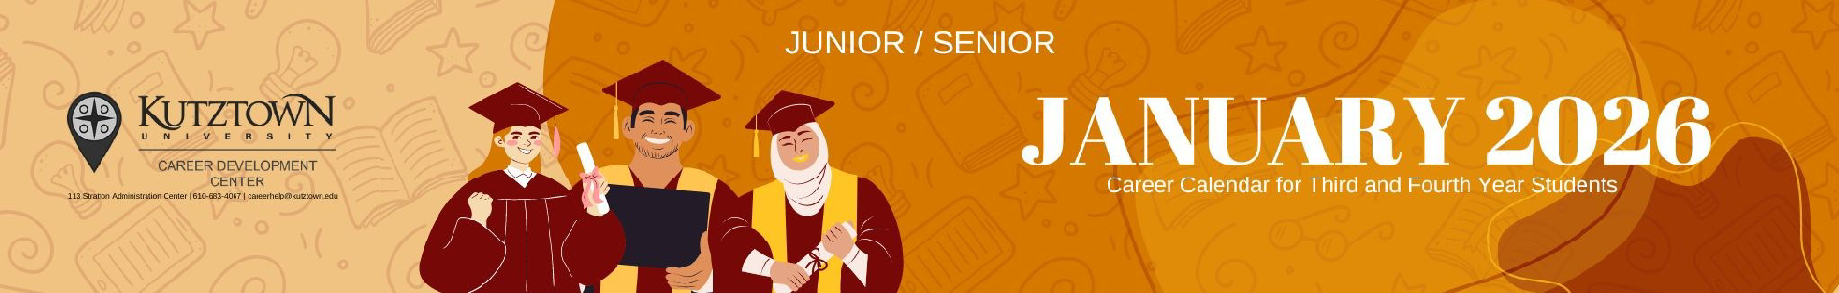

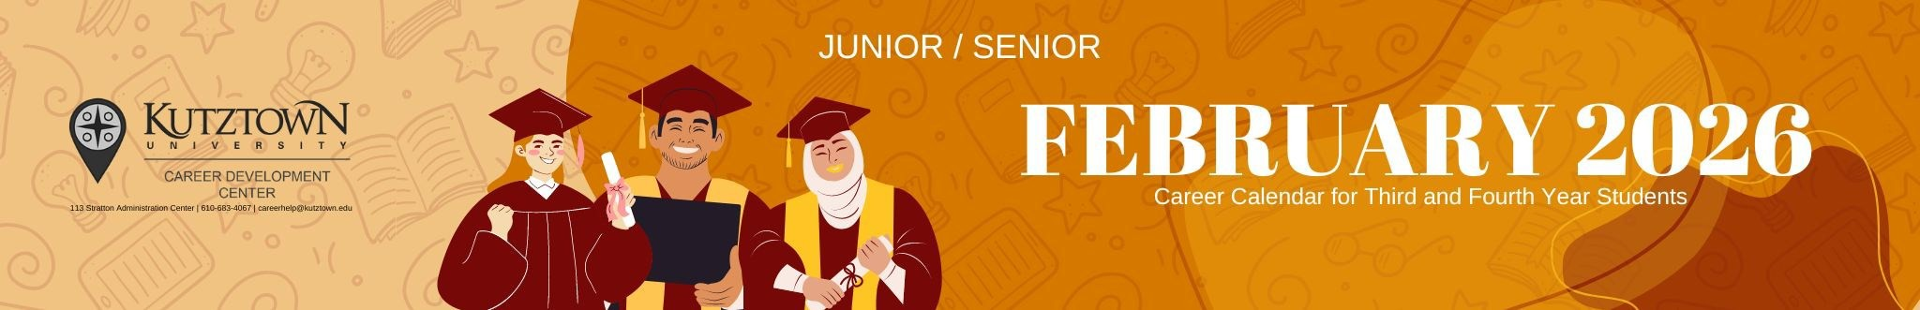

Mon | Tue | Wed | Thu |  | Fri
2 | 3      Senior Kick-Off  11-11:50 Virtual | 4  Senior Kick-Off  3-3:50 Virtual | 5  Designing Your Career Path  11-11:50 OM 138  Writing Your Resume & Cover Letter  2-2:50 AF 200  100 Days ‘til Graduation! | 6
9 | 10  Internship & Job Search Strategies  11-11:50 Virtual  Thinking About Grad School?  11-11:50 Stratton 116 | 11    Senior Kick-Off  7pm-8pm Virtual | 12    Senior Kick-Off  11-11:50 Virtual  LinkedIn: The How To  2-2:50 RL 29 |  | 13
This Sun 2/15 JC Penney Suit Up!
4-7pm Lehigh Valley Mall
16 | 17  Successful Interviewing  11-11:50 Stratton 116  GoinGlobal  Searching in the U.S. & Abroad  11-11:50 Virtual | 18  Designing Your Career Path  1-1:50 Virtual  The Washington Center Info Session Intern in D.C.!  2-2:50 Virtual | 19  Disney College Program  Info Session - Intern in Orlando!  11-11:50 MSU 250  Career Readiness: What Employers Want  1-1:50 AF 103  Mini Workshop Marathon Internship & Job Search Strategies 5pm Successful Interviewing 5:30pm  Writing Your Resume & Cover Letter 6pm Virtual | 20
23  Internship &  Job Search Strategies  2-2:50 OM 138 | 24  Career Readiness: What Employers Want  11-11:50 Virtual | 25 | 26  Writing Your Resume & Cover Letter  11-11:50 OM 138  Mini Workshop Marathon  Career Readiness: What Employers Want 5pm Designing Your Career Path 6pm  Virtual | 27

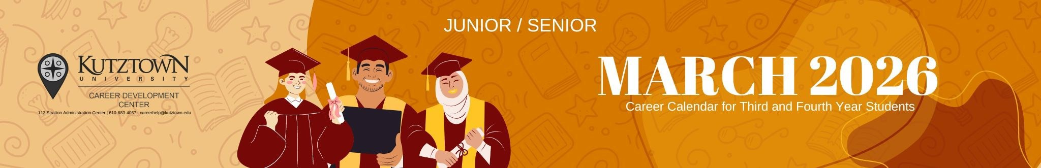


Mon | Tue | Wed | Thu | Fri
2 | 3  Successful Interviewing  11-11:50 OM 138  Peace Corps Info Session  11-11:50 Virtual | 4  Salary Negotiation  1-1:50 Virtual  Prepare for the Fair!  Whoopie Pies, Iced Coffee    & & Resume Reviews 11-1 RL Lobby  Mini Workshop Marathon Writing Your Resume & Cover Letter 5pm Internship & Job Search Strategies 5:30pm  Designing Your Career Path 6pm Virtual | 5  Designing Your Career Path  11-11:50 OM 138  Internship & Job Search Strategies  11-11:50 Virtual  Grad School Fair: KU Programs  11-11:50 MSU 250 | 6
9 | 10 | 11 | 12 | 13
 |  | Spring Internship & Job Fair | Writing Your Resume & Cover Letter  11-11:50 OM 138
 |  | 70+ employers!  12-3pm MSU 218 | The Washington Center Info Session  Intern in D.C.!
 |  | Free headshots too! | The Washington Center Info Session  Intern in D.C.!
 |  | Free headshots too! | 1-1:50 Virtual
16  Spring Break! >>> | 17  >>> | 18  >>> | 19  >>> | 20  >>>
Job Fair for Educators
70+ employers!
10-1 MSU 218
23  Thinking About Grad School?  3-3:50 AF 101 |   24  Coffee, Cookies & Resume Reviews  11-1 Library Lobby  Using Social Media in Your Job Search 11-11:50 Virtual | 25  Mini Workshop Marathon  Internship & Job Search Strategies 5pm Successful Interviewing 5:30pm Designing Your Career Path 6pm Virtual | 26  Career Readiness:  What Employers Want  11-11:50 Virtual | 27  Uline Site Visit  Visit, tour and network with Uline personnel at their Trexlertown location. Spots are limited.  Sign up on Handshake
30  Successful Interviewing  3-3:50 AF 200 | 31  Thinking About Grad School?  11-11:50 AF 103
Mock Interview Mania Week!
Sign up in Handshake
www.kutztown.edu/handshake

Mon Tue Wed Thu Fri

Mock Interview Mania Week!
Sign up in Handshake
www.kutztown.edu/handshake
1 2 3
Designing Your Career Path
11-11:50 AF 102
Writing Your Resume
& Cover Letter
11-11:50 AF 103

6 7
Internship
& Job Search Strategies
11-11:50 AF 101
Successful Interviewing
11-11:50 AF 103
8
Disney College Program
Info Session Intern in Orlando! 1-1:50 Stratton 116
9
Career Readiness: What Employers Want
11-11:50 AF 103
Thinking About Grad School?
2-2:50 AF 200

Sunday the 12th

Mini Workshop Marathon Designing Your Career Path 5:30pm Writing Your Resume & Cover Letter 6pm Virtual

13 14
Using Social Media
in Your Job Search
11-11:50 Virtual
15

Designing Your Career Path
1-1:50 AF 202
16
Writing Your Resume
& Cover Letter
11-11:50 AF 103

“It’s Getting Real!”
Cupcake Event
1-3 RL Lobby

Sunday the 19th

Mini Workshop Marathon
Career Readiness: What Employers Want 5pm Designing Your Career Path 5:30pm Successful Interviewing 6pm
Virtual

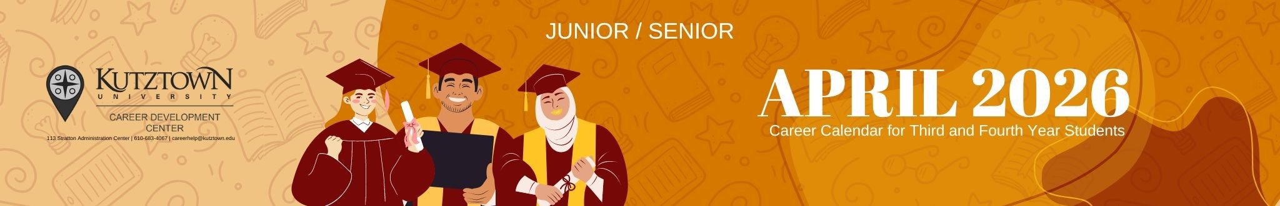




20 21 22 23 24

May 1
Internship & Job Search  Strategies  1-1:50 AF 103 | Successful Interviewing  11-11:50 AF 103  Salary Negotiation  11-11:50 Virtual | Career Readiness: What Employers Want  2-2:50 AF 103 | Designing Your Career Path  11-11:50 AF 102  Career Readiness: What Employers Want 11-11:50 AF 103
27 | 28 | 29 | 30
May 4 | May 5 | May 6 | May 7
11  Final Exams >>>> | 12  >>> | 13  >>> | 14  >>>

May 8
Last Day for Certificate Items

SATURDAY, MAY 16
Congratulations Graduates!!

