The Disney College Program is a paid internship comprised of living, learning and earning
components that is offered at the Walt Disney World® Resort and Disneyland® Resort. From

exclusive events and backstage access, to making lifelong memories with participants from across
the globe, our program is truly one-of-a-kind!
LIVING
Housing complexes are located near each Resort
Exclusive events and programming are held weekly within these complexes
Amenities include security, laundry, high-speed internet, pools, gyms and more!
Weekly housing costs are determined by unit size and number of occupants
EARNING
From costumes to role responsibilities, no two jobs are the same!
Applicants have the opportunity to express interest in the roles for which they would like to be considered

More than 20 different positions are offered across theme parks, resorts, water parks, mini-golf and Downtown Disney District/Disney Springs
Participants work the equivalent of a full-time schedule and must have full work availability, including days, nights, weekends and holidays

LEARNING
An array of collegiate, seminar and self-paced courses are offered on both coasts
Training classes, professional and personal development activities and networking opportunities are also available
Disney’s education program provides a unique and comprehensive experiential learning opportunity
QUICK FACTS
Established: 1981
Recruiting seasons: Spring and Fall, with extended programs available
Annual program participation:12,000-13,000 participants Applicants must have completed at least one
semester of college, be 18 years of age upon arrival and are currently taking classes at an accredited program or institution or graduated within the past six months
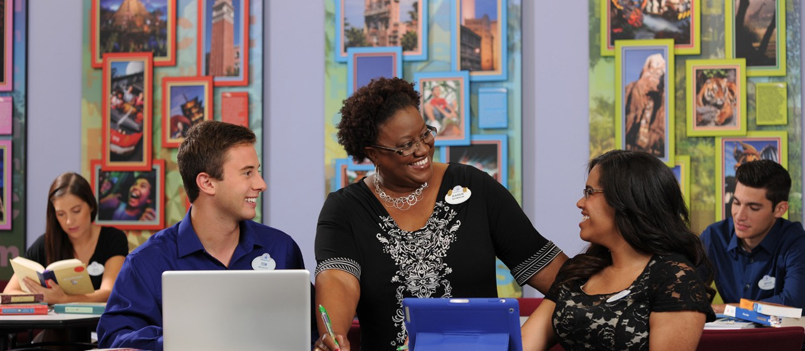
All majors are welcome



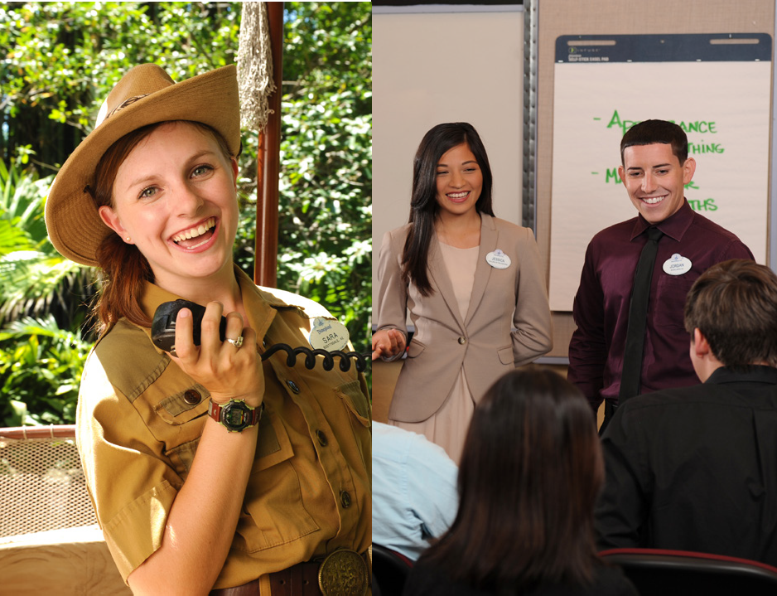



DisneyCollegeProgram.com
EOE • Drawing Creativity From Diversity • ©Disney
@DisneyCollegeProgram
@DisneyInterns

