ANNUAL SUMMARY
2024-2025 Helping KU students create a career
development plan, confidently approach their professional internship and
job search, and secure
meaningful


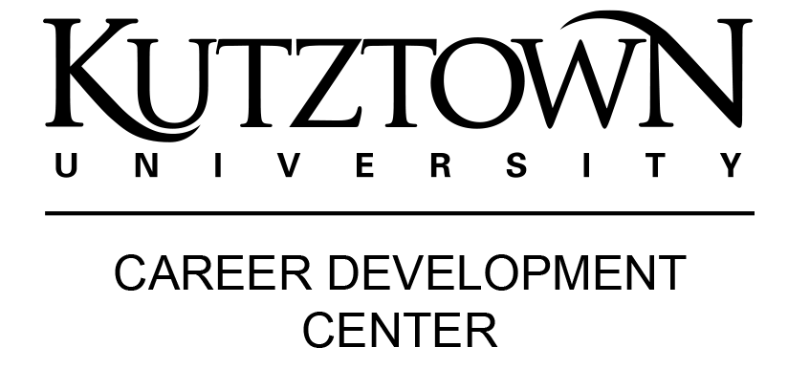

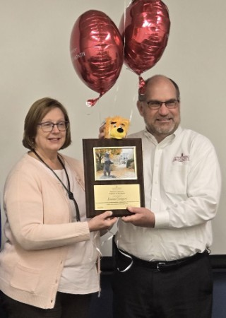
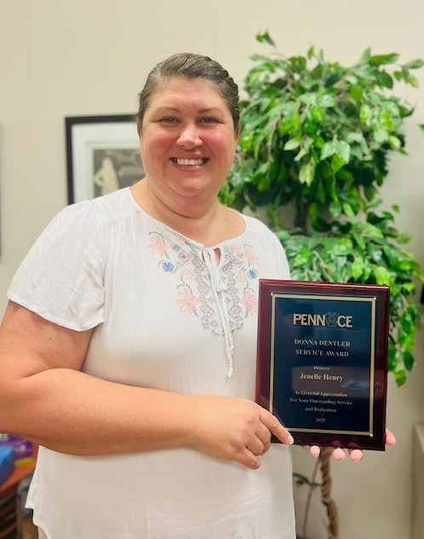
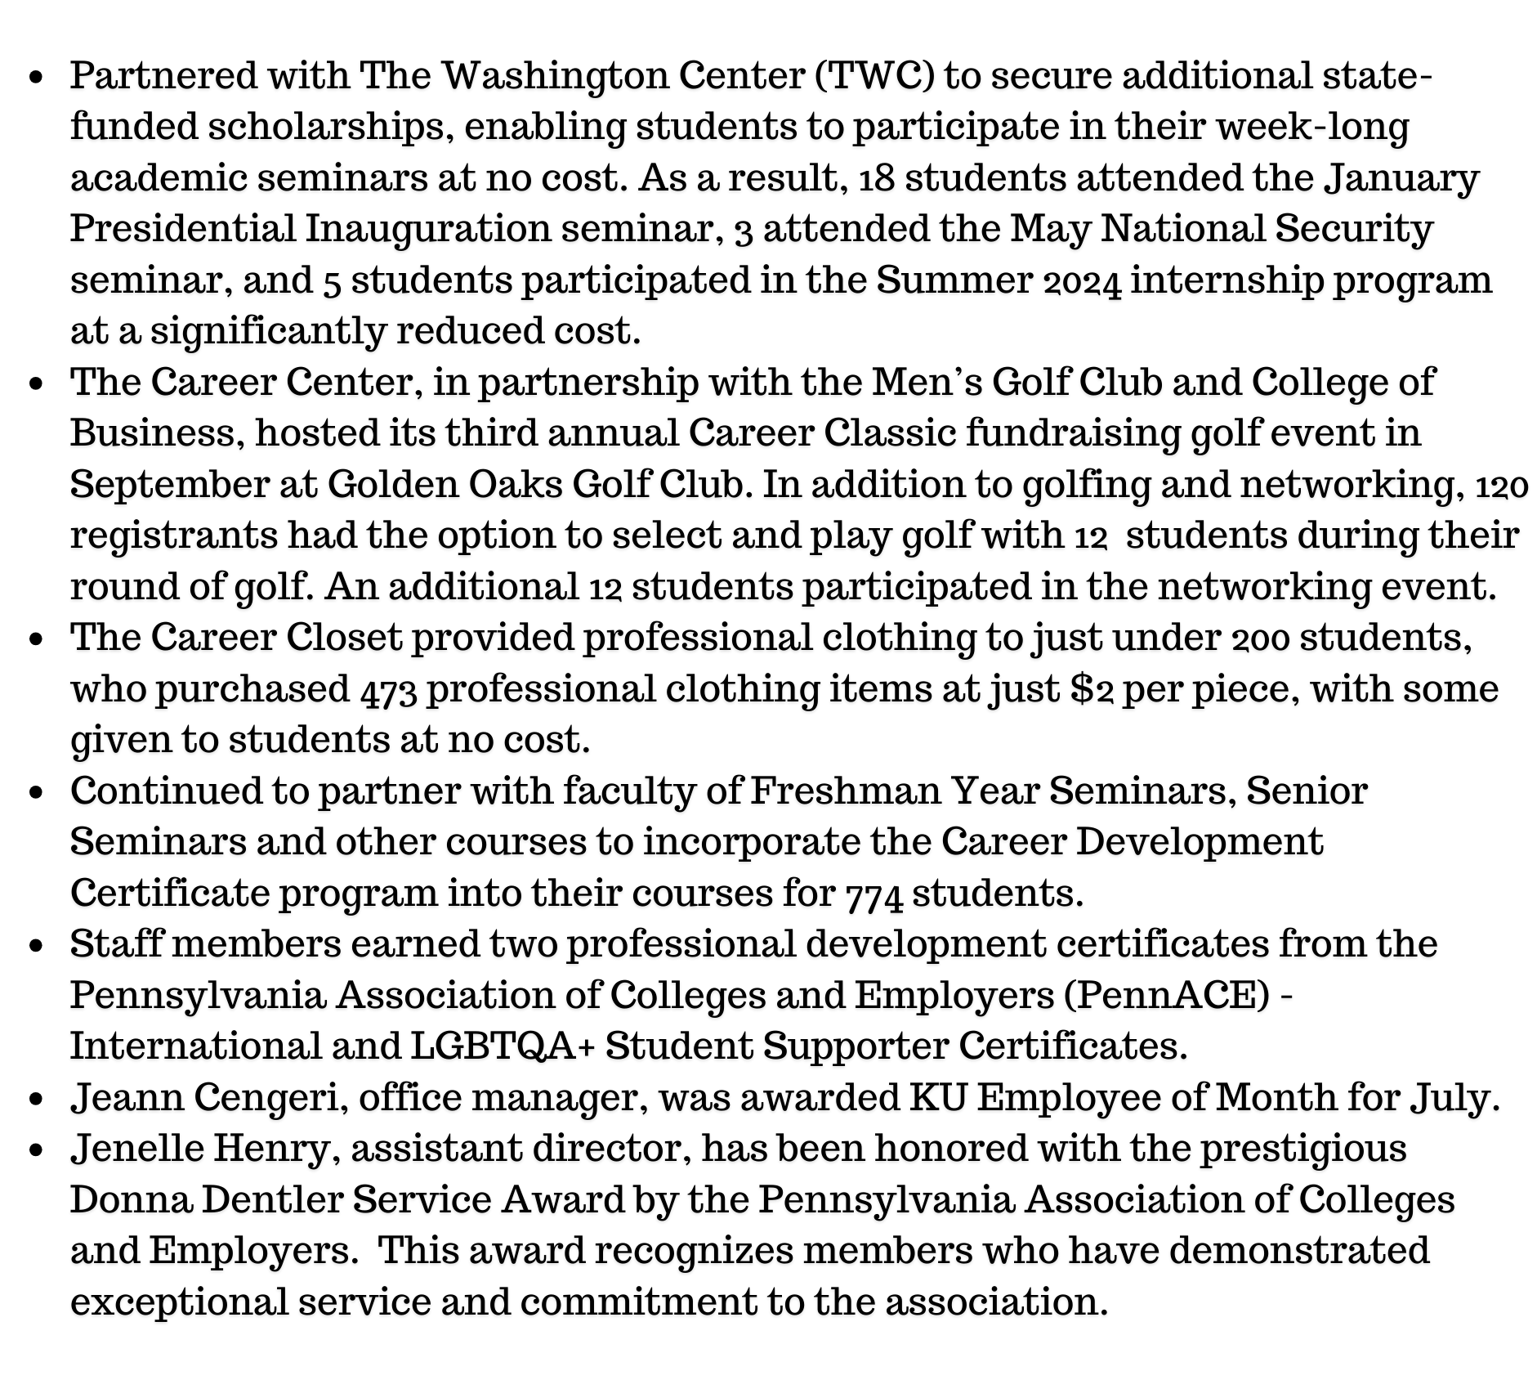
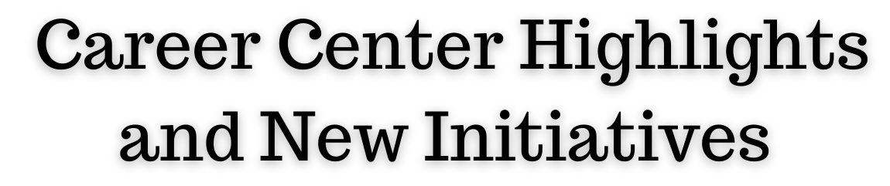
Continued strengthening the newly-designed micro-internship program. The inaugural group of eight (8) employers created and offered nine (9) micro-internships for students.
A portion of Clark Associates and Enterprise donations provided the ability to offer twelve (12) students a $1,000 scholarship from the Fund for Unpaid Interns.
Mock Interview Mania weeks in both Fall & Spring connected 202 students with 39 local recruiters for in-person, practice interviews.
employment.

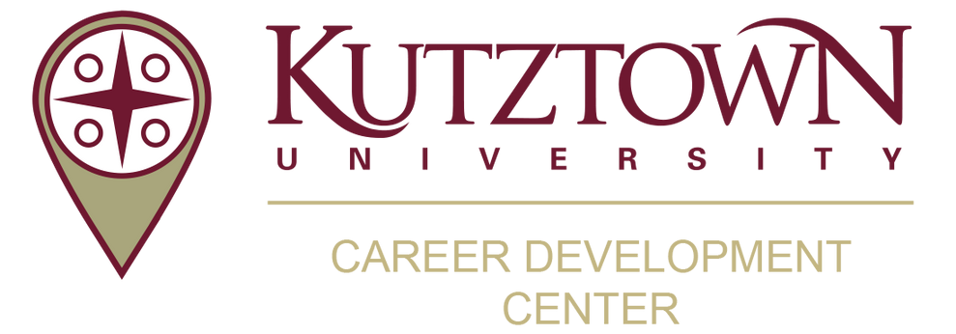
Student Engagement

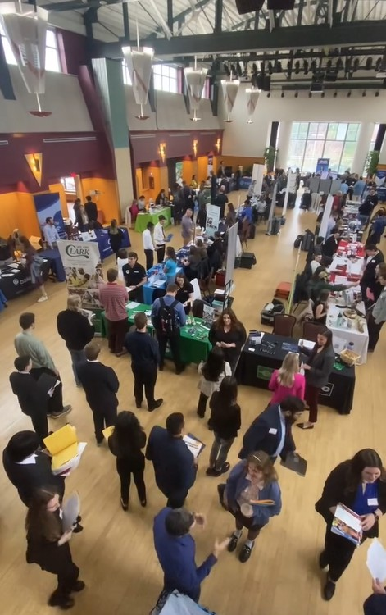
Special Events and Services
The CDC coordinates numerous career events for students.
Here are just a few:
Partnership with the College of Business to host its first-ever COB Career Day event with more than 250 students connecting with 16 panelists.
Collaboration with Disabilities Services Office to offer the Federal Workforce Recruitment Program
JCPenney Suit-Up Event each semester (discounted professional clothing) Mock Interview Mania with volunteer recruiters providing interviews and feedback
Compilation of Accounting and Education Resume Books sent to recruiters

Career Fairs
All Career Fairs were back to in-person.
Newly-created Criminal Justice Career Fair attracted 25 employers and 109 students. Students were offered free headshots by the university photographer.
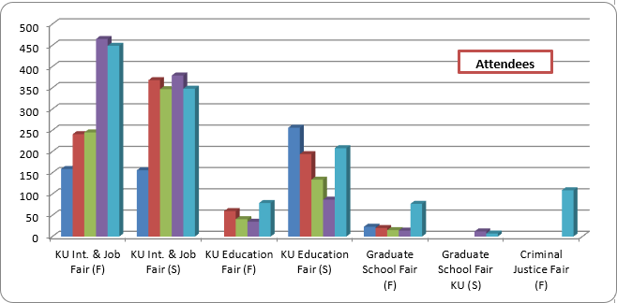
A luncheon with the KU faculty and staff was offered for recruiters during the in-person Internship and Job Fairs.

Workshops & Events
2024-25
2024-25
2024-25
2024-25
2024-25
2024-25
2024-25
Staff offered just over 300 in-class presentations and workshops on various career topics:

Topics: Designing Your Career Path
Choosing Your Major
Finding Internships
Job Search Strategies
Interviewing Strategies
Graduate School Search
How to Work A Career Fair
Senior Kickoffs/Orientations
Employer/Industry Panels and Info Sessions

Resume and Cover Letter Writing
Salary Negotiation
Soft Skills, Career Readiness
& Professionalism
2

Student Engagement


Student Engagement with the Career Center:

Highest-ever undergraduate student engagement remained high at 54%.
With the addition of a new Criminal Justice Career Fair and strong overall attendance across all events, a record-breaking 1,277 students participated in career fairs this year—the highest number in KU’s recent history.

Career Coaching/Counseling Appointments
On-on-one career coaching/counseling appointments returned to regular levels over the past few years, excluding 2023-24. Freshmen and Sophomores had the most appointments and the top topics of discussion included career choice, academic major choice, internship and job search strategies.
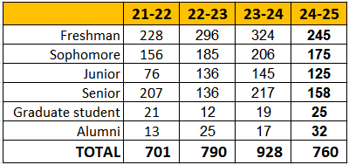
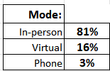

Review Service & Workshop Attendance
Students utilizing career coaches’ recommendations for their resumes steadily climbs, while workshop attendance declined.
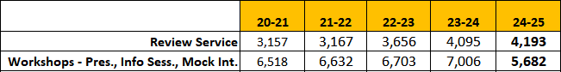

Certificate Programs
Continued to partner with faculty of Freshman Year Seminars, Senior Seminars and other courses to incorporate the Career Readiness Certificate program into their 29 courses for 744 students. 222 students completed, therefore earning, one of the career certificates.



Connect with the CDC @kucareercenter
3

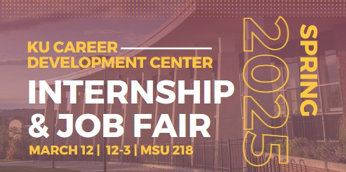

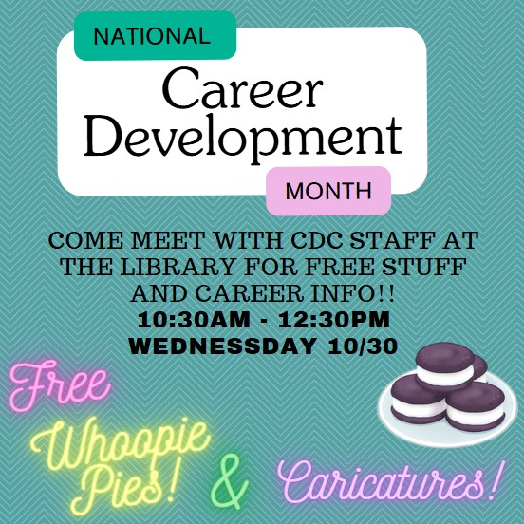
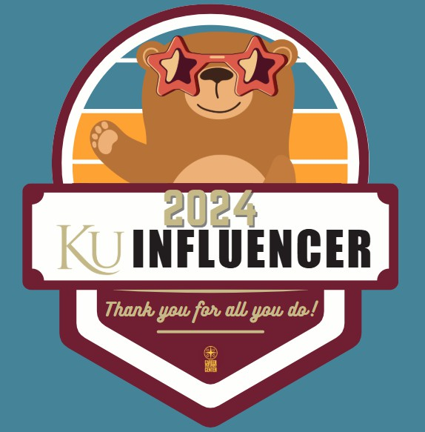
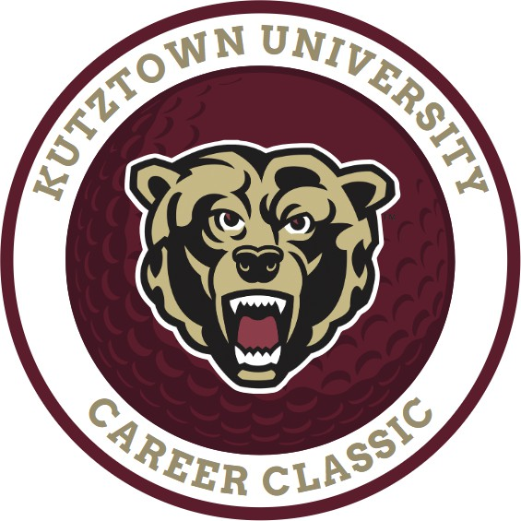
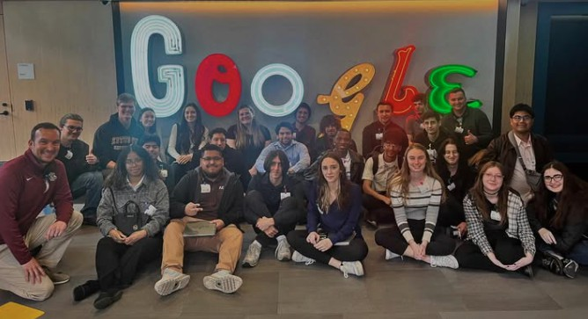
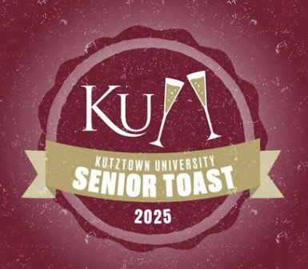
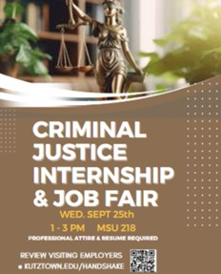
2024-25 Special Events

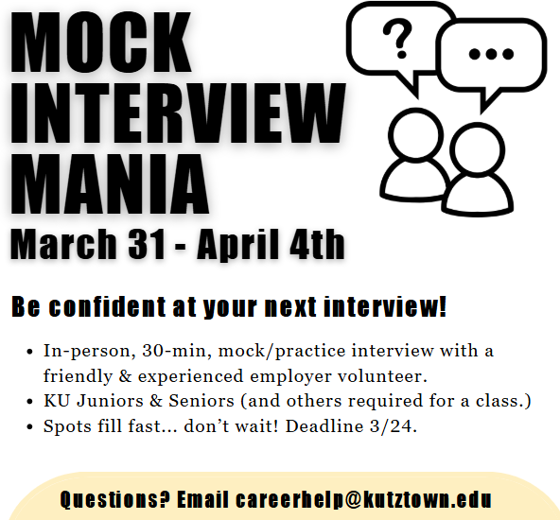

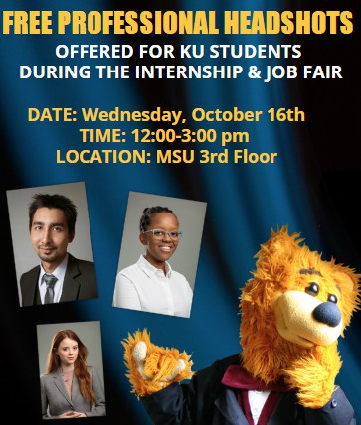
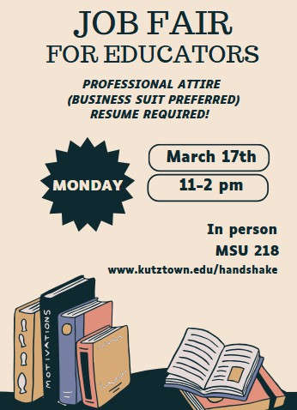

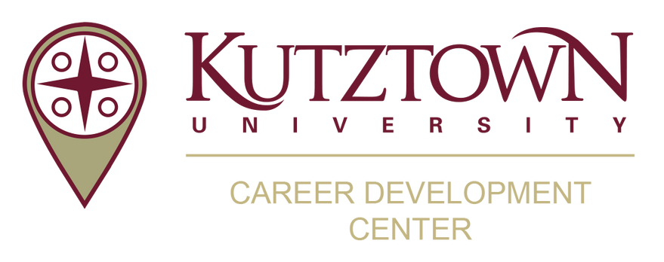
Employer Engagement

Handshake Postings
Handshake is the primary online resource for preparing and connecting students and alumni with employers as well as on-campus opportunities.
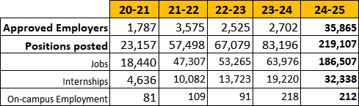

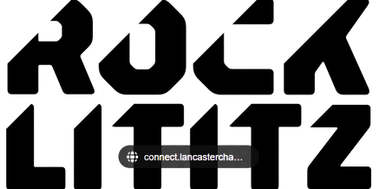
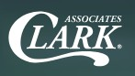


Connections
- Five Employer Site Visits/Tours for students to St. Luke’s (31), Rock Lititz (34), Clark Associates (26),
Google (30) and Air Products (7) (partnered with Disability Services Office’s MyPlace Program).
- Eight Employer On-Campus Workshops (ADP, B. Braun, Clark Associates, Core Consulting, East Penn, Fastenal, Lutron, Uline) to present workshops on career topics including professionalism, interviewing strategies, corporate social responsibility, recruiting/talent acquisition, and career readiness.
- Twenty-nine Employer On-Campus Information Tables

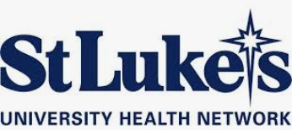
Career Fair Participation
Employers & Graduate Schools:
7

- Internship & Job Fair (Fall) 82
- Internship & Job Fair (Spring) 86
KU Graduate School Fair (Spring)
Education Fair (Fall)
70

- Graduate School Fair (Fall) 52
- Education Fair (Spring) 73

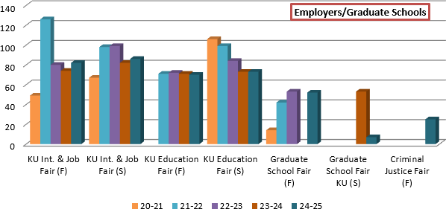
  - Criminal Justice Fair 25

5

