

BachelorofScienceinBusinessAdministrationwithamajorinGeneralBusiness

TheGeneralBusinessprogramisparticularlywell-suitedforthosewhowanttoworkinasmalltomediumsizedcompany wherethereisanexpectationofcompetencyacrossarangeofbusinessfunctions. Itisalsoagoodplacetostartforstudents whoareinterestedinstudyingbusinessbutareuncertainaboutwhichparticularfieldtheywanttostudy(e.g.Accounting, Finance,Marketing,Management,Entrepreneurship,SupplyChainManagement,HumanResourceManagement,Personal FinancialPlanning).

CareertypesassociatedwithGeneralBusiness
Conventional-“Organizer” Enterprising-“Persuader” Investigative-“Thinker”

Relatedskills,values,andqualities
- Aptitudeforworkingwithnumbers
- Abilitytoorganize,analyze,orinterpretnumericaldata
- Aptitudeforaccuracyanddetail
- Proficiencywithcomputers
- Abilitytomakesoundjudgmentsanddecisions andtosolvequantitativeproblems
- Excellentinterpersonalskillsandproficiencyinwritten andoralcommunications
- Abilitytoexplaincomplexfinancialdatatoothers
- Abilitytolead,supervise,anddirectothers
- Abilitytoworkaloneandconcentrateforlongperiodsoftime
- Hard-working

CoursesBusinessmajorstypicallyenjoy
- Finance
- Business
- BusinessMathematics
- ComputerOperations
- ComputerProgramming
- Economics
- Mathematics
- Statistics

CommoninterestsofGeneralBusinessmajors
- Maintainingaccuratepersonalfinancial/bankrecords
- Workingpart-timeorvolunteeringasatreasurer orincommetaxpreparer
- Solvingproblemsusinganalyticalandlogicalprocesses
- Usingorworkingwithcomputers
- Joininganaccounting-relatedorganization
- Attendingaccounting-relatedlecturesorconferences
- Traveling

FormoreinformationaboutthemajorContactthe DepartmentofBusinessAdministration,233deFrancesco, 610-683-4580,orvisithttps://www.kutztown.edu/ academics/colleges-and-departments/business

KUMajorsrelatedtoGeneralBusiness
BusinessAnalytics*,ComputerScience,Finance,Library Science,Management,Mathematics,Marketing,Public Administration
*minoronly

ForMoreInformationonGeneralBusinessCareersortospeaktoaCareerCounselor,contactKUCareerDevelopmentCenter 113StrattonAdministrationCenter*610-683-4067*careerhelp@kutztown.edu*www.kutztown.edu/careercenter



  - EnrollintheCareerExploration Certificate.
  - Attendinfosessionstolearnabout careerdevelopmentandpersonal branding.
  - MeetwithCDCcareercoach.
  - Attendinfosessionstolearn aboutresumewriting,and externships.
  - Confirmyourchoiceofmajor
  - EnrollintheCareerSuccess Certificate.
  - Completeaninternshipand/or undergraduateresearch.
  - Attendinfosessionsabout
    - Attendyourseniorkick-offand otherinfosessionstoprepareforjob search/gradschool.
    - UpdateyourresumeandLinkedIn profile.

      - Takeacareerassessmentto
andconsideroptionsfordouble
internships,interviewing,jobsearch • Createcoverletterdrafts.

identifyandconfirminterests.
      - Getinvolvedincampusclubsand organizations.
      - Developbasicworkplaceskills
majororminor.
  - Researchcareersofinterest.
  - Completeajobshadowing (externship)experience.
strategies,andgradschool.
    - BuildaLinkedInprofileand continuetomonitoryouronline presence.
  - Gainexperiencethroughinternships and/orundergraduateresearch.
  - Securereferencesforjob/gradschool applications.

throughjobsorvolunteerwork.
    - Seekmeaningfulemploy-mentor • Completeamockinterview.
      - Createyour“30second”commercial.

      - Talkwithprofessors,family,and friendsaboutcareerideas.
      - Conductinformationalinterviews withprofessionalsworkingin fieldsofinterest.
      - Developarelationshipwithyour professorsandfacultyadvisor.
volunteerworkinafieldrelated toyourmajor.
  - Exploreoptionsforunder-graduateresearchandstudy abroad.
  - Writearesumeandhaveit reviewedbytheCDC.
  - Manageyouronlinepresence.
- Buildskillsthroughresearch projects,part-timeemployment,and volunteerwork.
- ParticipateinCareersCafe& networkingprograms.
- Attendinternship&jobfairs.
- Takeonaleadershiproleina studentorganizationorwork.
- Considergraduateschooloptions andprepareforadmissionstests.
- MeetwithCDCtodevelop jobsearchstrategies.
- Researchemployers.
- Networkwithprofessionalsthrough eventsandsocialmedia.
- Joinaprofessionalorganizationin yourdiscipline.
- Attendthesenioretiquetteluncheon ordinner.
- Participateinjobfairsand on-campusinterviewing.

SampleCareerTitles
GeneralBusinessmajorscanbefoundworkinginawidevarietyofcareerfields. Herearejustsomecareertitlesthatmay beofinterest. Pleasenotethatsomejobsmayrequirefurthereducationandtraining.Tolearnmoreaboutthesecareers, visithttp://online.onetcenter.orgorwww.bls.gov/oco

  - Accountant
  - AccountsPayableClerk
  - Actuary
  - Auditor
  - BudgetAnalysts
  - Buyer
  - ChiefExecutive
  - ComplianceManager
  - Consultant
  - Controller
  - CreditAnalyst
  - CustomsBroker
  - Economist
  - FinanceAnalyst
  - FinanceDirector
  - FinancialAdvisor
  - GeneralSalesManager
  - HumanResourceSpecialist
  - HumanResourcesCoordinator
  - InsuranceSalesAgent
  - InvestmentBanker
  - LoanOfficer
  - LogisticsAnalyst
  - ManagementConsultant
  - MarketingSpecialist
  - OperationsManager
  - ProcurementClerk
  - ProductManager
  - Professor
  - PurchasingManager
  - Recruiter
  - SalesRepresentative
  - SocialMediaManager
  - SupplyChainManager
  - TaxPreparer
  - TrainingandDevelopmentManager

CommonInternshipSitesandEmployers
GeneralBusinessmajorsoftenfindinternshipsandemploymentinthefollowingindustries:

    - AccountingFirms
    - Banks
    - Business&Industry
    - Colleges/Universities
    - InsuranceCompanies
    - Non-profitorganizations
    - PrivatePractice
    - State/FederalGovernment
    - StockBrokerages


Handshakeistheprimaryonlineresource forpreparingandconnectingstudentsandalumniwithemployers. www.kutztown.edu/handshake

UsefulWebsitesforGeneralBusinessMajors
Whetheryouareresearchingrelatedcareerfields,applyingforinternshipsorjobs, orplanningtojoinaprofessionalassociation,thesewebsitesareforyou!

IndustryInformationandJob/InternshipSearchSites
ExecutiveandManagementJobList www.nationjob.com/management
InformationonAccountingCareers www.becker.com
LaSalleNon-ProfitCenter www.lasallenonprofitcenter.org
LinkedInJobs www.linkedin.com/jobs
MarketingJobs www.marketingjobs.com
SmallBusinessAdministration(SBA) (TipsonstartingyourbusinessfromtheUSGovernment) www.sba.gov
ProfessionalAssociations

AmericanInstituteofCertifiedPublic Accountants(AICPA)
www.aicpa-cima.com
AmericanManagementAssociation www.amanet.org
AmericanMarketingAssociation www.ama.org
AmericanFinanceAssociation www.afajof.org
NorthAmericanSocietyforSportManagement www.nassm.org
AssociationforSupplyChainManagement www.ascm.org
RelatedAreaEmployers

ADP
Amazon ClarkAssociates DHL
EastPennManufacturing EnterpriseHoldings FedEx FidelityInvestments Kohl'sCorporation
KutztownUniversity:SmallBusiness DevelopmentCenter NFIIndustries OlympusCorporationoftheAmericas PenskeTruckLeasing
SherwinWilliamsCompany Uline
VolvoGroup

BuildingYourResumeforaCareerinGeneralBusiness

Learnmoreaboutyour fieldanddevelopthe necessaryskillsfor employmentbygaining hands-onexperience throughexternships, internships,part-time jobsandrelated volunteerpositions.
Develop professionally through campus involvement and professional memberships.
This illustrates responsibility, leadership abilities and time management skills.

Buildingastrongresumeforyourcareerfieldstartslongbeforeyoueverstartyourjobsearch.
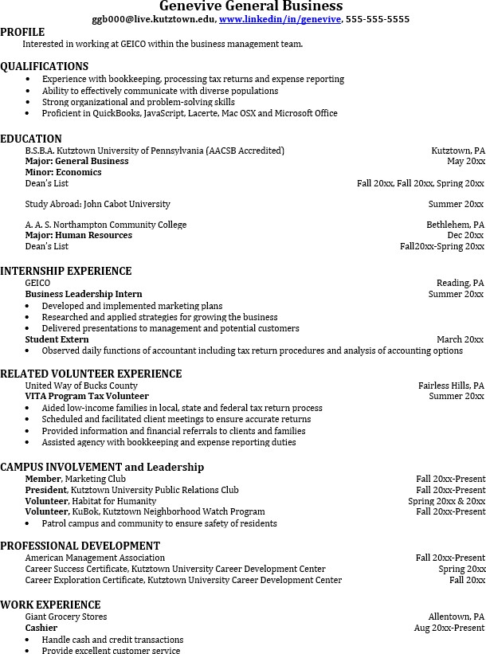
Employerswanttohiregraduateswhonotonlyhavethenecessaryeducationalbackgroundbutalso haveexperienceapplyingthatknowledgetoreallifesituations.
Takenoteoftheskills andknowledge obtainedthroughyour educational background andhands-on experiences.Highlight transferableskillssuch as organizationand communication.

ForMoreInformationonGeneralBusinessCareersortospeaktoaCareerCounseling,contactKUCareerDevelopmentCenter113Stratton AdministrationCenter*610-683-4067*careerhelp@kutztown.edu*www.kutztown.edu/careercenter

