- Paid, short-term projects
- 1-4 weeks, 10-40 hours total
- Remote, hybrid or in person
- Flexible work hours

Micro-Internship Program





“My micro-internship helped me feel more confident that I could handle an internship in the
future.”

- Resume builder
- Available during semester, winter or summer
– KU Student

- Uber vouchers or mileage reimbursement available for in-person opportunities



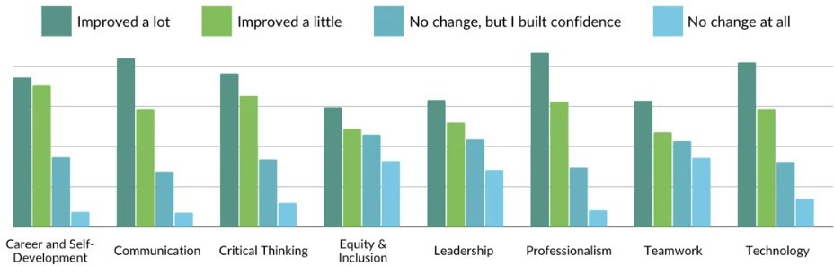

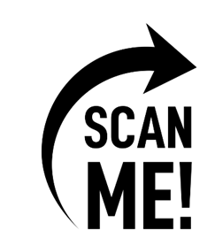
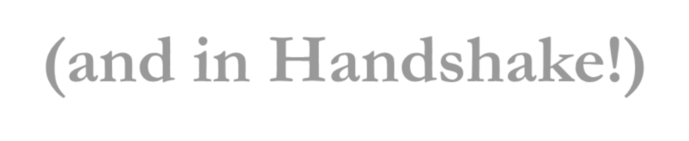
Questions? Contact the Career Development Center at careerhelp@kutztown.edu
Visit the Career Center website to see the latest opportunity listings: www.kutztown.edu/microinternhsips
(and in Handshake!)
Small Projects, Big Impact
Source: https://www.parkerdewey.com/blog/nace-competencies

