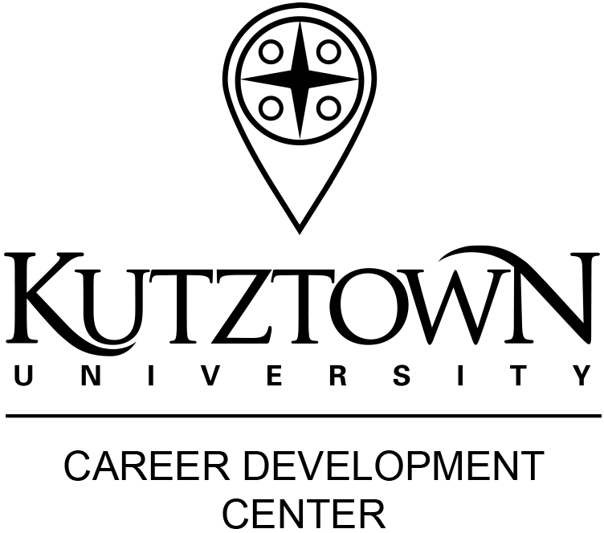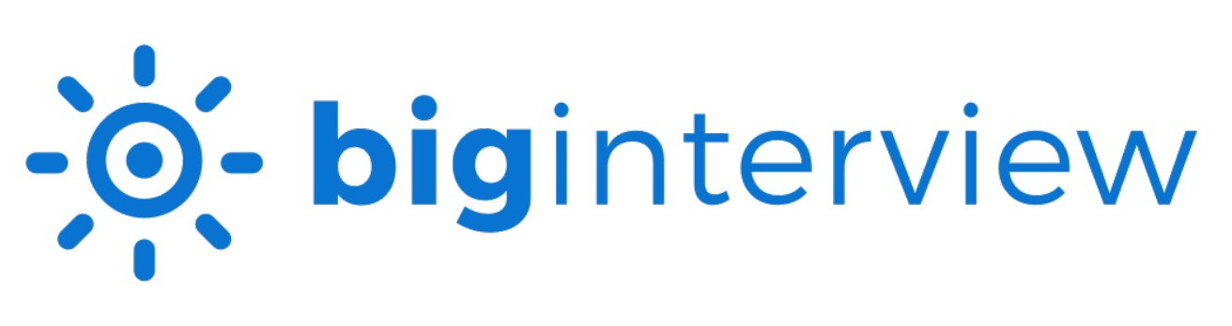
ONLINE MOCK INTERVIEWS

Making a good first impression is essential for a strong and successful interview.
Big Interview provides the opportunity for you to practice interviewing using your camera and microphone. Record your practice interview and submit it to the Career Development Center to have it reviewed by a friendly and experienced employer volunteer. The interview consists of several questions and takes approximately 20 minutes.
Tips for Success
- Click on the blue "How to use Assignments" button in Big Interview for a tutorial video.
- Dress professionally. Guidelines for
professional dress are on the CDC website.
- Place your computer/laptop on a sturdy
table or desk, fairly high up. Confirm your head and shoulders on the screen.
- Check your surroundings. Make sure your environment is free from background noise that your microphone might pick-up and
the backdrop is uncluttered and distraction free. Consider removing wall art so you
are the focal point.
- Look at the camera and not at the screen so you are making eye contact with your interviewer.
- Speak clearly and loudly into your microphone.

Get Started
- Go to www.kutztown.edu/biginterview.
- Login using your KU single sign on.
- If you have an Assignment Code (from your course assignment, Mock Interview Mania, etc.), click on the Assignments Tab and enter it.
- For the Career Certificate, click on the Learn Tab and then go to Fast Track and complete all sections so you earn 100% on the curriculum.

Tips for a Successful Experience
- You have 2:00 minutes for each question.
- You have a maximum of 2 takes for each question.
- You will be able to review the entire interview before submitting.
- Please do not delete an interview if you want someone to view it in the future.

See Reverse Side for Additional Instructions

113 Stratton Administration Center 610-683-4067
careerhelp@kutztown.edu www.kutztown.edu/careercenter
Career Development Center

Complete the Interview
- After reviewing the question, click "Start Recording" and record your answer. Your time is shown in the lower left hand corner. Make sure you do not go over the alloted time. When you are finished answering the question, you will need to hit the stop button to stop recording.
- Please note that you need to save each answer before continuing. You get 1 retry per question if you want to try to improve your answer.
- You then can review your answers and submit final answers for the entire assignment.
Request Feedback/Review – Please check the CDC calendar for mock interview review deadline.
- Depending on the timing of your submission, the review may take 2-3 weeks to be completed. Please plan accordingly for class assignments.
- All feedback is sent through Big Interview. You will be notified via email when feedback is submitted. If
the online interview was completed as part of a class assignment, you may need to take a screen shot of the feedback that was sent to you and submit that to your professor.

How your online mock interview will be reviewed:
Your overall interview will be critiqued by an employer volunteer based on the following criteria.
Additionally, you will receive feedback on the nature and content of each of your responses. Remember, interviewing is a skill; the more you practice the better you will get. If the results of this review are part of your evaluation for a class, please prepare appropriately and consider making more than one interview
attempt prior to submitting the best one for feedback.

Is the answer complete and compelling?
  - - Dodges or does not answer the question
  - - Answer is too short, too vague, or sounds inauthentic
  - - Answer could be more relevant, detailed, or interesting
  - - Answer is solid, but could be more compelling or memorable
  - - Excellent answer, presents the candidate in a positive and memorable way

Does this answer stay focused and concise and avoid rambling?
- - Answer is rambling and all over the place
- - Answer goes off on tangents and is too long
- - Answer is reasonably concise, but wanders a little
- - Answer is focused but there is room for improvement in either length or quality
- - Answer is focused and concise while presenting enough key details to impress

Does this answer convey interest and enthusiasm?
- - Answer raises red flags about candidate’s interest and enthusiasm
- - Answer conveys little enthusiasm
- - Answer sounds positive, but leaves some doubt
- - Answer is enthusiastic
- - Answer is both enthusiastic and backs up candidate’s interest with details

Is the answer clear and understandable?
- - It was very difficult to understand the answer due to speed and/or enunciation.
- - There were times when it was difficult to understand the speaker.
- - Answer was understandable but clarity could be improved.
- - Answer was clear and understandable.
- - Answer was delivered beautifully with excellent pace, volume, and enunciation.

Does the answer avoid too many filler words like um, uh, and you know?
- - The number of filler words is distracting and raises red flags
- - The number of filler words is noticeable and makes the candidate seem unpolished
- - Filler words popped up a few times, but not in a distracting way
- - Filler words did not detract from the quality of the answer in any way
- - Delivery was polished and natural, did not even notice any filler words

Does the candidate make consistent eye contact (with the camera)?
- - Avoids eye contact to the point of being distracting
- - Eye contact seems awkward, a lot of looking down or away or staring too fixedly
- - Eye contact seemed fine, maybe a bit of glancing away to think at times
- - Eye contact was good, seemed natural with no noticeable issues at all
- - Eye contact was great, candidate seemed engaged and interested the whole time

Does the candidate’s body language seem natural and confident?
- - Excessive slouching, defensive crossed arms, constant shifting, etc.
- - Body language was noticeably awkward at times
- - Body language seemed fine
- - Body language was good, natural and no noticeable issues at all
- - Body language was natural and confident and engaging

Is the candidate dressed appropriately?
- - Candidate’s attire is totally inappropriate for the type of interview.
- - While not totally inappropriate, the candidate’s attire should be adjusted.
- - Candidate’s attire is fine and shouldn’t raise any concerns
- - Candidate’s attire is professional and appropriate
- - Candidate’s attire is professional and smart, dressing for the job they want

