

Bachelor of Science: Information Technology
Minor: Computer Science, Information Technology, Game Development and Web Development, Data Science Certificate: Cybersecurity Certificate, Scripting for Data Manipulation, Database Design & Implementation

The Bachelor of Science in Information Technology focuses on application support, including network, security, and database. Upon graduation, these students may choose to work as cybersecurity specialists, network managers or technicians, system administrators, database administrators or web developers. Employers recommend one or more internships to be successful and competitive when entering this field.

Career types associated with Information Technology
(Is this a good fit for you? Are you a…)
- Investigative - “Thinker”
- Conventional - “Organizer”
- Social - “Helper”

Related skills, values, and qualities
- Ability to adapt to constant change
- Proficiency in reading, writing, and thinking, questioning, and analyzing
- Proficiency in problem solving
- Ability to think logically and organize
- Proficiency with computers
- Aptitude for accuracy and detail
- Strong math background
- Ability to work under pressure
- Ability to concentrate for long periods of time

Courses Information Technology majors typically
enjoy
- Algebra, Trigonometry, Calculus
- Computer Programming
- Computer Science
- Criminal Justice
- Information Technology
- Networking
- Cyber Security
- Web Development

Common interests of Information Technology majors
  - Working with computers, software, gaming
  - Troubleshooting and repairing electronic equipment
  - Completing puzzles or playing games of strategy
  - Solving logic problems
  - Participating in Computer Science or related clubs
  - Working part-time or volunteering in a technology store/department
  - Reading computer or technology publications
For more information about the major Contact the Computer Science and Information Technology Department, 256 Old Main,
610-683-4340, or visit www.kutztown.edu/csit CSITDepartment@kutztown.edu
KU Majors related to Information Technology Mathematics, Communication Design, Applied Digital Arts, Criminal Justice

For More Information on Computer Science/IT careers or to speak to a Career Counselor, contact KU Career Development Center 113 Stratton Administration Center * 610-683-4067 * careerhelp@kutztown.edu * www.kutztown.edu/careercenter



- Enroll in the Career Exploration Certificate.
- Attend info sessions to learn about career development and personal branding.
- Take a career assessment to
identify and confirm interests.
- Get involved in campus clubs and organizations.
- Develop basic workplace skills through jobs or volunteer work.
- Talk with professors, family, and friends about career ideas.
- Conduct informational interviews with professionals working in fields of interest.
- Develop a relationship with your professors and faculty advisor.
- Meet with CDC career coach.
- Attend info sessions to learn about resume writing, and externships.
- Confirm your choice of major and consider options for double major or minor.
- Research careers of interest.
- Complete a job shadowing (externship) experience.
- Seek meaningful employ-ment or volunteer work in a field related to your major.
- Explore options for under-graduate research and study abroad.
- Write a resume and have it reviewed by the CDC.
- Manage your online presence.

- Enroll in the Career Success Certificate.
- Complete an internship and/or undergraduate research.
- Attend info sessions about internships, interviewing, job search strategies, and grad school.
- Build a LinkedIn profile and continue to monitor your online presence.
- Complete a mock interview.
- Build skills through research projects, part-time employment, and volunteer work.
- Participate in employer panels, site visits & networking events.
- Attend internship & job fairs.
- Take on a leadership role in a student organization or work.
- Consider graduate school options and prepare for admissions tests.
- Attend your Senior Kick-off session and other info sessions to prepare for job search/grad school.
- Update your resume and LinkedIn profile.
- Create cover letter drafts.
- Gain experience through internships and/or undergraduate research.
- Secure references for job/grad school applications.
- Create your “30 second”
commercial/elevator pitch.
- Meet with CDC to develop job search strategies.
- Research employers.
- Network with professionals through events and social media.
- Join a professional organization
in your discipline.
- Attend the senior etiquette luncheon or dinner.
- Participate in job fairs and on-campus interviewing.

Sample Career Titles
Information Technology majors can be found working in a wide variety of career fields. Here are just some career titles that may be of interest. Please note that some jobs may require further education and training.
To learn more about these careers, visit http://online.onetcenter.org or www.bls.gov/oco.

Application/Programmer Computer Programmer Computer Installation Specialist Computer Service Technician Computer Systems Analyst Cryptographer/Cryptologist Cybersecurity Specialist Data/Database Analyst
Data Centre Technician Data Scientist Database Administrator
Data Communications/Security Analyst Educator/Trainer
Employee Relations Specialist End-User Computing Manager Engineering Lab Technician Environmental Technologist Information Scientist
Information Technology Consultant Information Security Analyst
Information Technology Specialist Information Systems Developer Information Systems Manager Information Technology Manager Information Technology Specialist Internet Developer
ISO Specialist LAN/Logistics Manager Machine Programmer Multimedia Developer
Network Administrator/Manager Network Engineer
On-Line Services Manager Operating Systems Programmer Operations Manager/Analyst PC Support Specialist
Product Development/Line Manager Product Forecaster/Estimator Production Support Specialist Programmer: Engineering & Sci.
Python Developer
Quality Assurance Analyst SAS Programmer
Senior Analyst Programmer Software Application Integrator Software Development Specialist Software Engineering Specialist Software Package Developer Software Support Tech/Specialist Systems Administrator/Analyst Systems Consultant
Systems Programmer Systems Technical Manager Technical Writer
User Support Analyst UI Programmer
Web Developer Web Designer

Common Internship Sites and Employers
Information Technology majors often find internships and
employment in the following fields/industries.

  - Banks & Investment Firms
  - Business & Industry
  - Colleges/Universities
  - Consulting Firms
  - Federal, State & Local
  - Healthcare
  - International Agencies
  - Manufacturing
  - Military
  - Research & Development
  - Telecommunications


Handshake is the primary online resource
for preparing and connecting students and alumni with employers.
www.kutztown.edu/handshake

Useful Websites for Information Technology Majors
Whether you are researching related career fields, applying for internships or jobs, or planning to join a professional association, these websites are for you!

Industry/Employment Information

Computer Jobs
www.computerjobs.com

Computer Work www.computerwork.com
Dice www.dice.com

IEEE
jobs.ieee.org
Internet Society www.internetsociety.org
Just Tech Jobs www.justtechjobs.com

Tech America www.techamerica.org
LinkedIn Jobs www.linkedin.com/jobs

U.S. Bureau of Labor Statistics
https://www.bls.gov/ooh/computer-and-information-technology/home.htm
Production Hub www.productionhub.com/jobs

Professional Associations
Agile Alliance https://www.agilealliance.org/

ASIS International https://www.asisonline.org/

Association for Computing Machinery www.acm.org
Association of IT Professionals www.aitp.org
Association for Women in Computing www.awc-hq.org

Computer Society www.computer.org

IT Association of America
www.itaa.org

Institute of Electrical & Electronics Engineers www.ieee.org (job postings too)
International Assoc. for Technology in Education www.iste.org

Related Area Employers

Air Products
Andesa Services
Armstrong World Industries
B. Braun Medical Inc. Brenntag
Brentwood Industries Clark Associates
Computer Aid Inc
Deloitte US Delivery Center Fidelity Information Services Gateway Ticketing
Hershey Entertainment & Resorts Kutztown University
Lehigh Valley Health Network LeverX
Listrak Inc.
Liquid Interactive Lutron Electronics Neo Pangea
Olympus Oracle
Penn Interactive Penske
PPL Electric Utilities SAP
St. Luke's University Health Network UHS of Delaware, Inc.
Versum Materials Zulily

Building Your Resume for a Career in Information Technology
Building a strong resume for your career field starts long before you ever start your job search. Employers want to hire graduates who not only have the necessary educational background but also have experience applying that knowledge.

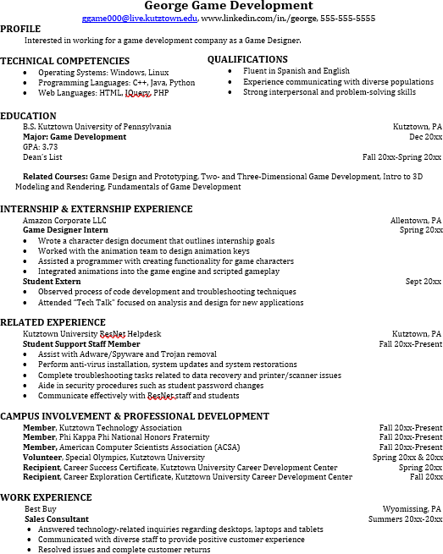
Learn more about your field and develop the necessary skills for employment by gaining hands-on experience through internships.

Utilize summer breaks to acquire valuable experience via volunteer or employment opportunities related to your major.

Develop professionally through campus involvement and professional memberships.
This illustrates responsibility, leadership abilities and time management skills.

For More Information on IT careers or to speak to a Career Counselor, contact KU Career Development Center 113 Stratton Administration Center * 610-683-4067 * careerhelp@kutztown.edu * www.kutztown.edu/careercenter

