

Bachelor of Science in Business Administration with a major in Accounting
Accountants maintain the financial records, supervise the recording of transactions for businesses, corporations,
not-for-profit organizations, and governmental units. Accountants design and maintain systems to record changes in assets and liabilities, supervise accounting for expenses, payments, purchases, and inventories, prepare periodic tax and financial reports, and report information about the organization’s performance to internal and external entities such as management, shareholders, creditors, and vendors. Areas of concentration include public, corporate/managerial, or government accounting, and internal auditing. The Accounting major prepares students for the Uniform Certified Public Accountant Examination (CPA) and is a solid basis for employment as an accountant, or in other areas such as small business, entrepreneurship, financial analysis, banking and credit analysis. Some students elect to pursue education beyond the B.S.B.A. as most states require 150 credit hours of education to become a CPA. It is recommended that students complete one or more internships to be successful and competitive when entering the field of accounting.

Career types associated with Accounting
(Is this a good fit for you? Are you a...)
- Conventional - “ Organizer”
- Enterprising - “Persuader”
- Investigative - “Thinker”

Related skills, values, and qualities
- Aptitude for working with numbers
- Ability to organize, analyze, or interpret
numerical data
- Aptitude for accuracy and detail
- Proficiency with computers
- Ability to make sound judgments and decisions and to solve quantitative problems
- Excellent interpersonal skills and proficiency in written and oral communications
- Ability to explain complex financial data to others
- Ability to lead, supervise, and direct others
- Ability to work alone and concentrate for long periods of time
- Hard-working

Courses Accounting majors typically enjoy
- Finance
- Business
- Business Mathematics
- Computer Operations
- Computer Programming
- Economics
- Mathematics
- Statistics

Common interests of Accounting majors
- Maintaining accurate personal financial/bank records
- Working part-time or volunteering as a treasurer or income tax preparer
- Solving problems using analytical and logical processes
- Enjoying working with computers/software
- Joining an accounting-related organization
- Attending accounting-related lectures and conferences
- Traveling

For more information about the major Contact the Department of Business Administration, 233 deFrancesco, 610-683-4580,
or visit www.kutztown.edu/Accounting

KU Majors related to Accounting Computer Science, Finance, Library Science, Management, Mathematics, Marketing, Public Administration



For More Information on Accounting Careers or to speak to a Career Counseling, contact KU Career Development Center 113 Stratton Administration Center * 610-683-4067 * careerhelp@kutztown.edu * www.kutztown.edu/careercenter



  - Enroll in the Career Exploration Certificate.
  - Attend info sessions to learn about career development and personal branding.
  - Take a career assessment to
identify and confirm interests.
  - Get involved in campus clubs and organizations.
  - Develop basic workplace skills through jobs or volunteer work.
  - Talk with professors, family, and friends about career ideas.
  - Conduct informational interviews with professionals working in fields of interest.
  - Develop a relationship with your professors and faculty advisor.
- Meet with CDC career coach.
- Attend info sessions to learn about resume writing, and externships.
- Confirm your choice of major and consider options for double major or minor.
- Research careers of interest.
- Complete a job shadowing (externship) experience.
- Seek meaningful employ-ment or volunteer work in a field related to your major.
- Explore options for under-graduate research and study abroad.
- Write a resume and have it reviewed by the CDC.
- Manage your online presence.
- Enroll in the Career Success Certificate.
- Complete an internship and/or undergraduate research.
- Attend info sessions about internships, interviewing, job search strategies, and grad school.
- Build a LinkedIn profile and continue to monitor your online presence.
- Complete a mock interview.
- Build skills through research projects, part-time employment, and volunteer work.
- Participate in employer panels, site visits & networking events.
- Attend internship & job fairs.
- Take on a leadership role in a student organization or work.
- Consider graduate school options and prepare for admissions tests.
- Attend Senior Kick-off session and other info sessions to pre-pare for job search/grad school.
- Update your resume and LinkedIn profile.
- Create cover letter drafts.
- Gain experience through internships and/or undergraduate research.
- Secure references for job/grad school applications.
- Create your “30 second”
commercial/elevator pitch.
- Meet with CDC to develop job search strategies.
- Research employers.
- Network with professionals through events and social media.
- Join a professional organization
in your discipline.
- Attend the senior etiquette luncheon or dinner.
- Participate in job fairs and on-campus interviewing.

Sample Career Titles
Accounting majors can be found working in a wide variety of career fields. Here are just some career titles that may be of interest. Please note that some jobs may require further education and training. To learn more about these careers,
visit http://online.onetcenter.org or www.bls.gov/oco

  - Actuary
  - Assistant Controller
  - Auditor
  - Bank Examiner
  - Benefits Administrator
  - Budgetary Control Analyst
  - Certified Public Accountant
  - Chief Cost Accountant
  - Chief Financial Officer
  - CIA Agent
  - Claims Adjuster
  - Collection Agent
  - Commercial Banker
  - Commodities Trader
  - Consumer Credit Officer
  - Controller
  - Corporate Accountant
  - Cost Accountant
  - Credit and Collection Specialist
  - Entrepreneur
  - Estate Planner
  - FBI Agent
  - Financial Analyst
  - General Auditor
  - Governmental Accountant
  - Industrial Buyer
  - Internal Auditor
  - International Trade Specialist
  - Inventory Control Specialist
  - IRS Investigator
  - Loan Administrator
  - Loan Officer
  - Logistics Specialist
  - Managerial Accountant
  - Management Consultant
  - Methods and Procedures Specialist
  - Payroll Manager
  - Personal Financial Planner
  - Plant Accountant
  - Professor
  - Public Accountant
  - Securities Broker
  - Stockbroker
  - Systems Analyst
  - Tax Lawyer
  - Tax Specialist
  - Treasurer
  - Treasury Management Specialist
  - Trust Accountant
  - Underwriter

Common Internship Sites and Employers
Accounting majors often find internships and employment in the following industries:

    - Accounting Firms
    - Banks
    - Business & Industry
    - College/Universities
    - Insurance Companies
    - Non-profit organizations
    - Private Practice
    - State/Federal Government
    - Stock Brokerages



Handshake is the primary online resource
for preparing and connecting students and alumni with employers. www.kutztown.edu/handshake

Useful Websites for Accounting Majors
Whether you are researching related career fields, applying for internships or jobs, or planning to join a professional association, these websites are for you!

Industry/Employment Information

Information on Accounting Careers www.becker.com

AICPA
www.startheregoplaces.com

Career Bank www.careerbank.com
CPA Directory & Job Postings www.cpadirectory.com

Accounting Jobs Today
www.jobboard.accountingjobstoday.com
Pennsylvania Institute of Certified Public Accountants Career Center http://www.picpa.org

Accounting Career Center
http://www.accountingcoach.com/careers
LinkedIn Jobs www.linkedin.com/jobs
Professional Associations

American Institute of Certified Public Accountants (AICPA)
www.aicpa-cima.com
The Association of Accountants and Financial Professionals in Business www.imanet.org
American Accounting Association http://aaahq.org
National Association of Black Accountants www.nabainc.org

PA Institute of Certified Public Accountants
www.picpa.org
Institute of Internal Auditors www.theiia.org
American Society of Women
Accountants
www.aswa.org
American Association of Latino Professionals in Finance and Accounting
www.alpfa.org
Financial Executives International www.financialexecutives.org
Association of Government Accountants www.agacgfm.org
Related Area Employers
Andersen Air Products Baker Tilly BBD LLP BDO
Buckno Lisicky
Campbell, Rappold & Yurasits LLP Carpenter Technology Corporation Clark Associates, Inc.
Deloitte
East Penn Manufacturing Enersys, Inc.
Ernst & Young Grant Thornton
Herbein + Company, Inc Hershey Entertainment & Resorts KPMG
Kreischer Miller
Kutztown University: Accounts Payable Dept., Foundation Office, & Small Business Development Ctr.
Maillie, LLP
Molinari Oswald LLC Olympus
PA Department of Revenue Penske
PPL Electric Utilities PwC
RKL
S.R. Snodgrass, P.C. SEI, Inc.
Vanguard

Building Your Resume for a Career in Accounting
Learn more about your field and develop the necessary skills for employment by gaining hands-on experience through externships, internships, part-time jobs and related volunteer positions.
Develop professionally through campus involvement and professional memberships.
This illustrates responsibility, leadership abilities and time management skills.
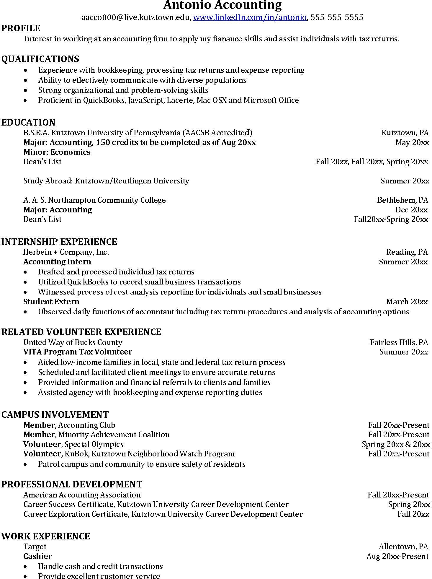
Building a strong resume for your career field starts long before you ever start your job search. Employers want to hire graduates who not only have the necessary educational background but also have experience applying that knowledge to real life situations.
Take note of the skills and knowledge obtained through your educational background and hands-on experiences.
Highlight transferable skills such as organization and communication.

For More Information on Accounting Careers or to speak to a Career Counseling, contact KU Career Development Center 113 Stratton Administration Center * 610-683-4067 * careerhelp@kutztown.edu * www.kutztown.edu/careercenter

