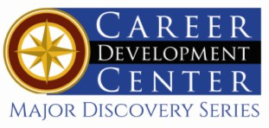

Bachelor of Fine Arts: Animated Arts
Concentrations: Animation, Pre-production, 3D Modeling

Students studying Animated Art at Kutztown University with a focus in Animation, Pre-production, or 3D Modeling develop a wide range of technical and creative skills. These include proficiency in 2D and 3D animation techniques, storyboarding, visual storytelling, concept design, and 3D modeling. Students gain experience with industry-standard software for 2D animation and 3D modeling, rigging, texturing, and animating characters and environments. Through hands-on projects, they also learn the fundamentals of narrative development, character design, layout, and production workflows, preparing them for careers in animation, game design, visual development, and related creative industries. Junior and senior years include internship opportunities, group projects and capstone courses, that prepare students for careers in these creative visual professions.

Career types associated with Animated Arts
(Is this a good fit for you? Are you a…)
- Artistic - “Creator”
- Social - “Helper”
- Enterprising - “Persuader”

Related skills, values, and qualities
- Ability to communicate ideas, thoughts, and feelings visually
- Ability to think creatively
- Strong sense of expertise and manual dexterity
- Familiarity with traditional art approaches as well as other new and digital media
- Intuition and innovation in understanding and extracting ideas to generate visual concepts
- Organization and attention to detail
- Strong interpersonal and networking skills

Common interests of Animated Arts majors
- Watching animations and movies
- Creating video productions
- Writing and storytelling
- Creating unique characters
- Digital drawing
- Playing video games
- Painting and sculpture
- Attending art shows and other visual art events
For more information about the major Contact The Department of Art and Design 115 Sharadin, 610-683-4540
or visit www.kutztown.edu/academics/colleges-and-departments/visual-and-performing-arts/

Courses Animated Arts majors typically enjoy
- Art
- Design
- Information Technology
- Cinema Television & Media
- Animation
- Game Development
- Marketing
- Writing

KU Majors related to Animated Arts
Art, Art History, Art Education, Communication Design, Professional Writing, Cinema, Television & Media, Game Development

For More Information on Animated Arts careers or to speak to a Career Counselor, contact KU Career Development Center 113 Stratton Administration Center * 610-683-4067 * careerhelp@kutztown.edu * www.kutztown.edu/careercenter



- Enroll in the Career Exploration Certificate.
- Attend info sessions to learn about career development and personal branding.
- Take a career assessment to
identify and confirm interests.
- Get involved in campus clubs and organizations.
- Develop basic workplace skills through jobs or volunteer work.
- Talk with professors, family, and friends about career ideas.
- Conduct informational interviews with professionals working in fields of interest.
- Develop a relationship with your professors and faculty advisor.
- Meet with CDC career coach.
- Attend info sessions to learn about resume writing, and externships.
- Confirm your choice of major and consider options for double major or minor.
- Research careers of interest.
- Complete a job shadowing (externship) experience.
- Seek meaningful employ-ment or volunteer work in a field related to your major.
- Explore options for under-graduate research and study abroad.
- Write a resume and have it reviewed by the CDC.
- Manage your online presence.

- Enroll in the Career Success Certificate.
- Complete an internship and/or undergraduate research.
- Attend info sessions about internships, interviewing, job search strategies, and grad school.
- Build a LinkedIn profile and continue to monitor your online presence.
- Complete a mock interview.
- Build skills through research projects, part-time employment, and volunteer work.
- Participate in employer panels, site visits & networking events.
- Attend internship & job fairs.
- Take on a leadership role in a student organization or work.
- Consider graduate school options and prepare for admissions tests.
- Attend your Senior Kick-off session and other info sessions to prepare for job search/grad school.
- Update your resume and LinkedIn profile.
- Create cover letter drafts.
- Gain experience through internships and/or undergraduate research.
- Secure references for job/grad school applications.
- Create your “30 second”
commercial/elevator pitch.
- Meet with CDC to develop job search strategies.
- Research employers.
- Network with professionals through events and social media.
- Join a professional organization
in your discipline.
- Attend the senior etiquette luncheon or dinner.
- Participate in job fairs and on-campus interviewing.

Sample Career Titles
Animated Arts majors can be found working in a wide variety of career fields. Here are just some career titles that may be of interest. Please note that some jobs may require further education and training.
To learn more about these careers, visit http://online.onetcenter.org or www.bls.gov/oco.

2D/3D Animators Animator
Character Animator/Modeler Game Designer/Concept Artist Digital Arts Instructor
Art Teacher Media Assistant
Digital Strategy Manager Multimedia Designer Digital Brand Manager Virtual Reality Designer Filmmaker

Environmental Modeler Simulations FX Technical Director Storybord Designer
Visual Development Artist Digital Compositor
VFX Supervisor
Motion Graphics Designer Website Graphic Designer

Common Internship Sites and Employers
Animated Arts majors often find internships and employment in the following fields/industries.

  - Freelancer for any industry
  - Art & Design Studios/Galleries
  - Publishing Firms
  - Museums
  - Television Studios
  - Community Arts Organizations
  - Media/Design Firms
  - Movies/Film/Entertainment
  - Gaming
  - Independent Studios



Handshake is the primary online resource
for preparing and connecting students and alumni with employers.
www.kutztown.edu/handshake

Useful Websites for Animated Arts Majors
Whether you are researching related career fields, applying for internships or jobs, or planning to join a professional association, these websites are for you!

Industry/Employment Information
National Endowment for the Arts www.arts.gov
NY Foundation for the Arts www.nyfa.org
ResArtis www.resartis.org
Art Deadline http://artdeadline.com

Creating an Animation Demo Reel (Pixar) www.bloopanimation.com/animation-demo-reel/

Professional Associations
Industrial Designers Society of America www.idsa.org/job-board
American Institute of Graphic Artists www.designjobs.aigia.org
Southern Graphics Council http://sgcinternational.org
International Game Developers Association www.igda.org
Women in Animation https://womeninanimation.org

Job/Internship Search Boards

HitMaker https://hitmaker.net
LinkedIn Jobs
www.linkedin.com/jobs
Art Station www.artstation.com

Production Hub www.productionhub.com/jobs
Animated Jobs.com https://animatedjobs.com
Game Developer.com https://jobs.gamedeveloper.com
www.mediabistro.com https://ispyrecruiting.com https://dribbble.com

Related Area Employers
Allentown Art Museum ArtsQuest
Bento Box Berks Arts
Blizzard Entertainment DaBrian Marketing Group Gavin
Goggleworks
Nerd Street Games NeoPangea
New Arts Program Milkroom Entertainment Rodale Institute Warner Brothers WebFX, Inc.

Related Employers
Pixar Animation Studios Lucasfilm Animation Industrial Light & Magic
Walt Disney Animation Studios Cartoon Network Studios Adult Swim
Warner Bros. Animation DreamWorks Animation Studios Sony Pictures Animation
20th Century Fox Animation Marvel Studios
Schell Games Rockstar Games

Building Your Resume for a Career in Animated Arts

Utilize summer breaks to acquire valuable experience via volunteer or employment opportunities related to your major.

Develop professional-ly through campus involvement and professional memberships.
This illustrates responsibility, leadership abilities and time management skills.

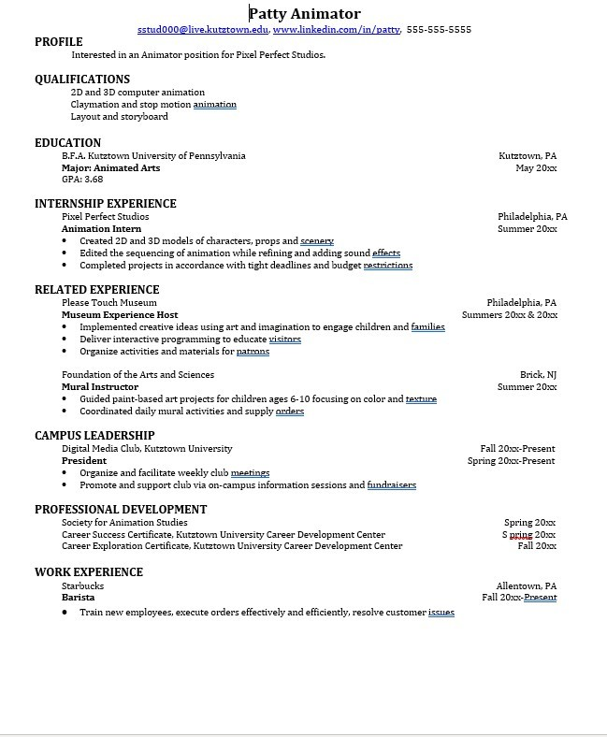
Building a strong resume for your career field starts long before you ever start your job search. Employers want to hire graduates who not only have the necessary educational background but also have experience applying that knowledge.
Learn more about your field and develop the necessary skills for employment by gaining hands-on experience through internships.

For More Information on Animated Arts careers or to speak to a Career Counselor, contact KU Career Development Center 113 Stratton Administration Center * 610-683-4067 * careerhelp@kutztown.edu * www.kutztown.edu/careercenter

