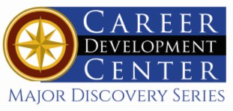

Bachelor of Fine Arts: Art
With Specializations in: Ceramics, Drawing, Painting, Photography, Printmaking, Sculpture, Textiles & Material Studies & Ceramics

Minor: Art
Artists create images or objects to communicate ideas, thoughts, or feelings using a variety of techniques and media. Art is an expansive and dynamic field with a wide variety of career paths. A BFA in Art will prepare you to find meaningful work in fields that rely on creativity, attention to detail, and problem-solving. Our graduates go on to thrive as working artists as well as in careers such as art conservation, art therapy, education, curation, arts administration, and photojournalism.

Career types associated with Art
(Is this a good fit for you? Are you a…)
- Artistic - “Creator”
- Social - “Helper”
- Enterprising - “Persuader”

Common interests of Art majors
- Volunteering in an art studio or museum
- Attending art shows and other visual art events
- Traveling
- Visual & Material Culture

Related skills, values, and qualities
- Ability to communicate ideas, thoughts, and feelings visually
- Ability to think creatively
- Strong sense of craftsmanship and manual dexterity
- Familiarity with traditional art approaches as well as other new and digital media
- Intuition and innovation in understanding and extracting ideas to generate visual concepts
- Organization and attention to detail
- Strong interpersonal and networking skills
- High degree of commitment to field of study.

Courses Art majors typically enjoy
- Art History
- Ceramics
- Drawing
- Painting
- Photography
- Printmaking
- Sculpture
- Weaving, Textiles & Material Studies

For more information about the major Contact Department of Art and Design 310 Sharadin, 610-683-4540

KU Majors related to Art
Animated Arts, Art Education, Art History, Communication Design

For More Information on Art careers or to speak to a Career Counselor, contact KU Career Development Center 113 Stratton Administration Center * 610-683-4067 * careerhelp@kutztown.edu * www.kutztown.edu/careercenter

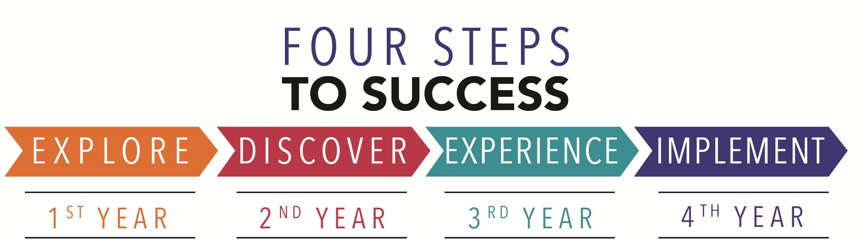

- Enroll in the Career Exploration Certificate.
- Attend info sessions to learn about career development and personal branding.
- Take a career assessment to
identify and confirm interests.
- Get involved in campus clubs and organizations.
- Develop basic workplace skills through jobs or volunteer work.
- Talk with professors, family, and friends about career ideas.
- Conduct informational interviews with professionals working in fields of interest.
- Develop a relationship with your professors and faculty advisor.
- Meet with CDC career coach.
- Attend info sessions to learn about resume writing, and externships.
- Confirm your choice of major and consider options for double major or minor.
- Research careers of interest.
- Complete a job shadowing (externship) experience.
- Seek meaningful employ-ment or volunteer work in a field related to your major.
- Explore options for under-graduate research and study abroad.
- Write a resume and have it reviewed by the CDC.
- Manage your online presence.
- Enroll in the Career Success Certificate.
- Complete an internship and/or undergraduate research.
- Attend info sessions about internships, interviewing, job search strategies, and grad school.
- Build a LinkedIn profile and continue to monitor your online presence.
- Complete a mock interview.
- Build skills through research projects, part-time employment, and volunteer work.
- Participate in employer panels, site visits & networking pro-grams.
- Attend internship & job fairs.
- Take on a leadership role in a student organization or work.
- Consider graduate school
options and prepare for
- Attend your Senior Kick-off and other info sessions to prepare for job search/grad school.
- Update your resume and LinkedIn profile.
- Create cover letter drafts.
- Gain experience through internships and/or undergraduate research.
- Secure references for job/grad school applications.
- Create your “30 second”
commercial/elevator pitch.
- Meet with CDC to develop job search strategies.
- Research employers.
- Network with professionals through events and social media.
- Join a professional organization in your discipline.
- Attend the senior etiquette
luncheon or dinner.
- Participate in job fairs and on-campus interviewing.

Sample Career Titles
Art majors can be found working in a wide variety of career fields. Here are just some career titles that may be of interest. Please note that some jobs may require further education and training.

ARTS:
Studio Artist
Art Administrator Art Critic
Art Historian Art Teacher Art Therapist
Wearable Designer Fabricator Illustrator
Interior Designer Mold Maker Mural Artist
Reviewer
Studio Technician
PHOTOGRAPHY:
Photo Editor
Commercial Photographer Wedding & Portrait Photographer Photojournalist

DIGITAL:
Videographer Video Editor Web Designer
GALLERY AND MUSEUM WORK:
Art Curator Art Dealer Art Director
Conservator & Restorer
Framer
Gallery Owner Museum Educator Preparer/Installer

To Learn more about these careers, visit http://online.onetcenter.org or www.bls.gov/oco.

Common Internship Sites and Employers
Art majors often find internships and employment in the following fields/industries.

  - Photo Studios
  - Art Studios
  - Galleries
  - Mural Projects
  - Printmaking Workshops
  - Community Arts Organizations
  - Fabricators
  - Art Journals
  - Museums


Handshake is the primary online resource
for preparing and connecting students and alumni with employers.
www.kutztown.edu/handshake

Useful Websites for Art Majors
Whether you are researching related career fields, applying for internships or jobs, or planning to join a professional association, these websites are for you!

Industry/Employment Information
CaFÉ
www.callforentry.org

National Endowment for the Arts www.arts.gov
NY Foundation for the Arts www.nyfa.org

PA Council on the Arts www.arts.pa.gov
ResArtist
s www.resartis.org

Job/Internship Search Boards
Museum Jobs
www.museumjobs.com

Greater Phila Cultural Alliance www.philaculture.org
LinkedIn Jobs www.linkedin.com/jobs

Professional Associations

College Art Association www.collegeart.org

National Council on Education in the
Ceramic Arts
www.nceca.net

Southern Graphics Council http://sgcinternational.org
Surface Design Association www.surfacedesign.org

Related Area Employers
Allentown Art Museum Alternative Gallery ArtsQuest
Banana Factory Baum School of Art
Brandywine River Museum of Art Chester County History Center Clay On Main
The Clay Studio of Philadelphia Everhart Museum of Natural History The Fabric Workshop and Museum GoggleWorks Center for the Arts Historic Bethlehem Museums & Sites Lancaster Medical Heritage Museum Lehigh Valley Arts Council Pennsylvania Historical & Museum Commission
Philadelphia Museum of Art
Quiet Valley Living Historical Farm Reading-Berks Guild of Craftsmen Reading Public Museum

Building Your Resume for a Career in Art

Building a strong resume for your career field starts long before you ever start your job search. Employers want to hire graduates who not only have the necessary educational background but also have experience applying that knowledge.

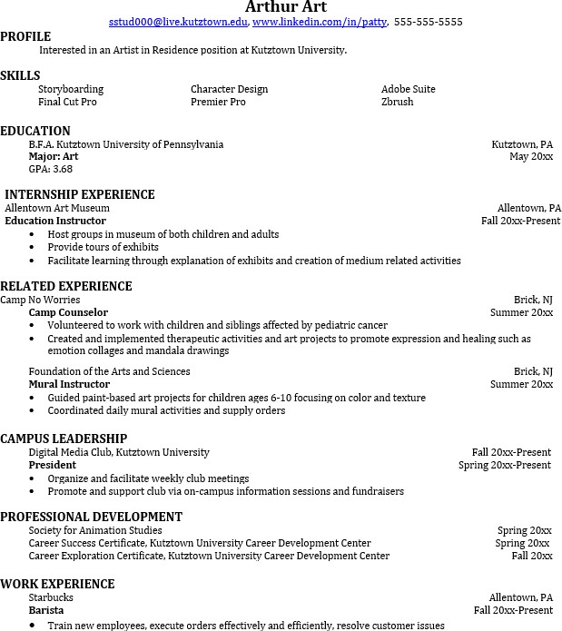
Learn more about your field and develop the necessary skills for employment by gaining hands-on experience through internships.

Utilize summer breaks to acquire valuable experi-ence via volunteer or employment
opportunities relat-ed to your major.

Develop profes-sionally through campus involvement and professional memberships.
This illustrates responsibility, leadership abilities and time manage-ment skills.

For More Information on Art careers or to speak to a Career Counselor, contact KU Career Development Center 113 Stratton Administration Center * 610-683-4067 * careerhelp@kutztown.edu * www.kutztown.edu/careercenter

