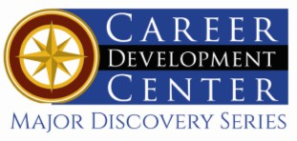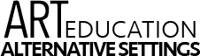

Bachelor of Science in Art Education-Alternative Settings
People create art to communicate ideas, thoughts, or feelings. A variety of methods and an assortment of materials or tools can be utilized to create, including oils, watercolors, acrylics, pastels, pencils, pen and ink, plaster, clay, metals, fiber, and computers. Kutztown University’s renowned art education program with a long history is one of the best in the country. As an art education major, you will receive a sound general education as well as rich experiences in your field. You will gain the knowledge and confidence to become the best possible facilitator of art experiences.

Career types associated with Art Education
(Is this a good fit for you? Are you a…)
- Social - “Helper”
- Artistic - “Creator”
- Enterprising - “Persuader”

Related skills, values, and qualities
- Able to communicate ideas, thoughts, and feelings with a variety of materials and media
- Intuition and innovation in understanding and
extracting ideas to generate visual concepts
- Ability to handle interpersonal relationships
- Familiarity with graphics and database systems
- Ability to plan, facilitate, assess and reflect
- Desire and ability to work with others
- Enthusiasm for facilitating growth and understandings
- Ability to incorporate technology into curriculum and instruction
- Ability to adjust to public scrutiny & criticism
- Ability to meet deadlines and accept feedback
- Display empathy

Courses Art Education majors typically enjoy
- Studio Art
- Art History
- Ceramics
- Textiles
- Photography
- Drawing & Painting
- Public Speaking
- Interpersonal Communication
- Human Growth & Development
- Psychology

Common interests of Art Education majors
- Working part-time or volunteering in an art studio, museum, preschool, or camp setting
- Participating in community service organizations
- Attending art fairs and other visual art events
- Serving as a tutor, peer counselor, or youth group leader
- Creating artworks
- Presenting at art-related conference
For more information about the major Contact the Department of Art Education, 410 Sharadin, 610-683-4520,
or visit www.kutztown.edu/ArtEducation

KU Majors related to Art Education

Communication Design, Crafts, Studio Art, Art History, Elementary Education, Library Science, Music Education, Secondary Education, Special Education.
Artistic students may also be interested in: Advertising*, Cinema, Television and Media Production, English, German, International Studies*, Literature*, Music, PA German Studies*, Philosophy, Professional Writing, Public Relations*, Spanish, or Communication Studies.
*minor only

For More Information on Art Education-Alternative Settings careers or to speak to a Career Counselor, contact KU Career Development Center 113 Stratton Administration Center * 610-683-4067 * careerhelp@kutztown.edu * www.kutztown.edu/careercenter

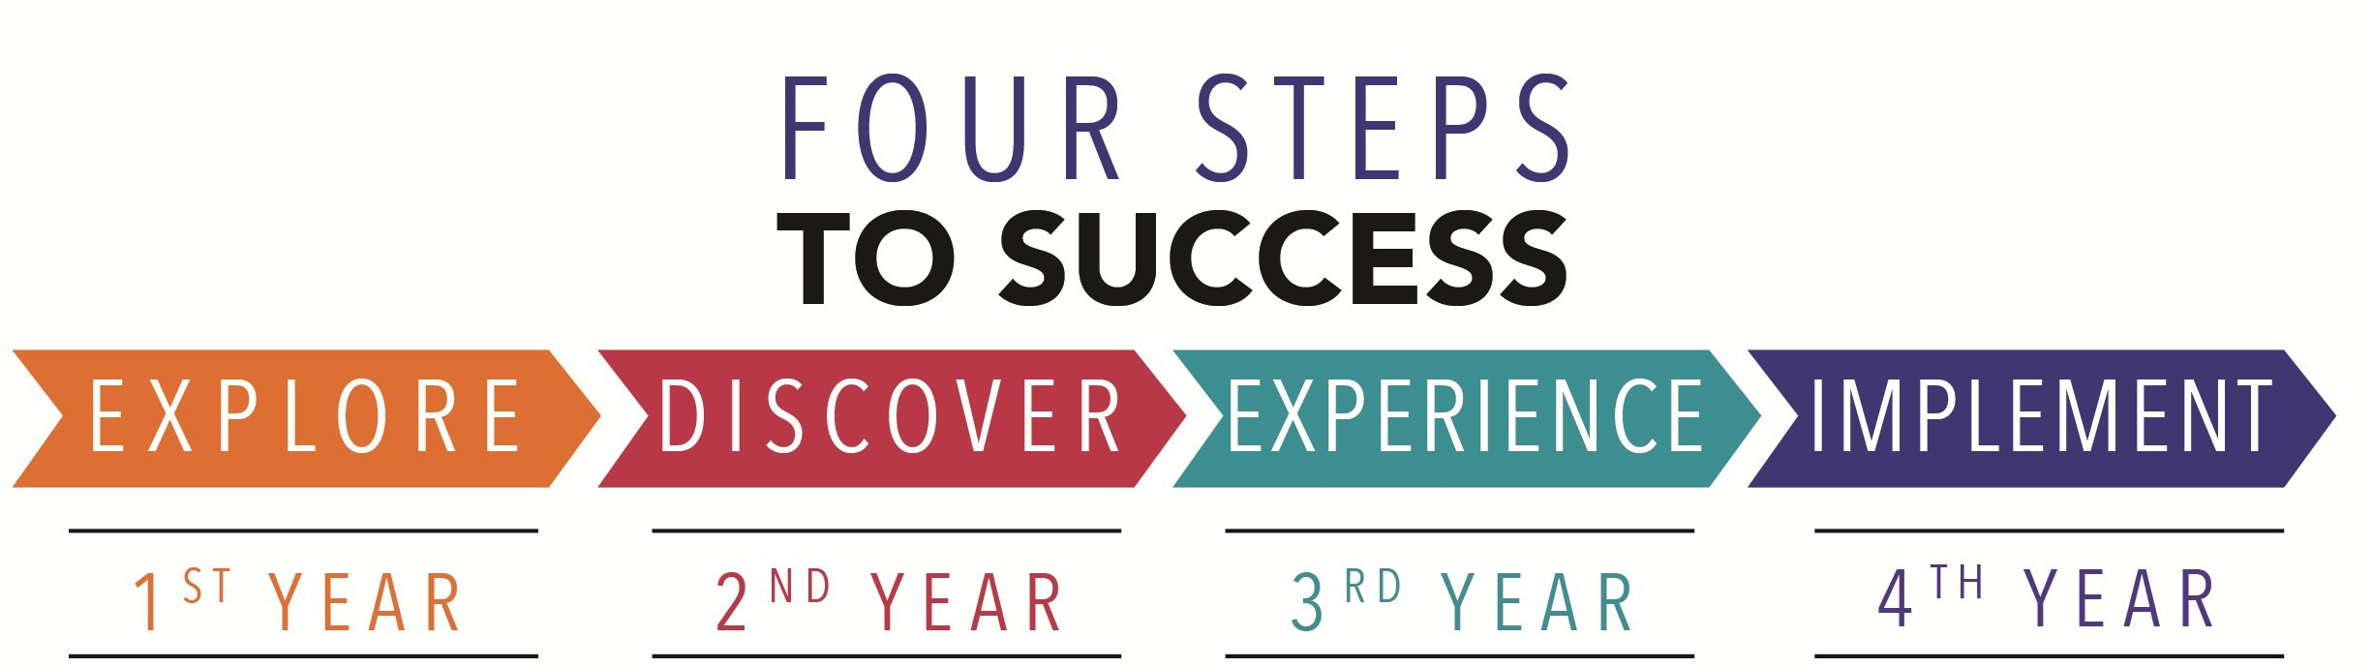
- Enroll in the Career Exploration Certificate.
- Attend info sessions to learn about career development and personal branding.
- Take a career assessment to identify and confirm interests.
- Get involved in campus clubs
and organizations.
- Develop basic workplace skills through jobs or volunteer work.
- Talk with professors, family, and friends about career ideas.
- Conduct informational interviews with professionals working in fields of interest.
- Develop a relationship with your professors and faculty advisor.

- Meet with CDC career coach.
- Attend info sessions to learn about resume writing, and externships.
- Confirm your choice of major and consider options for double major or minor.
- Research careers of interest.
- Complete a job shadowing (externship) experience.
- Seek meaningful employ-ment or volunteer work in a field related to your major.
- Explore options for under-graduate research and study abroad.
- Write a resume and have it reviewed by the CDC.
- Manage your online presence.
- Enroll in the Career Success Certificate.
- Complete an internship and/or undergraduate research.
- Attend info sessions about internships, interviewing, job search strategies, and grad school.
- Build a LinkedIn profile and continue to monitor your online presence.
- Complete a mock inter-view.
- Build skills through research projects, part-time employ-ment, and volunteer work.
- Participate in employer panels, site visits & net-working events.
- Attend internship & job fairs.
- Take on a leadership role in a student organization or work.
- Consider graduate school options and prepare for
- Attend your Senior Kick-off session and other info sessions to prepare for job search/grad school.
- Update your resume and LinkedIn profile.
- Create cover letter drafts.
- Gain experience through internships and/or undergraduate research.
- Secure references for job/grad school applications.
- Create your “30 second”
commercial/elevator pitch.
- Meet with CDC to develop job search strategies.
- Research employers.
- Network with professionals through events and social media.
- Join a professional organization in your discipline.
- Attend the senior etiquette
luncheon and dinner.
- Participate in job fairs and on-campus interviewing.

Sample Career Titles
Art Education-Alternative Settings majors can be found working in a wide variety of career fields. Here are just some career titles that may be of interest. Please note that some jobs may require further education and training.

  - Adult Education Teacher
  - Advertiser
  - Alumni Relations Coordinator
  - Animator
  - Architectural Conservationist
  - Art Appraiser
  - Art Auctioneer
  - Art Conservationist
  - Art Critic
  - Art Director
  - Artist
  - Art Investor
  - Art Lawyer
  - Art Supply Store Manager
  - Art Teacher
  - Art Therapist
  - Assistant Principal
  - Book Illustrator
  - Cartoonist
  - College Professor
  - Commercial Designer
  - Community/Public Service Administrator
  - Curator
  - Costume Designer
  - Day Care Administrator
  - Educational Programmer
  - Education and Training Administrator
  - Education Management Specialist
  - Educational Administrator
  - Education Consultant
  - Educational Materials Sales Rep.
  - Elementary School Teacher
  - Fashion Designer
  - Graphic Designer
  - Guidance Counselor
  - Furniture Designer
  - Greeting Card Illustrator
  - Interior Designer
  - Internet/Web Page Designer
- Jewelry Designer
- Layout Editor
- Newspaper Artist
- Museum Educator
- Painter or Sculptor
- Paintings Restorer
- Peace Corps/VISTA Worker
- Personnel Director
- Photojournalist
- Photographer
- Preschool Administrator
- Preschool Teacher
- Principal
- Publisher
- Secondary School Teacher
- Set Designer
- Student Affairs Administrator
- Curriculum Specialist
- Textile Designer
- Tutor

To learn more about these careers, visit http://online.onetcenter.org or www.bls.gov/oco.

Common Internship Sites and Employers
Art Education-Alternative Settings majors often find internships and employment in the following industries.

  - Art Galleries/Museums
  - State and Federal Government Youth Services
  - Camps
  - Heath based centers
  - Public and Private Schools
  - International Schools
  - Colleges and Universities
  - Community Centers/Non-Profit Organizations
  - Educational Publishers
  - Business and Industry
  - Religious Institutions
  - Hospitals



Handshake is the primary online resource for preparing and connecting students and alumni with employers.

Useful Websites for Art Education-Alternative Settings Majors

Whether you are researching related career fields, applying for internships or jobs, or planning to join a professional association, these websites are for you!

Industry/Employment Information
PA Department of Education www.pa.gov/agencies/education.html

NJ Department of Education
www.state.nj.us/education

Education Week www.edweek.org

Related Area Employers
Job/Internship Search Sites
LinkedIn Jobs
www.linkedin.com/jobs

PA-REAP
www.pareap.net

PA-Educator.net www.pa-educator.net
US-REAP
www.usreap.net
Teachers-Teachers www.teachers-teachers.com

Southern Teacher’s Agency
www.southernteachers.com

K-12jobs.com www.k12.com

Education Job Page www.nationjob.com/education
School Spring www.schoolspring.com
K12 Job Spot www.k12jobspot.com

Professional Associations

PA School Board Association www.psba.org
American Federation of Teachers
www.aft.org
PA Art Education Association www.paee.org
National Art Education Association www.arteducators.org
National Education Association www.nea.org
Association of Arts Admin. Educators http://artsadministration.org
American Alliance of Museums www.aam-us.org

American Art Therapy Association https://arttherapy.org

The National Association of Independent Schools www.nais.org

ArtsQuest, Barnes Foundation, Berks Arts, Berks Catholic High School, Bridgette Mayer Gallery, Clay On Main, Everhart Museum of Natural History, Science and Art; Goggleworks, James A. Michener Art Museum, Lehigh Valley Arts Council, Main Line Art Center, Sorrelli Jewelry, Studio B Art Gallery, Susquehanna Art Museum, YMCA of Reading and Berks County, Yocum Institute for
Arts Education

Building Your Resume for a Career in Art Education-Alternative Settings
Building a strong resume for your career field starts long before you ever start your job search. Employers
want to hire graduates who not only have the necessary educational background but also have experience

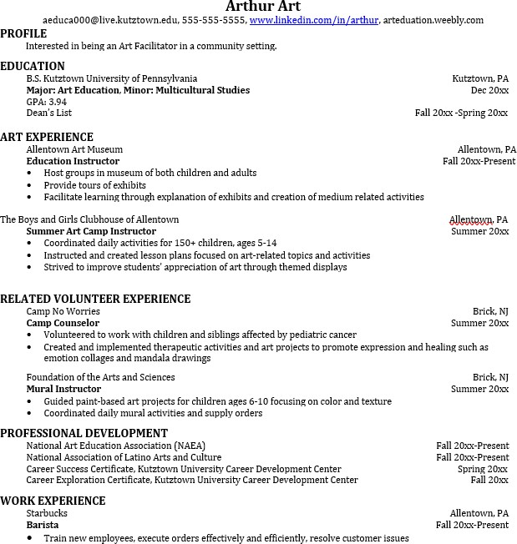
Learn more about your field and develop the necessary skills for employment by gaining hands-on experience through internships.

Utilize summer breaks to acquire valuable experience via volunteer or employment opportunities related to your major.

Develop professionally through campus involvement and professional memberships.
This illustrates responsibility, leadership abilities and time management skills.

For More Information on Art Education-Alternative Settings careers or to speak to a Career Counselor, contact KU Career Development Center 113 Stratton Administration Center * 610-683-4067 * careerhelp@kutztown.edu * www.kutztown.edu/careercenter

