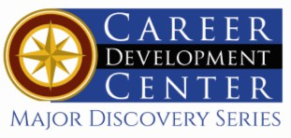

Bachelor of Science in Art Education Minor: Art Education

Artists create art to communicate ideas, thoughts, or feelings. They use a variety of methods—painting, sculpting, or illustration—and an assortment of materials and tools, including oils, watercolors, acrylics, pastels, pencils, pen and ink, plaster, clay, and computers. Art work may be realistic, stylized, or abstract and may depict objects, people, nature, or events. Kutztown University’s renowned art education program is one of the best and largest in the country. As an art education major, you will receive a solid general education, rich experience in your field, and you will gain the confidence and know how to become the best possible art teacher.

Career types associated with Art Education
(Is this a good fit for you? Are you a…)
- Social - “Helper”
- Artistic - “Creator”
- Enterprising - “Persuader”

Related skills, values, and qualities
- Able to communicate ideas, thoughts, and feelings with a variety of materials and media
- A heightened sense of beauty, rhythm, and style
- Intuition and innovation in understanding and
extracting ideas to generate visual concepts
- Ability to handle classroom situations
- Familiarity with graphics and database systems
- Ability to plan, teach, assess and reflect
- Desire and ability to work with children
- Enthusiasm for teaching
- Ability to incorporate technology into the curriculum and instruction
- Ability to adjust to close public scrutiny & criticism
- Ability to meet deadlines and accept feedback

Courses Art Education majors typically enjoy
- Art
- Art History
- Ceramics
- Textiles
- Photography
- Drawing and Painting
- Public Speaking
- Interpersonal Communication
- Human Growth & Development
- Psychology

Common interests of Art Education majors
- Working part-time or volunteering in an art studio, museum, preschool, or camp setting
- Participating in community service organizations
- Attending art fairs and other visual art events
- Serving as a tutor, peer counselor, or youth group leader
- Drawing and painting
- Developing skills in weaving, sculpture, macramé, furniture restoration, photography, or digital imaging
- Presenting at art related conferences

For more information about the major Contact the Department of Art Education, 410 Sharadin, 610-683-4520,
or visit www.kutztown.edu/ArtEducation

KU Majors related to Art Education

Communication Design, Art History, Studio Art, Elementary Education, Library Science, Music Education, Secondary Education, Special Education.
Artistic students may also be interested in: Advertising*, Cinema, Television and Media Production, English, German, International Studies*, Literature*, Music, PA German Studies*, Philosophy, Professional Writing, Public Relations*, Spanish, or Communication Studies.
*minor only

For More Information on Art Education careers or to speak to a Career Counselor, contact KU Career Development Center 113 Stratton Administration Center * 610-683-4067 * careerhelp@kutztown.edu * www.kutztown.edu/careercenter


- Enroll in the Career Exploration Certificate.
- Attend info sessions to learn about career development and personal branding.
- Take a career assessment to identify and confirm interests.
- Get involved in campus clubs
and organizations.
- Develop basic workplace skills through jobs or volunteer work.
- Talk with professors, family, and friends about career ideas.
- Conduct informational interviews with professionals working in fields of interest.
- Develop a relationship with your professors and faculty advisor.

- Meet with CDC career coach.
- Attend info sessions to learn about resume writing, and externships.
- Confirm your choice of major and consider options for double major or minor.
- Research careers of interest.
- Complete a job shadowing (externship) experience.
- Seek meaningful employ-ment or volunteer work in a field related to your major.
- Explore options for under-graduate research and study abroad.
- Write a resume and have it reviewed by the CDC.
- Manage your online presence.
- Enroll in the Career Success Certificate.
- Complete an internship and/or undergraduate research.
- Attend info sessions about internships, interviewing, job search strategies, and grad school.
- Build a LinkedIn profile and continue to monitor your online presence.
- Complete a mock inter-view.
- Build skills through research projects, part-time employ-ment, and volunteer work.
- Participate in employer panels, site visits, & net-working events.
- Attend internship & job fairs.
- Take on a leadership role in a student organization or work.
- Consider graduate school options and prepare for

- Attend your Senior Kick-off session and other info sessions to prepare for job search/grad school.
- Update your resume and LinkedIn profile.
- Create cover letter drafts.
- Gain experience through internships and/or undergraduate research.
- Secure references for job/grad school applications.
- Create your “30 second”
commercial/elevator pitch.
- Meet with CDC to develop job search strategies.
- Research employers.
- Network with professionals through events and social media.
- Join a professional organization
in your discipline.
- Attend the senior etiquette luncheon or dinner.
- Participate in job fairs and on-campus interviewing.

Sample Career Titles
Art Education majors can be found working in a wide variety of career fields. Here are just some career titles that may be of interest. Please note that some jobs may require further education and training.

  - Adult Education Teacher
  - Advertiser
  - Alumni Relations Coordinator
  - Animator
  - Architectural Conservationist
  - Art Appraiser
  - Art Auctioneer
  - Art Conservationist
  - Art Critic
  - Art Director
  - Artist
  - Art Investor
  - Art Lawyer
  - Art Supply Store Manager
  - Art Teacher
  - Art Therapist
  - Assistant Principal
  - Book Illustrator
  - Cartoonist
  - College Professor
  - Commercial Designer
  - Community/Public Service Administrator
  - Curator
  - Costume Designer
  - Day Care Administrator
  - Educational Programmer
  - Education and Training Administrator
  - Education Management Specialist
  - Educational Administrator
  - Education Consultant
  - Educational Materials Sales Rep.
  - Elementary School Teacher
  - Fashion Designer
  - Graphic Designer
  - Guidance Counselor
  - Furniture Designer
  - Greeting Card Illustrator
  - Interior Designer
  - Internet/Web Page Designer
- Jewelry Designer
- Layout Editor
- Newspaper Artist
- Painter or Sculptor
- Paintings Restorer
- Peace Corps/VISTA Worker
- Personnel Director
- Photojournalist
- Photographer
- Preschool Administrator
- Preschool Teacher
- Principal
- Publisher
- Secondary School Teacher
- Set Designer
- Student Affairs Administrator
- Curriculum Specialist
- Textile Designer
- Tutor

To learn more about these careers, visit http://online.onetcenter.org or www.bls.gov/oco.

Common Internship Sites and Employers
Art Education majors often find internships and employment in the following industries.

  - Public and Private Schools
  - International Schools
  - Art Galleries/Museums
  - State and Federal Government Youth Services
  - Colleges and Universities
  - Community Centers/Non-Profit Organizations
  - Educational Publishers
  - Business and Industry



Handshake is the primary online resource
for preparing and connecting students and alumni with em-ployers.

Useful Websites for Art Education Majors
Whether you are researching related career fields, applying for internships or jobs, or planning to join a professional association, these websites are for you!

Industry/Employment Information
PA Department of Education Pa.gov/agencies/education/html

NJ Department of Education
www.state.nj.us/education
Education Week www.edweek.org

WOOLOO
www.wooloo.org
Art & Art Deadlines www.artdeadlineslist.com

Res Artis www.resartis.org
TransArtists
www.transartists.org

Job/Internship Search Sites
PA-REAP
www.pareap.net

US-REAP
www.usreap.net
Southern Teacher’s Agency
www.southernteachers.com

K-12jobs.com www.k12.com
K12 Job Spot ww.k12jobspot.com

Education Job Page www.nationjob.com/education
School Spring
www.schoolspring.com

LinkedIn Jobs www.linkedin.com/jobs

Professional Associations

PA School Board Association www.psba.org

American Federation of Teachers
www.aft.org

PA State Education Association www.psea.org
Pennsylvania Art Education Association www.paea.org

National Art Education Association www.arteducators.org
National Education Association www.nea.org

Building Your Resume for a Career in Art Education
Utilize summer breaks to acquire valuable experience via volunteer or employment opportunities related to your major.

Develop professionally through campus involvement and professional memberships.
This illustrates responsibility, leadership abilities and time management skills.

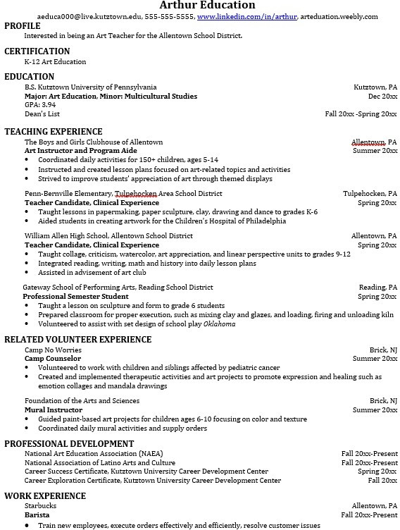
Building a strong resume for your career field starts long
Learn more about your field and develop the necessary skills for employment by gaining hands-on experience through internships.

For More Information on Art Education careers or to speak to a Career Counselor, contact KU Career Development Center 113 Stratton Administration Center * 610-683-4067 * careerhelp@kutztown.edu * www.kutztown.edu/careercenter

