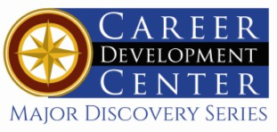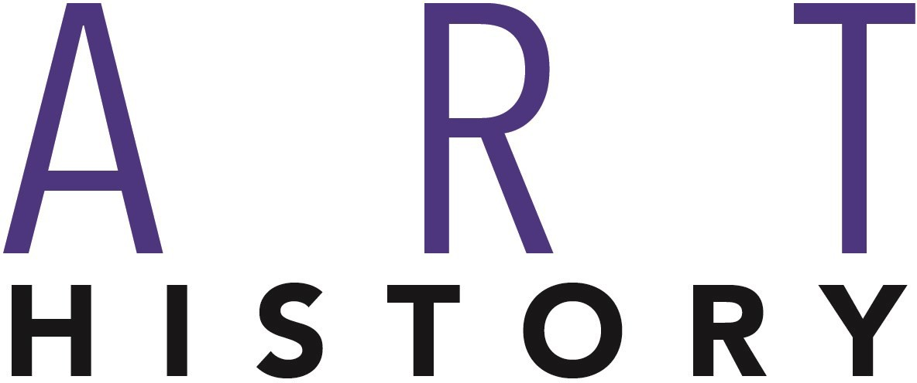

Bachelor of Fine Arts: Art History

The Bachelor of Fine Arts in Art History affords students the unique opportunity to study the discipline of Art History through traditional academic means as well as through professional settings provided by internships, field trips, and visiting artists and scholars. A major in Art History will strongly prepare students for career opportunities related to cultural tourism, as well as work in museums, galleries, auction houses, art conservation and more.

Career types associated with Art History
(Is this a good fit for you? Are you a…)
- Artistic - “Creator”
- Investigative - “Thinker”
- Social - “Helper”

Related skills, values, and qualities
- Ability to communicate ideas, thoughts, and feelings
visually
- Hands on
- Fascinated by the past
- Ability to think creatively
- Familiarity with traditional art approaches as well as other new and digital media
- Intuition and innovation in understanding and extracting ideas to generate visual concepts
- Organization and attention to detail
- Strong interpersonal and networking skills
- Love/Appreciation for history
- Ability to compete in a changing market that is exciting and highly competitive
- Problem Solving

Courses Art History majors typically enjoy
Common interests of Art History majors
- Working part-time or volunteering in an art studio, museum, or gallery
- Photography
- Digital imaging
- Drawing and painting
- Attending art shows and other visual art events
- Traveling
- Marketing & Branding

For more information about the major Contact Department of Art and Design 311 Sharadin, 610-683-4619

KU Majors related to Art History
Art Education, Crafts, History, Anthropology, History, Professional Writing, Library Science

- Art
- History
- Drawing
- Painting
- Photography
- Watercolors
- Printmaking
For More Information KU Career Develop-
on Art History careers or to speak to a Career Counselor, contact ment Center
- Textiles
- Ceramics
- Anthropology
- Professional Writing
- Library Science
- History

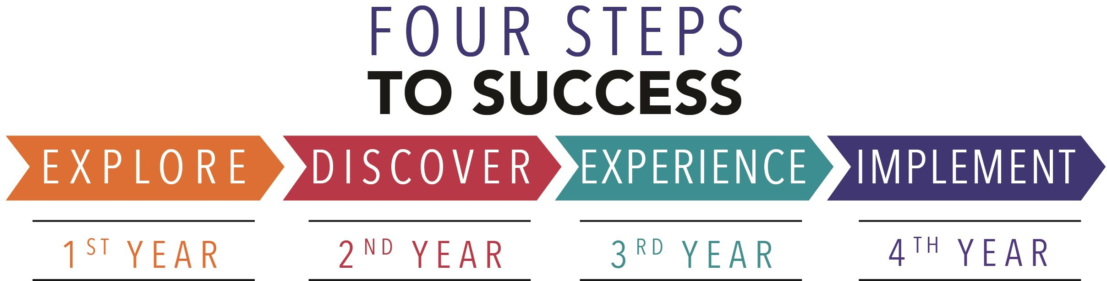

- Enroll in the Career Exploration Certificate.
- Attend info sessions to learn about career development and personal branding.
- Take a career assessment to
identify and confirm interests.
- Get involved in campus clubs and organizations.
- Develop basic workplace skills through jobs or volunteer work.
- Talk with professors, family, and friends about career ideas.
- Conduct informational interviews with professionals working in fields of interest.
- Develop a relationship with your professors and faculty advisor.
- Meet with CDC career coach.
- Attend info sessions to learn about resume writing, and externships.
- Confirm your choice of major and consider options for double major or minor.
- Research careers of interest.
- Complete a job shadowing (externship) experience.
- Seek meaningful employ-ment or volunteer work in a field related to your major.
- Explore options for under-graduate research and study abroad.
- Write a resume and have it reviewed by the CDC.
- Manage your online presence.

- Enroll in the Career Success Certificate.
- Complete an internship and/or undergraduate research.
- Attend info sessions about internships, interviewing, job search strategies, and grad school.
- Build a LinkedIn profile and continue to monitor your online presence.
- Complete a mock interview.
- Build skills through research projects, part-time employment, and volunteer work.
- Participate in employer panels, site visits & networking events.
- Attend internship & job fairs.
- Take on a leadership role in a student organization or work.
- Consider graduate school options and prepare for admissions tests.
- Attend your Senior Kick-off session and other info sessions to prepare for job search/grad school.
- Update your resume and LinkedIn profile.
- Create cover letter drafts.
- Gain experience through internships and/or undergraduate research.
- Secure references for job/grad school applications.
- Create your “30 second”
commercial/elevator pitch.
- Meet with CDC to develop job search strategies.
- Research employers.
- Network with professionals through events and social media.
- Join a professional organization
in your discipline.
- Attend the senior etiquette luncheon or dinner.
- Participate in job fairs and on-campus interviewing.

Sample Career Titles
Art History majors can be found working in a wide variety of career fields. Here are just some career titles that may be of interest. Please note that some jobs may require further education and training.
To learn more about these careers, visit http://online.onetcenter.org or www.bls.gov/oco.

Art Advisor
Art Administrator Antiquarian Book Trade Antiques Dealer Architectural Conservator Art Gallery Manager Art Investment
Art Lawyer
Art Preservationist Art Publicist
Artist Representative Art Librarian
Arts Organization Consultant Auction House Assistant
College Professor Corporate Curator Curatorial Consultant Estate Appraiser
Freelance Collection Manager Freelance Writer Independent Producer Museum Curator
Museum Educator Museum Registrar Teacher
Sample Advertisements Visual Resource Curator

Common Internship Sites and Employers
Art History majors often find internships and employment in the following fields/industries.

  - Photo Studios
  - Art Studios
  - Galleries
  - Mural Projects
  - Publishing Firms
  - Archives
  - Printmaking Workshops
  - Community Arts Organizations
  - Magazines/Newspapers
  - Museums
  - Archeology
  - Auction Houses



Handshake is the primary online resource
for preparing and connecting students and alumni with employers.
www.kutztown.edu/handshake

Useful Websites for Art History Majors
Whether you are researching related career fields, applying for internships or jobs, or planning to join a professional association, these websites are for you!

Industry/Employment Information
National Endowment for the Arts
www.arts.gov

NY Foundation for the Arts www.nyfa.org
ResArtis www.resartis.org

TransArtists www.transartists.org
WOOLOO
www.wooloo.org

Arts and Art Deadlines
www.artdeadlineslist.com

Allentown Art Museum www.allentownartmuseum.org

Philadelphia Museum of Art
http://www.philamuseum.org

Job/Internship Search Boards
Museum Jobs
www.museumjobs.com

Greater Phila Cultural Alliance www.philaculture.org
LinkedIn Jobs www.linkedin.com/jobs

Professional Associations
College Art Association www.collegeart.org

American Association of Museums
www.aam-us.org

Southern Graphics Council http://sgcinternational.org

Related Area Employers
Allentown Art Museum Alternative Gallery ArtsQuest
Brandywine River Museum of Art Clay On Main
Everhart Museum of Natural History Goggle Works
Historic Bethlehem Museums & Sites Lehigh Valley Arts Council Pennsylvania Historical and Museum Commission
Philadelphia Museum of Art Reading Public Museum

Building Your Resume for a Career in Art History
Utilize summer breaks to acquire valuable experience via volunteer or employment opportunities related to your major.

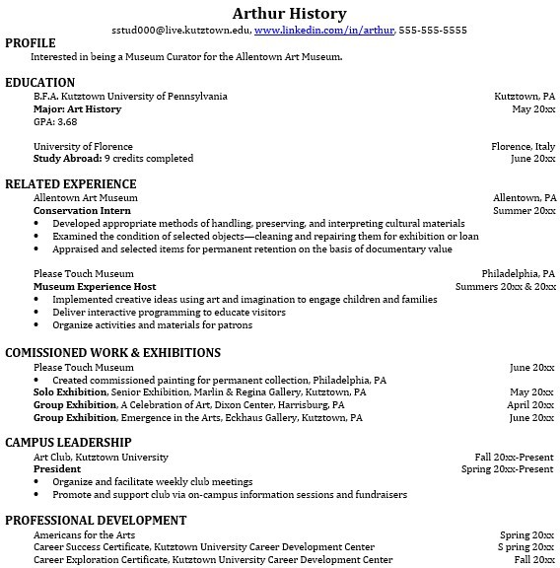
Building a strong resume for your career field starts long before you ever start your job search. Employers want to hire graduates who not only have the necessary educational background but also have experience applying that knowledge.
Learn more about your field and develop the necessary skills for employment by gaining hands-on experience through internships.

Develop professionally through campus involvement and professional memberships.
This illustrates responsibility, leadership abilities and time management skills.

For More Information on Art History careers or to speak to a Career Counselor, contact KU Career Development Center 113 Stratton Administration Center * 610-683-4067 * careerhelp@kutztown.edu * www.kutztown.edu/careercenter

