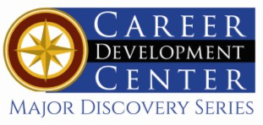

Bachelor of Science: Chemistry Minor: Chemistry
Certificate: Biotechnology

Chemistry is the study of composition, structure, and properties of matter and the interactions between them. The KU chemistry program provides extensive hands-on laboratory experience to develop the skills required for industry and graduate school and is approved by the American Chemical Society. Chemistry majors may go on to have careers in a variety of industries, research laboratories and government agencies. With a Bachelor of Science degree, graduates may find employment doing laboratory work, assisting on a research team, working in product development, or may work in the business-related areas of plant management, marketing or sales. Employers recommend one or more

Career types associated with Chemistry
(Is this a good fit for you? Are you a…)
- Investigative - “Thinker”
- Realistic - “Doer”
- Enterprising - “Leader”

Related skills, values, and qualities
- Proficiency in reading, writing, thinking, questioning,
analyzing and problem solving
- Ability to organize, analyze and interpret scientific research
- Strong math skills
- Proficiency with computers
- Good manual dexterity and ability to operate scientific equipment
- Aptitude for accuracy and detail
- Ability to conduct and explain scientific research

Courses Chemistry majors typically enjoy
- Algebra/Trigonometry/Calculus
- Chemistry
- Computer Science
- Earth Science
- Geometry
- Physical Science

Common interests of Chemistry majors
- Conducting research and participating in science fairs and competitions
- Attending science exhibits, museums, and demonstrations
- Participating in chemistry or science clubs
- Working part-time or volunteering in a pharmacy, hospital, or with an environmental conservation organization
- Watching scientific programs
- Cooking
For more information about the major Contact the Physical Sciences Department, 425 Boehm, 610-683-4447 or visit www.kutztown.edu/ Chemistry

KU Majors related to Chemistry
Biology, Biochemistry, Environmental Science, Marine Biology, Secondary Education– Science

Investigative students may also be interested in: Anthropology, Computer Science, Criminal Justice, Economics*, Geography, Geology, German Studies, History, International Studies*, Mathematics, Multicultural Studies*, Physics, Political Science,
Psychology, Sociology, Spanish, and Women’s
Studies*
* minor only

For More Information on Chemistry careers or to speak to a Career Counselor, contact KU Career Development Center 113 Stratton Administration Center * 610-683-4067 * careerhelp@kutztown.edu * www.kutztown.edu/careercenter



- Enroll in the Career Exploration Certificate.
- Attend info sessions to learn about career development and personal branding.
- Take a career assessment to
identify and confirm interests.
- Get involved in campus clubs and organizations.
- Develop basic workplace skills through jobs or volunteer work.
- Talk with professors, family, and friends about career ideas.
- Conduct informational interviews with professionals working in fields of interest.
- Develop a relationship with your professors and faculty advisor.
- Meet with CDC career coach.
- Attend info sessions to learn about resume writing, and externships.
- Confirm your choice of major and consider options for double major or minor.
- Research careers of interest.
- Complete a job shadowing (externship) experience.
- Seek meaningful employ-ment or volunteer work in a field related to your major.
- Explore options for under-graduate research and study abroad.
- Write a resume and have it reviewed by the CDC.
- Manage your online presence.
- Enroll in the Career Success Certificate.
- Complete an internship and/or undergraduate research.
- Attend info sessions about internships, interviewing, job search strategies, and grad school.
- Build a LinkedIn profile and continue to monitor your online presence.
- Complete a mock interview.
- Build skills through research projects, part-time employment, and volunteer work.
- Participate in employer panels, site visits & networking events.
- Attend internship & job fairs.
- Take on a leadership role in a student organization or work.
- Consider graduate school options and prepare for admissions tests.
- Attend your Senior Kick-off and other info sessions to prepare for job search/grad school.
- Update your resume and LinkedIn profile.
- Create cover letter drafts.
- Gain experience through internships and/or undergraduate research.
- Secure references for job/grad school applications.
- Create your “30 second”
commercial/elevator pitch.
- Meet with CDC to develop job search strategies.
- Research employers.
- Network with professionals through events and social media.
- Join a professional organization in your discipline.
- Attend the senior etiquette
luncheon or dinner.
- Participate in job fairs and on-campus interviewing.

Sample Career Titles
Chemistry majors can be found working in a wide variety of career fields. Here are just some career titles that may be of interest. Please note that some jobs may require further education and training.
To learn more about these careers, visit http://online.onetcenter.org or www.bls.gov/oco.

  - Agricultural Scientist
  - Agronomist
  - Anesthesiologist
  - Assayer
  - Biochemist
  - Chemical Engineer
  - Chemical Oceanographer
  - Chemist
  - Chemistry Technologist
  - Clarifying Plant Operator
  - College Professor
  - Consumer Protection Specialist
  - Crime Lab Analyst
  - Cytotechnologist
  - Dentist
  - Dietician
  - Environmental Health Specialist
  - Food and Drug Analyst
  - Food Scientist
  - Forensic Chemist
  - Genetic Counselor
  - Geneticist
  - Geologist
  - High School Teacher
  - Hydrologist
  - Industrial Health Engineer
  - Industrial Hygienist
  - Metallurgist
  - Molecular Biologist
  - Nuclear Scientist
  - Nutritionist
  - Occupational Safety Specialist
  - Patent Examiner
  - Perfumer
  - Pharmaceutical Sales Rep.
  - Pharmacist
  - Pharmacologist
  - Physician
  - Plastics Engineer
  - Product Tester
  - Quality Assurance Manager
  - Risk Manager
  - Soil Scientist
  - Toxicologist
  - Underwater Technician
  - Veterinarian
  - Wastewater Treatment Chemist
  - Water Purification Specialist

Common Internship Sites and Employers
Chemistry majors often find internships and employment in the following fields/industries.

- Chemical Companies
- Colleges & Universities
- Cosmetology Labs
- Engineering Firms
- Food Companies/Administration
- Newspapers and Magazines
- Mining Companies
- Petroleum Refineries
- Pharmaceutical Companies
- State & Federal Government
- Textile Manufacturers



Handshake is the primary online resource
for preparing and connecting students and alumni with employers.
www.kutztown.edu/handshake

Useful Websites for Chemistry Majors
Whether you are researching related career fields, applying for internships or jobs, or planning to join a professional association, these websites are for you!

Industry/Employment Information

Careers in Federal Government www.makingthedifference.org

Careers Resources for STEM www.careercornerstone.org
CIRRUS—Chemistry Internet Resource
for Research
cirrus.chem.plu.edu

ChemWeb.com chemweb.com

Chemical Elements chemicalelements.com
Journal of Chemical Education jchemed.chem.wisc.edu
Life Sciences World www.lifesciencesworld.com

National Academies
www.nas.edu

Pharma. Research & Manufacturing www.phrma.org
LinkedIn Job Search www.linkedin.com/jobs

Research Experience for Undergraduates
REU’s
https://new.nsf.gov/funding/ opportunities/research-experiences-undergraduates-reu

Job/Internship Search Sites
BioPharmGuy http://biopharmguy.com

BioSpace www.biospace.com
Chemistry Jobs chemistryjobs.com

Environmental Careers World Job Bank www.environmentaljobs.com
Medical Jobs www.medicaljobs.org
MedZilla www.medzilla.com

New Scientist Jobs www.newscientistjobs.com Science Careers www.sciencecareers.org

Professional Associations
American Academy of Forensic Science www.aafs.org
American Association for the Advancement of Science www.aaas.org
American Assoc. of Clinical Chemistry www.aacc.org
American Chemical Society www.acs.org American Institute of Chemists www.theaic.org Council for Chemical Research www.ccrhq.org
Counsel for the Advancement of Science Writing www.casw.org

Related Area Employers

Actalent Aptagen BioSpectra
Borough of Kutztown Water Department
Carpenter Technology DaVinci Science Center East Penn Manufacturing Eurofins Scientific EnerSys
Environmental Protection Agency International Flavors and
Fragrances Lehigh County Authority Lubrizol Life Sciences
NSF-Research Experience for
Undergraduates Merck & Co., Inc.
M.J. Reider Associates, Inc. Nestle Waters
PA-DEP
Pfizer, Inc.
Suburban Testing Labs Teva Pharmaceuticals Quaker Chemical Wacker Chemical

Building Your Resume for a Career in Chemistry
Building a strong resume for your career field starts long before you ever start your job search. Employers want to hire graduates who not only have the necessary educational background but also have experience applying that knowledge.

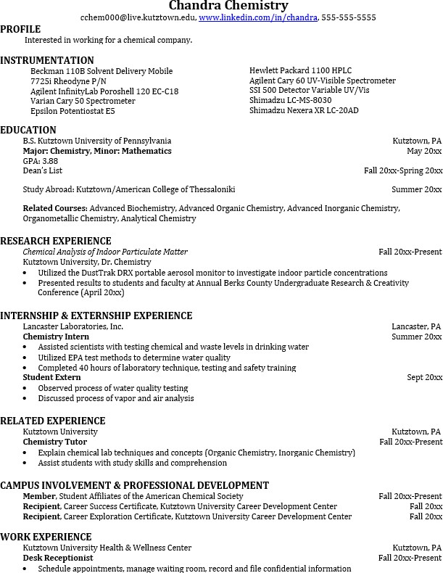
Learn more about your field and develop the necessary skills for employment by gaining hands-on experience through internships & related experiences

Utilize summer breaks to acquire valuable experience via volunteer or employment opportunities related to your major.

Develop professionally through campus involvement and professional memberships.
This illustrates responsibility, leadership abilities and time management skills.

For More Information on Chemistry careers or to speak to a Career Counselor, contact KU Career Development Center 113 Stratton Administration Center * 610-683-4067 * careerhelp@kutztown.edu * www.kutztown.edu/careercenter

