

Bachelor of Science: Cinema, Television and Media Production Minor: Cinema, Television and Media Production
Certificates: Digital Video Production, Audio Production & Television Production

Cinema, Television and Media Production encompasses the fields of broadcasting, video production, audio production, cable TV, corporate TV, as well as more recent media distribution formats such as CD, DVD and the Internet. These majors become familiar with all aspects of the electronic media industry and are given comprehensive training in video and audio production for a variety of audiences and content distribution methods. Students begin working with equipment their very first year. A required full-time internship in the last semester prior to graduation gives KU Cinema, Television and Media Production majors an edge in their professional preparation. Graduates have found employment in broadcast radio and television, cable television, production houses, and corporate video.

Career types associated with Cinema, Television and Media Production
For More Information on Cinema, Television and Media Production Careers or to speak to a Career Counselor, contact
KU Career Development Center • 113 Stratton Administration Center • 610-683-4067 • careerhelp@kutztown.edu • www.kutztown.edu/careercenter
(Is this a good fit for me? Are you a…)
- Realistic - “Doer”
- Enterprising - “Persuader”
- Social - “Helper”

Skills associated with the Cinema, Television and Media Production major
- Ability to communicate ideas, thoughts, and feelings visually
- Ability to think creatively and meet deadlines
- Written & verbal communication skills and ability to gather information and data
- Demonstrate creativity ability and artistic expression
- Ability to perform in a hands-on, equipment-based environment
- Aptitude for accuracy and detail
- Ability to concentrate intensely and work alone for long periods of time

Related courses Cinema, Television and Media Production majors typically enjoy
- Art/Graphic Design
- Computers
- English/Writing
- Journalism
- Photography
- Science

Common interests of Cinema, Television and Media Production majors
- Making and editing movies
- Taking pictures
- Working with computers and electronic equipment
- Joining a film, communications, or media club
- Working part-time or volunteering in a radio
or TV station
- Creating advertising material for community organizations and other groups

For more information about this major Contact the Cinema, Television, and Media Production Department
202 Rickenbach Learning Center, 610-683-4492 or visit www.kutztown.edu/ElectronicMedia

KU Majors related to Cinema, Television and Media Production
Communication Studies, Computer Science, English,
and English/Professional Writing
Realistic students may also be interested in: Anthropology, Art History*, Biochemistry, Biology, Chemistry, Criminal Justice, Environmental Science, Geography, Geology, Management, Marine Science, Mathematics, Physics, Sport Administration.

*minor only

- Enroll in the Career Exploration Certificate.
- Attend info sessions to learn about career development and personal branding.
- Take a career assessment to identify and confirm interests.
- Get involved in campus clubs and organizations.
- Develop basic workplace skills through jobs or volunteer work.
- Talk with professors, family, and friends about career ideas.
- Conduct informational interviews with professionals working in fields of interest.
- Develop a relationship with your professors and faculty advisor.

- Meet with CDC career coach.
- Attend info sessions to learn about resume writing, and externships.
- Confirm your choice of major and consider options for double major or minor.
- Research careers of interest.
- Complete a job shadowing (externship) experience.
- Seek meaningful employ-ment or volunteer work in a field related to your major.
- Explore options for under-graduate research and study abroad.
- Write a resume and have it reviewed by the CDC.
- Manage your online presence.

- Enroll in the Career Success Certificate.
- Complete an internship and/or undergraduate research.
- Attend info sessions about internships, interviewing, job search strategies, and grad school.
- Build a LinkedIn profile and continue to monitor your online presence.
- Complete a mock interview.
- Build skills through research projects, part-time employment, and volunteer work.
- Participate in employers pan-els, site visits & networking events.
- Attend internship & job fairs.
- Take on a leadership role in a student organization or work.
- Consider graduate school options and prepare for admissions tests.
- Attend your Senior Kick-off session and other info sessions to prepare for job search/grad school.

- Update your resume and LinkedIn profile.
- Create cover letter drafts.
- Gain experience through internships and/or undergraduate research.
- Secure references for job/grad school applications.
- Create your “30 second”
commercial/elevator pitch.
- Meet with CDC to develop job search strategies.
- Research employers.
- Network with professionals through events and social media.
- Join a professional organization in your discipline.
- Attend the senior etiquette luncheon or dinner.
- Participate in job fairs and on-campus interviewing.

Sample Career Titles
Cinema, Television and Media Production majors can be found working in a wide variety of career fields. Here are just some career titles that may be of interest. Please note that some jobs may require further education and training.

  - Actor
  - Advertising Account Executive
  - Advertising Copywriter
  - Broadcast Advertising Specialist
  - Casting Manager
  - Communications Lawyer
  - Contestant/Guest Coordinator
  - Continuity Writer
  - Copywriter
  - Director’s Assistant
  - Director: Film, Video, Theatre
  - Disc Jockey
  - Editor
  - Editorial Assistant
  - Electronic Publication Specialist
  - Government Relations Specialist
  - Journalist
  - Lighting Technician
  - Market Research Specialist
  - Mass Communications Manager
  - Media Buyer/Manager
  - Motion Picture Industry Artist
  - Narrator
  - News Reporter
  - News Writer/Editor
  - Photographer
  - Photojournalist
  - Producer: TV, Film, Theatre
  - Production Assistant
  - Program Director
  - Public Information Officer
  - Public Relations Assistant
  - Publisher
  - Radio/TV Announcer
  - Recording Industry Representative
  - Representative
  - Sales Representative (Radio/TV)
  - Salesperson
  - Script Writer
  - Social Media Manager
  - Sports Promoter
  - Sportscaster
  - Station Manager
  - Teacher: Media
  - Technical Writer
  - Television Engineer/Manager
  - Video Programmer
  - Weather Forecaster
  - Web Caster/Developer
  - Writer/Author

To learn more about these careers, visit http://online.onetcenter.org or www.bls.gov/ooh.

Common Internship Sites and Employers
Cinema, Television and Media Production majors often find internships and employment in the following industries:

    - Broadcast Radio and Television
    - Business & Industry
    - Cable Television Companies
    - Corporate Video Firms
    - Educational Institutions
    - Telecommunications Organizations
    - Magazine/Newspapers
    - Production Companies
    - Public Relation Firms
    - Web Development/Social Media Firms


Handshake is the primary online resource
for preparing and connecting students and alumni with employers. www.kutztown.edu/handshake

Useful Websites for Cinema, Television and Media

Whether you are researching related career fields, applying for intern-ships or jobs, or planning to join

Industry/Employment Information
Career Guide www.khake.com
Corporation for Public Broadcasting www.cpb.org

Cyber College www.cybercollege.com
Greater Philadelphia Cultural Alliance www.philaculture.org/jobbank

International Film & TV Production Directory
www.mandy.com
Journalism Jobs www.journalismjobs.com

LinkedIn Job Search www.linkedin.com/jobs

Production Hub www.productionhub.com/jobs

Professional Associations

American Federation of Television & Radio Artists
www.sagaftra.org
American Sportscasting Association www.americansportscastersonline.com

Broadcast Education Association www.beaweb.org
Center for Communication www.cencom.org

International Radio & Television Society www.irtsfoundation.org
National Association of Broadcasters www.nab.org

National Association of Broadcast Employees & Technicians www.nabetcwa.org
Society of Broadcast Engineers www.sbe.org

Employers
ArtsQuest
ASR Media Productions
Aurora Films
Billy Penn at WHYY
Blue Ridge Communications TV
Charmcine
FOX43 WPMT
Hatboro-Horsham School District Kutztown Univ.: University Relations Lafayette College Athletics
Lehigh Valley Iron Pigs
Live Stream Hand
Paperboy Media Group Propulsion
Major League Rugby Media Labs Reading Resolution Pictures Reda Films
Stimulus
TC Motion Upstage Video
Young Atlas Productions

Building Your Resume for a Career in Cinema, Television and Media Production
Develop professionally through campus involvement and professional memberships.
This illustrates responsibility, leadership abilities and time management skills.
Learn more about your field and devel-op the necessary skills for employment by gaining
hands-on experience through externships, internships, part-time jobs and related volunteer positions.
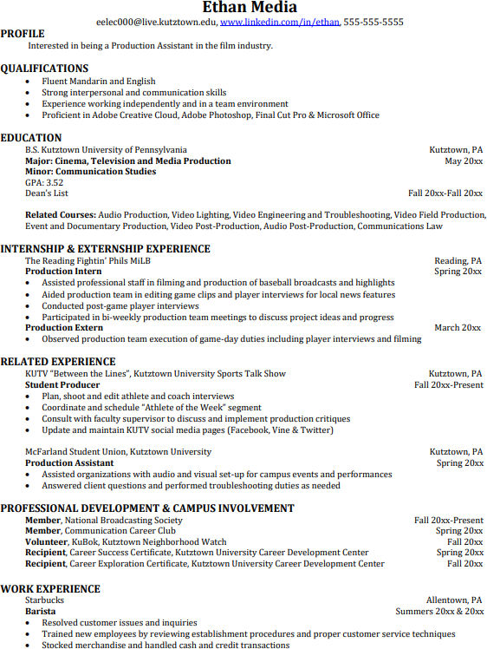
Building a strong resume for your career field starts long before you ever start your job search. Employers want to hire graduates who not only have the necessary educational background but also have experience applying that knowledge to real life situations.
Take note of the skills and knowledge obtained through your educational background and hands-on experiences.
Highlight transferable skills such as fluency and technological proficiencies.

