

Bachelor of Fine Arts: Communication Design
With Specialization in: Graphic Design, Advertising Design, Interactive Design, or Illustration

Communication Design is about visual and print communications. The highly creative and thought provoking work of graduates from the Communication Design department informs and persuades on behalf of clients in a wide range of organizations and professions. The four year BFA curriculum in Communication Design is geared toward building student knowledge through a structured fundamental program and a variety of upper-level courses in Graphic Design, Advertising Design, Illustration and Interactive Design. Employers recommend one or more internships to be successful and competitive when entering this field.

Career types associated with Communication Design
(Is this a good fit for you? Are you a…)
- Realistic - “Doer”
- Artistic - “Creator”
- Enterprising - “Persuader”

Related skills, values, and qualities
- Ability to communicate ideas, thoughts, and feelings visually
- Aptitude in spatial relationships and manual dexterity
- Critical observation and critical thinking skills
- Ability to think creatively
- Strong interpersonal and networking skills
- Ability to persuade, present and communicate ideas
- Ability to meet deadlines
- Concentration and self-discipline
- Ability to withstand scrutiny and criticism

Courses Communication Design majors typically enjoy
- Art
- Drawing and Painting
- Photography
- Web Page Design
- Advertising
- Marketing

Common interests of Communication Design majors
- Working part-time or volunteering in an art
studio, museum or advertising agency
- Attending art shows, festivals, and art exhibits
- Drawing and painting
- Photography
- Digital imaging
- Creating advertising material for local community organizations and other groups

For more information about the major Contact Department of Art and Design 302 Sharadin, 610-683-4530,
or visit www.kutztown.edu/CommunicationDesign

KU Majors related to Communication Design Art Education, Cinema, Television and Media Production, Studio Art, Marketing

For More Information on Communication Design careers or to speak to a Career Counselor, contact KU Career Development Center 113 Stratton Administration Center * 610-683-4067 * careerhelp@kutztown.edu * www.kutztown.edu/careercenter


  - Enroll in the Career Exploration Certificate.
  - Attend info sessions to learn about career development and personal branding.
  - Take a career assessment to identify and confirm interests.
  - Get involved in campus clubs
and organizations.
  - Develop basic workplace skills through jobs or volunteer work.
  - Talk with professors, family, and friends about career ideas.
  - Conduct informational interviews with professionals working in fields of interest.
  - Develop a relationship with your professors and faculty advisor.
- Meet with CDC career coach.
- Attend info sessions to learn about resume writing, and externships.
- Confirm your choice of major and consider options for double major or minor.
- Research careers of interest.
- Complete a job shadowing (externship) experience.
- Seek meaningful employ-ment or volunteer work in a field related to your major.
- Explore options for under-graduate research and study abroad.
- Write a resume and have it reviewed by the CDC.
- Manage your online presence.

- Enroll in the Career Success Certificate.
- Complete an internship and/ or undergraduate research.
- Attend info sessions about internships, interviewing, job search strategies, and grad school.
- Build a LinkedIn profile and continue to monitor your online presence.
- Complete a mock interview.
- Build skills through research projects, part-time employ-ment, and volunteer work.
- Participate in employer panels, site visits & networking events.
- Attend internship & job fairs.
- Take on a leadership role in a student organization or work.
- Consider graduate school options and prepare for admissions tests.
- Attend your Senior Kick-off session and other info ses-sions to prepare for job search/grad school.
- Update your resume and LinkedIn profile.
- Create cover letter drafts.
- Gain experience through internships and/or undergraduate research.
- Secure references for job/ grad school applications.
- Create your “30 second”
commercial/elevator pitch.
- Meet with CDC to develop job search strategies.
- Research employers.
- Network with professionals through events and social media.
- Join a professional organi-zation in your discipline.
- Attend the senior etiquette
luncheon or dinner.
- Participate in job fairs and on-campus interviewing.

Sample Career Titles
Communication Design majors can be found working in a wide variety of career fields. Here are just some career titles that may be of interest. Please note that some jobs may require further education and training.
To learn more about these careers, visit http://online.onetcenter.org or www.bls.gov/oco.

  - Advertising Artist
  - Animator
  - App Developer
  - Art Administrator
  - Art Consultant
  - Art Director
  - Artist’s Agent
  - CD/Record Cover Designer
  - Creative Director
  - Designer
  - Display Designer
  - Editorial Designer
  - Exhibition Designer
  - Freelance Designer
  - Freelance Illustrator
  - Fashion Artist/Designer
  - Gallery Owner
  - Graphic Arts Technician
  - Greeting Card Artist
  - Illustrator
  - Label Designer
  - Landscape Architect
  - Magazine Designer/Illustrator
  - Medial
  - Motion Picture Artist
  - Motion Picture Scenic Designer
  - Municipal Graphic Designer
  - Newspaper Layout Artist
  - Photographer
  - Product Designer/Illustrator
  - Set Designer/Illustrator
  - UX/UI Designer
  - Web Designer

Common Internship Sites and Employers
Communication Design majors often find internships and employment in the following industries.

  - Photo Studios
  - Art Studios
  - Advertising Agencies
  - Webpage Companies
  - Graphic Design Studios
  - Motion Picture Studios
  - Schools/Camps
  - Interior Design Firms
  - Media Production Companies
    - Community Arts Organizations
    - Magazines/Newspapers
    - Photo Agencies & Studios
    - Publishing Firms



Handshake is the primary online resource
for preparing and connecting students and alumni with employers.
www.kutztown.edu/handshake

Useful Websites for Communication Design Majors
Whether you are researching related career fields, applying for internships or jobs, or planning to join a professional association, these websites are for you!

Industry/Employment Information

National Endowment for the Arts www.arts.gov

NY Foundation for the Arts www.nyfa.org

ResArtis www.resartis.org

Art Deadline http://artdeadline.com

Graphic Arts & Printing Career Guide www.khake.com/page27.html

Recognition in Advertising www.oneclub.org
Professional Associations College Art Association www.collegeart.org

Southern Graphics Council http://sgcinternational.org

Nat’l Assoc. of Independent Artists
Www.naiartists.org

Society of American Graphic Artists www.sagaprints.com

American Association of Advertising Agencies www.aaaa.org

American Institute of Graphic Arts www.aiga.org

Job/Internship Search Boards
Working Not Working https://workingnotworking.com

Greater Phila Cultural Alliance www.philaculture.org/jobbank

Aquent Talent Agency www.aquent.com

Communication Arts www.creativehotlist.com

LinkedIn Jobs www.linkedin.com/jobs

Production Hub www.productionhub.com/jobs

Related Area Employers

ArtsQuest Crayola
DaBrian Marketing Group Gretna Theatre
Hershey Company L&H Companies Larson Design Group Listrak
Liquid Interactive
QVC
Sorrelli Jewelry Suzy Rae Design

Building Your Resume for a Career in Communication Design
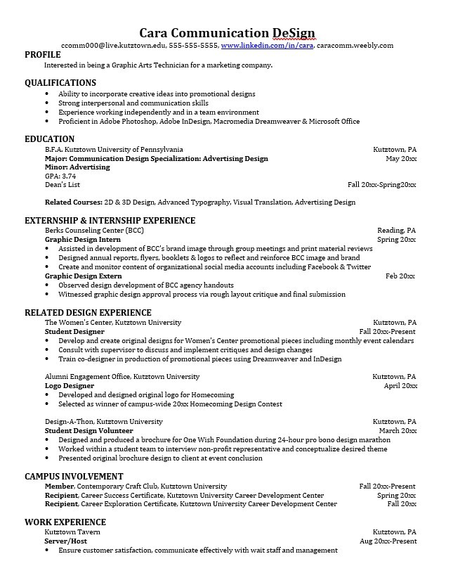
Building a strong resume for your career field starts long before you ever start

Learn more about your field and develop the necessary skills for employment by gaining hands-on experience through internships.

Utilize summer breaks to acquire valuable experience via volunteer or employment opportunities related to your major.

Develop professionally through campus involvement and professional memberships.
This illustrates responsibility, leadership abilities and time management skills.

For More Information on Communication Design careers or to speak to a Career Counselor, contact KU Career Development Center 113 Stratton Administration Center * 610-683-4067 * careerhelp@kutztown.edu * www.kutztown.edu/careercenter

