


Bachelor of Science: Computer Science
Minor: Computer Science, Information Technology, Game Development and Web Development Certificate: Cybersecurity Certificate, Scripting for Data Manipulation, Database Design & Implementation

The Bachelor of Science degree in Computer Science is a traditional computer science degree. It focuses on the fundamentals for computer science and application development. Students who receive a degree in Computer Science may choose to work in a variety of areas after graduation, software/application developers, systems analysts, quality assurance analysts, and software support specialist, or go on to graduate school. Employers recommend one or more internships to be successful and competitive when entering this field.

Career types associated with Computer Science
(Is this a good fit for you? Are you a…)
- Investigative - “Thinker”
- Conventional - “Organizer”
- Social - “Helper”

Related skills, values, and qualities
- Ability to adapt to constant change
- Proficiency in reading, writing, and thinking, questioning, and analyzing
- Proficiency in problem solving
- Ability to think logically and organize
- Proficiency with computers
- Aptitude for accuracy and detail
- Strong math background
- Ability to work under pressure

Courses Computer Science majors typically enjoy
- Algebra, Trigonometry, Calculus
- Computer Programming
- Computer Science
- Criminal Justice
- Information Technology
- Networking
- Cyber Security
- Web Development

Common interests of Computer Science majors
  - Working with computers, software, gaming
  - Troubleshooting and repairing electronic equipment
  - Completing puzzles or playing games of strategy
  - Solving logic problems
  - Participating in Computer Science or related clubs
  - Working part-time or volunteering in a technology
store/department
  - Reading computer or technology publications

For more information about the major Contact the Computer Science and Information Technology Department, 256 Old Main,
610-683-4340, or visit www.kutztown.edu/csit CSITDepartment@kutztown.edu
KU Majors related to Computer Science Mathematics, Physics, Communication Design, Applied Digital Arts, Criminal Justice

For More Information on Computer Science/IT careers or to speak to a Career Counselor, contact KU Career Development Center 113 Stratton Administration Center * 610-683-4067 * careerhelp@kutztown.edu * www.kutztown.edu/careercenter



- Enroll in the Career Exploration Certificate.
- Attend info sessions to learn about career development and personal branding.
- Take a career assessment to
identify and confirm interests.
- Get involved in campus clubs and organizations.
- Develop basic workplace skills through jobs or volunteer work.
- Talk with professors, family, and friends about career ideas.
- Conduct informational interviews with professionals working in fields of interest.
- Develop a relationship with your professors and faculty advisor.
- Meet with CDC career coach.
- Attend info sessions to learn about resume writing, and externships.
- Confirm your choice of major and consider options for double major or minor.
- Research careers of interest.
- Complete a job shadowing (externship) experience.
- Seek meaningful employ-ment or volunteer work in a field related to your major.
- Explore options for under-graduate research and study abroad.
- Write a resume and have it reviewed by the CDC.
- Manage your online presence.

- Enroll in the Career Success Certificate.
- Complete an internship and/or undergraduate research.
- Attend info sessions about internships, interviewing, job search strategies, and grad school.
- Build a LinkedIn profile and continue to monitor your online presence.
- Complete a mock interview.
- Build skills through research projects, part-time employment, and volunteer work.
- Participate in employer panels, site visits & networking events.
- Attend internship & job fairs.
- Take on a leadership role in a student organization or work.
- Consider graduate school options and prepare for admissions tests.
- Attend your Senior Kick-off session and other info sessions to prepare for job search/grad school.
- Update your resume and LinkedIn profile.
- Create cover letter drafts.
- Gain experience through internships and/or undergraduate research.
- Secure references for job/grad school applications.
- Create your “30 second”
commercial/elevator pitch.
- Meet with CDC to develop job search strategies.
- Research employers.
- Network with professionals through events and social media.
- Join a professional organization
in your discipline.
- Attend the senior etiquette luncheon or dinner.
- Participate in job fairs and on-campus interviewing.

Sample Career Titles
Computer Science majors can be found working in a wide variety of career fields. Here are just some career titles that may be of interest. Please note that some jobs may require further education and training.
To learn more about these careers, visit http://online.onetcenter.org or www.bls.gov/oco.

Application/Programmer Communications Specialist Computer Engineer Computer Facilities Manager Computer Marketing/Sales Computer Security Analyst Computer Service Technician Computer Systems Analyst CQI Production Manager Cryptographer/Cryptologist Cybersecurity Manager Cybersecurity Specialist Data/Database Analyst
Data Communications/Security Analyst Data Scientist
Distribution Manager
End-User Computing Manager Engineering Lab Technician Environmental Technologist
Forensic Computer Analyst Hardware Sales/Service Person Information Scientist
Information Systems Developer Information Systems Manager Information Technology Manager Market Analyst
Incident Responder ISO Specialist
IT Security Specialist
Network Administrator/Manager Network Security Engineer
On-Line Services Manager Operating Systems Programmer Operations Manager/Analyst PC Support Specialist
Product Development/Line Manager Product Forecaster/Estimator Production Scheduler/Planner
Production Support Specialist Programmer: Engineering & Sci. Quality Assurance Analyst Security Analyst
Security Architect
Security Consultant
Software Engineering Specialist Software Support Tech/Specialist Systems Administrator/Analyst Systems Consultant
Systems Programmer Systems Technical Manager Technical Sales/Support Rep. Telecommunications Manager User Support Analyst
Web Designer

Common Internship Sites and Employers
Computer Science majors often find internships and
employment in the following fields/industries.

  - Banks & Investment Firms
  - Business & Industry
  - Colleges/Universities
  - Consulting Firms
  - Data Science
  - Federal, State & Local
  - Healthcare
  - International Agencies
  - Manufacturing
  - Mathematics
  - Military
  - Research & Development
  - Telecommunications



Handshake is the primary online resource
for preparing and connecting students and alumni with employers.
www.kutztown.edu/handshake

Useful Websites for Computer Science Majors
Whether you are researching related career fields, applying for internships or jobs, or planning to join a professional association, these websites are for you!

Industry/Employment Information

Computer Jobs
www.computerjobs.com

Computer Work www.computerwork.com

Dice www.dice.com
Internet Society www.internetsociety.org
Just Tech Jobs www.justtech.com

LinkedIn Jobs www.linkedin.com/jobs

Production Hub www.productionhub.com/jobs

Professional Associations

American Society for Info Science & Technology
www.asist.org
Association for Computing Machinery www.acm.org
Association of IT Professionals www.aitp.org

Computer Society www.computer.org
Instrumentation, Systems and Automation Society https://www.isa.org/
Institute of Electrical & Electronics Engineers
www.ieee.org (job postings too)
International Assoc. for Technology in Education www.iste.org

National Cybersecurity Alliance https://www.staysafeonline.org/
Women in Cybersecurity https://www.wicys.org/

Related Area Employers

Air Products
Andesa Services
Armstrong World Industries
B. Braun Medical Inc. Brenntag
Brentwood Industries Clark Associates
Computer Aid Inc
Deloitte US Delivery Center East Penn Manufacturing
Fidelity Information Services Gateway Ticketing
Hershey Entertainment & Resorts Kutztown University
Lehigh Valley Health Network LeverX
Listrak Inc.
Liquid Interactive Lutron Electronics Neo Pangea
Olympus Oracle
Penn Interactive Penske
PPL Electric Utilities SAP
St. Luke's University Health Network Versum Materials
Zulily

Building Your Resume for a Career in Computer Science
Building a strong resume for your career field starts long before you ever start your job search. Employers want to hire graduates who not only have the necessary educational background but also have experience applying that knowledge.

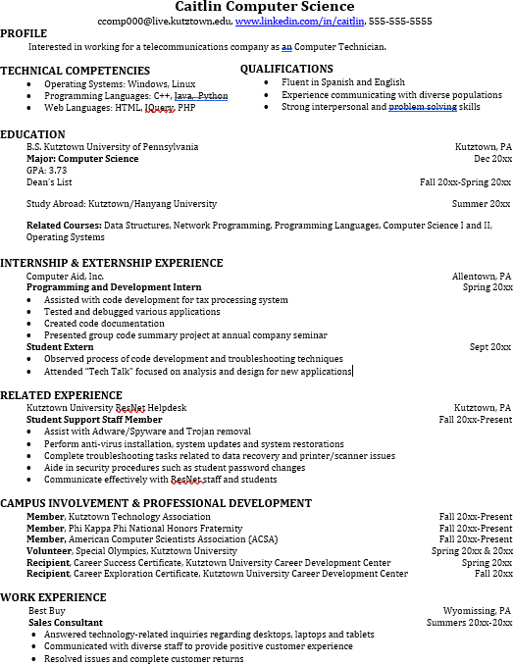
Learn more about your field and develop the necessary skills for employment by gaining hands-on experience through clinical practice.

Utilize summer breaks to acquire valuable experience via volunteer or employment opportunities related to your major.

Develop professionally through campus involvement and professional memberships.
This illustrates responsibility, leadership abilities and time management skills.

For More Information on Computer Science careers or to speak to a Career Counselor, contact KU Career Development Center 113 Stratton Administration Center * 610-683-4067 * careerhelp@kutztown.edu * www.kutztown.edu/careercenter

