

Bachelor of Science: Criminal Justice
Bachelor of Science: Criminal Justice with Paralegal
Minor: Criminal Justice, Forensic Studies, Homeland Security Certificate: Cybersecurity

The field of criminal justice affords students an opportunity to learn about some of the nation's most pressing problems: crime, justice, and social control. Criminal justice majors study law enforcement, courts, law and corrections, as well as agencies dealing with juvenile offenders. Students have the option of selecting from two programs: Criminal Justice or Criminal Justice with Paralegal Studies. Students interested in law may incorporate Pre-Law Studies into their curriculum. Graduates may work in a wide range of federal, state, and local government as well as private agencies. Employers recommend one or more internships to be successful and competitive when entering this field.

Career types associated with Criminal Justice
(Is this a good fit for you? Are you a…)
- Enterprising - “Leader”
- Social - “Helper”
- Realistic - “Doer”

Related skills, values, and qualities
- Strong oral and written communication skills
- Sensitivity to and tolerance of people of differing genders, ages, and ethnicities
- Ability to conduct research and effective interviews
- Ability to work well under pressure
- Strong ethical and moral values
- Ability to observe and analyze situations
- Ability to evaluate problems and make appropriate decisions
- Aptitude for leadership

Courses Criminal Justice majors typically enjoy
- Civics/Government
- Criminal Justice
- Economics
- History
- Physical Education
- Psychology
- Social Studies
- Sociology

Common interests of Criminal Justice majors
- Working part-time or volunteering in a community service agency/non-profit group
- Serving as a leader in a school or community organization
- Serving as a peer counselor, tutor, or hotline
assistant
- Reading about social issues and attending lectures and conferences related to Criminal Justice
- Participating in military activities and/or serving as a volunteer in fire or law enforcement organizations
For more information about the major Contact the Criminal Justice Department, 365 Old Main, 484-646-4265, or visit www.kutztown.edu/Criminal Justice

KU Majors related to Criminal Justice
Psychology, Public Administration, Sociology

Enterprising students may also be interested in: Accounting, Advertising*, Communication Design, Communication Studies, Economics*, Education, English-Professional Writing, Environmental Science, Finance, History, International Studies*, Sport Management, Library Science, Literature*, Management, Marketing, Multicultural Studies*, Political Science, Public Relations*, Social Work, Writing*.
* minor only

For More Information on Criminal Justice careers or to speak to a Career Counselor, contact KU Career Development Center 113 Stratton Administration Center * 610-683-4067 * careerhelp@kutztown.edu * www.kutztown.edu/careercenter



- Enroll in the Career Exploration Certificate.
- Attend info sessions to learn about career development and personal branding.
- Take a career assessment to
identify and confirm interests.
- Get involved in campus clubs and organizations.
- Develop basic workplace skills through jobs or volunteer work.
- Talk with professors, family, and friends about career ideas.
- Conduct informational interviews with professionals working in fields of interest.
- Develop a relationship with your professors and faculty advisor.
- Meet with CDC career coach.
- Attend info sessions to learn about resume writing, and externships.
- Confirm your choice of major and consider options for double major or minor.
- Research careers of interest.
- Complete a job shadowing (externship) experience.
- Seek meaningful employ-ment or volunteer work in a field related to your major.
- Explore options for under-graduate research and study abroad.
- Write a resume and have it reviewed by the CDC.
- Manage your online presence.

- Enroll in the Career Success Certificate.
- Complete an internship and/or undergraduate research.
- Attend info sessions about internships, interviewing, job search strategies, and grad school.
- Build a LinkedIn profile and continue to monitor your online presence.
- Complete a mock interview.
- Build skills through research projects, part-time employment, and volunteer work.
- Participate in employment panels, site visits & networking events.
- Attend internship & job fairs.
- Take on a leadership role in a
student organization or work.
- Consider graduate school options and prepare for
- Attend your Senior Kick-off session and other info sessions to prepare for job search/grad school.
- Update your resume and LinkedIn profile.
- Create cover letter drafts.
- Gain experience through internships and/or undergraduate research.
- Secure references for job/grad school applications.
- Create your “30 second”
commercial/elevator pitch.
- Meet with CDC to develop job search strategies.
- Research employers.
- Network with professionals through events and social media.
- Join a professional organization
in your discipline.
- Attend the senior etiquette luncheon or dinner.
- Participate in job fairs and on-campus interviewing.

Sample Career Titles
Criminal Justice majors can be found working in a wide variety of career fields. Here are just some career titles that may be of interest. Please note that some jobs may require further education and training.
To learn more about these careers, visit http://online.onetcenter.org or www.bls.gov/oco.

Airport Security Officer
Alcohol, Tobacco & Firearms Officer Attorney
Bailiff
Body Guard
Border Patrol Agent Case Assistant
Child Support Agency Worker CIA Agent
Community Service Coordinator Corrections Facilities Manager Corrections Officer
Court Administrator/Clerk Criminal Investigator Criminologist
Customs Agent Deportation Officer Deputy Marshall/Sheriff Detective
Drug Enforcement Agent Employment Agency Recruiter Environmental Conservation Officer FBI Agent
Firefighter
Fish & Game Warden Housing/Tenant Representative Industrial Security Specialist Juvenile Court Counselor
Law Clerk
Law Enforcement Officer Legal Assistant
Litigation Manager Media Criminologist
Non-Profit Organization Advocate Paralegal
Park Ranger Parole/Probation Officer Police Detective
Police Instructor Polygraph Examiner Postal Service Investigator Pre-Trial Services Officer
Private Investigator/Security Officer
Public Defender Public Safety Officer Secret Service Agent Security Officer Social Service Worker State Police Officer
Substance Abuse Counselor Resident Supervisor Surveillance Officer Teacher
U.S .Marshall
Victim Services Specialist Vocational Rehabilitation Counselor Warden

Common Internship Sites and Employers
Criminal Justice majors often find internships and employment in the following fields/industries.

- Airports
- Financial Institutions
- Compliance/Legal Departments
- Courts and Law Offices
- Medical Groups
- Military and Para-Military Groups
- Non-Profit Organizations
- Private Business
- Law Enforcement
- Law Offices
- Public Interest Advocacy
- State/Federal Government



Handshake is the primary online resource
for preparing and connecting students and alumni with employers.
www.kutztown.edu/Handshake

Useful Websites for Criminal Justice Majors
Whether you are researching related career fields, applying for internships or jobs, or planning to join a professional association, these websites are for you!

Industry/Employment Information
Careers in Corrections www.corrections.com/networks/careers
Government Jobs www.governmentjobs.com

Making the Difference www.makingthedifference.org
https://www.criminaljusticeprograms.com/ criminal-justice-careers/

Police Employment www.policeemployment.com
Police One www.policeone.com
USA Jobs www.usajobs.gov

United States Department of Justice www.justice.gov
PA State Civil Service Commission www.scsc.pa.gov

Law Crossing Www.lawcrossing.com
LinkedIn Jobs www.linkedin.com/jobs

Professional Associations

Academy of Criminal Justice Sciences www.acjs.org
American Criminal Justice Association
www.acjalae.org

American Correctional Association www.aca.org
American Probation & Parole Association www.appa-net.org
American Society of Criminology www.asc41.com
Association for Criminal Justice Research www.acjrca.org

International Association for the Study of Organized Crime
www.iasoc.net

National Criminal Justice Association www.ncja.org
National Federation of Paralegal Associ-ations www.paralegals.org
Related Area Employers
Police
Allentown Police Department Bethlehem Police Department Central Intelligence Agency
Exeter Township Police Department Federal Bureau of Investigation Office of Inspector General Pennsylvania State Police
Reading Police Department The Washington Center Courts
Berks County District Attorney
Office of Lehigh County District Attorney Office of Montgomery County District
Attorney
Office of Pennsylvania Attorney General
Corrections
Bucks County Juvenile Probation Federal Bureau of Prisons Lehigh County Jail
Lehigh County Juvenile Probation Montgomery County Adult Probation Pennsylvania Department of Corrections
U.S. Probation and Pretrial Services, Middle District of Pennsylvania Human Services
Berks Connections / Pretrial Services Community Services Group KidsPeace
Pennsylvania Department of Human Services
Safe Berks

Building Your Resume for a Career in Criminal Justice

Develop professionally through campus involvement and professional memberships.
This illustrates responsibility, leadership abilities and time management skills.
Utilize summer breaks to acquire valuable experience via volunteer or employment opportunities related to your major.
Building a strong resume for your career field starts long before you ever start your job search.
Employers want to hire graduates who not only have the necessary educational background
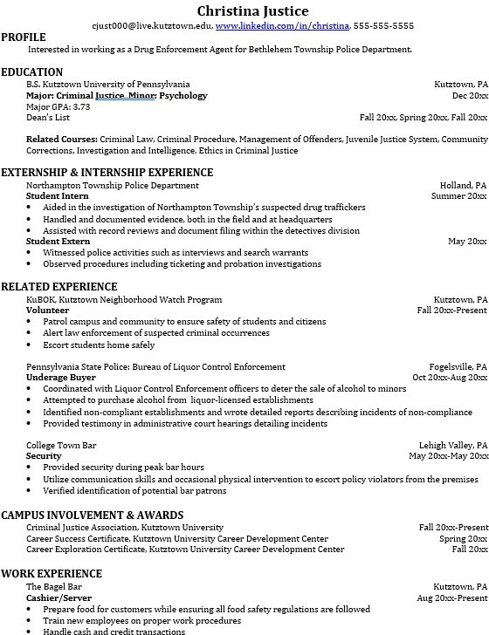
but also have experience

Learn more about your field and develop the necessary skills for employment by gaining hands-on experience through internships & related experiences.

For More Information on Criminal Justice careers or to speak to a Career Counselor, contact KU Career Development Center 113 Stratton Administration Center * 610-683-4067 * careerhelp@kutztown.edu * www.kutztown.edu/careercenter

