Bachelor of Science in Education: Elementary Education Pre K-4 Bachelor of Science in Education: Elementary Education 4-8
With Concentrations in: 1) Math and Science, 2) Math and English/Language Art and Reading,
3) Math and Social Studies, 4) Science, English/Language Art and Reading, 5) Science and Social Studies
Our future is in the children - which is why it's so important to nurture, educate and guide them in life. Elementary education teachers have a dramatic impact and role in the life of children. The Department of Elementary Education program prepares teacher candidates for all the challenges involved in educating today's young minds through general and specialized course curricula.

Career types associated with Elementary Education
Social - “Helper” Enterprising - “Persuader” Artistic - “Creator”

Related skills, values, and qualities
- Strong interpersonal skills and ability to communicate ideas, facts and abstract concepts to others
- Ability to interact with people of diverse backgrounds
and personalities
- Desire and ability to work with children and youth
- Enthusiasm for teaching
- Sense of humor and friendly attitude
- Ability to organize, maintain records and meet deadlines
- Ability to use and incorporate technology into teaching
- Ability to make decisions, solve problems and remain calm in stressful situations
- Ability to adjust to close public scrutiny & criticism

Courses Elementary Education majors enjoy
- Psychology
- Public Speaking
- English
- Interpersonal Communications
- Child Development
- Sociology
- Social Studies
- Science
- Math

Common interests of Elementary Edu. majors:
- Working part-time or as a volunteer in a preschool, nursery, elementary, or middle school
- Playing team sports or participating in community service organizations
- Serving as a religious school, children’s church or
vacation Bible school teacher
- Attending lectures, workshops, or conventions
related to education
- Helping to organize and plan social events
- Working part-time or as a volunteer peer/camp counselor, tutor, 4-H leader or scout leader

For more information about the major: Contact the Elementary, Middle Level, Library and Technologies Education Department
201 Beekey, 610-683-4262
KU Majors related to Elementary Education: Middle level Education, Special Education, Library Science, Art Education, Music Education
El Ed students may also be interested in: Advertising *, Cinema, Television and Media Production, Economics *, English, German Studies, History, Human Resource Mgt. (cert), International
Studies *, Literature *, Marketing, Multicultural Studies
*, PA German Studies *, Philosophy/Religious Studies, Political Science, Psychology, Public Administration, Public Relations *, Secondary Education, Spanish, Sport Administration, Social Work, Sociology, Speech Communication, Women’s Studies
*, Writing* * minor only



For More Information on Elementary Education Careers or to speak to a Career Counseling, contact KU Career Development Center 113 Stratton Administration Center * 610-683-4067 * careerhelp@kutztown.edu * www.kutztown.edu/careercenter

  - Enroll in the Career Exploration Certificate.
  - Attend info sessions to learn about career development and personal branding.
  - Take a career assessment to
identify and confirm interests.
  - Get involved in campus clubs and organizations.
  - Develop basic workplace skills through jobs or volunteer work.
  - Talk with professors, family, and friends about career ideas.
  - Conduct informational interviews with professionals working in fields of interest.
  - Develop a relationship with your professors and faculty advisor.

- Meet with CDC career coach.
- Attend info sessions to learn about resume writing, and externships.
- Confirm your choice of major and consider options for double major or minor.
- Research careers of interest.
- Complete a job shadowing (externship) experience.
- Seek meaningful employ-ment or volunteer work in a field related to your major.
- Explore options for under-graduate research and study abroad.
- Write a resume and have it reviewed by the CDC.
- Manage your online presence.
- Enroll in the Career Success Certificate.
- Complete an internship and/or undergraduate research.
- Attend info sessions about internships, interviewing, job search strategies, and grad school.
- Build a LinkedIn profile and continue to monitor your online presence.
- Complete a mock interview.
- Build skills through research projects, part-time employment, and volunteer work.
- Participate in Careers Cafe & networking programs.
- Attend internship & job fairs.
- Take on a leadership role in a student organization or work.
- Consider graduate school options and prepare for admissions tests.
- Attend your senior kick-off and other info sessions to prepare for job search/grad school.
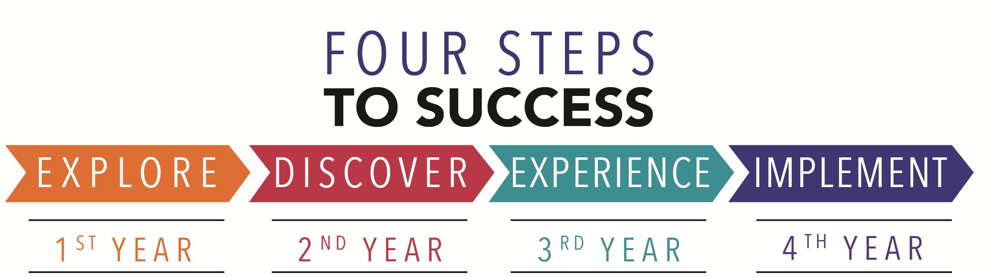
- Update your resume and LinkedIn profile.
- Create cover letter drafts.
- Gain experience through internships and/or undergraduate research.
- Secure references for job/grad school applications.
- Create your “30 second”
commercial.
- Meet with CDC to develop job search strategies.
- Research employers.
- Network with professionals through events and social media.
- Join a professional organization in your discipline.
- Attend the senior etiquette
dinner.
- Participate in job fairs and on-campus interviewing.

Sample Career Titles
Elementary Education majors can be found working in a wide variety of career fields. Here are just some career titles that may be of interest. Please note that some jobs may require further education and training.

  - Adult Education Teacher
  - Adventure/Outdoor Edu. Teacher
  - Alumni Relations Coordinator
  - Assistant Principal
  - Athletic Coach/Director
  - Business Education Teacher
  - Child Life Specialist
  - College President
  - College Professor/Dean
  - Community/Public Svc. Administrator
  - Counselor
  - Day Care Administrator
  - Director of Guidance
  - Education and Training Administrator
  - Education Management Specialist
  - Educational Administrator
  - Education Consultant
  - Educational Resource Coordinator
  - Educational Materials Sales
  - Educational Researcher
  - Educational Therapist
  - Elementary School Teacher
  - Employee Training Instructor
  - Grant Writer
  - Guidance Counselor
  - Historic Site Administrator
  - Kindergarten Teacher
  - Librarian
  - Library Consultant
  - Missionary Worker
  - Peace Corps/VISTA Volunteer
  - Personnel Director
  - Preschool Administrator
  - Preschool Teacher
  - Principal
  - Registrar
  - Resource Teacher
    - Religious Education Teacher
    - Religious Education Coordinator
    - School Psychologist
    - School Social Worker
    - School Superintendent
    - Secondary School Teacher
    - Social Services Volunteer
    - Special Education Administrator
    - Special Education Teacher
    - Speech Pathologist
    - Student Admissions Administrator
    - Student Affairs Administrator
    - Tutor
    - Curriculum Specialist
    - Textbook Writer
    - Training Specialist
    - Tutor
    - Vocational Rehab Counselor
    - Vocational/Technical Teacher

To learn more about these careers, visit http://online.onetcenter.org or www.bls.gov/oco.

Common Internship Sites and Employers
Elementary Education majors often find internships and employment in the following fields/industries:

      - Business and Industry
      - Camps
      - Public and Private Schools
      - Churches
      - Colleges and Universities
      - Youth Services
      - Non-Profit Organizations
      - Community Centers/Non Profits
      - Educational Publishers
      - Child Care Agencies
      - Hospitals
      - Libraries
      - State and Federal Government


Handshake is the primary online resource for preparing and connecting students and alumni
with employers. www.kutztown.edu/handshake

Useful Websites for Elementary Education Majors:
Whether you are researching related career fields, applying for internships or jobs, or planning to join a professional association, these websites are for you!

Industry/Employment Information
O*NET OnLine www.onetonline.org

Occupational Outlook Handbook. www.bls.gov/ooh
PA Department of Education www.pa.gov/agencies/education/ html

NJ Department of Education www.state.nj.us/education
Education Week www.edweek.org
LinkedIn Jobs www.linkedin.com/jobs

Job/Internship Search Boards
PA-REAP
www.pareap.net

PA-Educator.net www.pa-educator.net
Teachers-Teachers
www.teachers-teachers.com

Southern Teacher’s Agency
www.southernteachers.com
Education Job Page www.nationjob.com/education

School Spring www.schoolspring.com
US-REAP
www.reap.net

Pennsylvania State School Boards Assoc.
www.PSBA.org

Professional Associations

PA School Board Association www.psba.org

American Federation of Teachers www.aft.org

PA State Education Association
www.psea.org
National Education Association www.nea.org

National Association for the Education of Young Children
www.naeyc.org

Teachers of English to Speakers of Other Languages www.tesol.org
Association of Childhood Education
International www.acei.org

Building Your Resume for a Career in Elementary Education
Learn more about your field and develop the necessary skills for employment by gaining hands-on experience through clinical practice and related work or volunteer experience.
Develop professionally through campus involvement and professional memberships.
This illustrates responsibility, leadership abilities and time management skills.
Building a strong resume for your career field starts long before you ever start your job search. Employers want
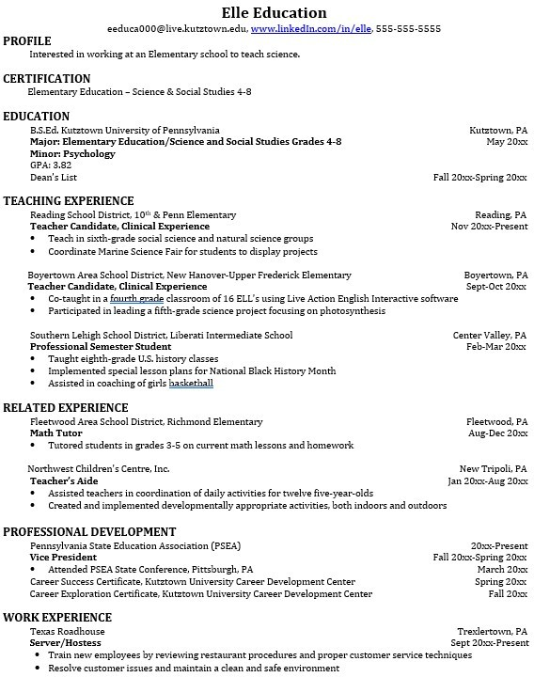
to hire graduates who not only have the necessary educational background but also have experience applying that knowledge to real life situations.
Take note of the skills and knowledge obtained through your educational background and hands-on experiences.
Highlight transfera-ble skills such as time management, organization and rapport building.

For More Information on Elementary Education Careers or to speak to a Career Counseling, contact KU Career Development Center 113 Stratton Administration Center * 610-683-4067 * careerhelp@kutztown.edu * www.kutztown.edu/careercenter

