

Bachelor of Science: Game Development
Minor: Computer Science, Information Technology, Game Development and Web Development Certificate: Database Design & Implementation

The Bachelor of Science degree in Game Development is an interdisciplinary degree. It focuses on computer science courses for game development, but also includes art, music and writing courses providing students a cross-disciplinary knowledge base in game development. Students who receive a degree in Game Development may choose to work in a variety of areas after graduation, such as game developer, video game programmer, game designer, mobile app developer, and web developer. Employers recommend one or more internships to be successful and competitive when entering this field.

Career types associated with Game Development
(Is this a good fit for you? Are you a…)
- Investigative - “Thinker”
- Conventional - “Organizer”
- Social - “Helper”
- Realistic - ”Doer”

Related skills, values, and qualities
- Ability to adapt to constant change
- Proficiency in reading, writing, and thinking, questioning, and analyzing
- Proficiency in problem solving
- Ability to think logically and organize
- Proficiency with computers
- Aptitude for accuracy and detail
- Interest in Art/Drawing
- Ability to work under pressure

Courses Game Development majors typically enjoy
- Algebra, Trigonometry, Calculus
- Art
- Design
- Game Design
- Computer Programming
- Computer Science
- Web Development
- Creative Writing

Common interests of Game Development majors
  - Working with computers, software, gaming
  - Completing puzzles or playing games of strategy
  - Solving logic problems
  - Participating in eSports or gaming related clubs
  - Sketching or drawing game characters or scenes
  - Working part-time or volunteering in a technology store/department
  - Reading computer or technology publications
For more information about the major Contact the Computer Science and Information Technology Department, 256 Old Main,
610-683-4340, or visit www.kutztown.edu/csit CSITDepartment@kutztown.edu
KU Majors related to Game Development Mathematics, Communication Design, Applied Digital Arts, Studio Art

For More Information on Computer Science/IT careers or to speak to a Career Counselor, contact KU Career Development Center 113 Stratton Administration Center * 610-683-4067 * careerhelp@kutztown.edu * www.kutztown.edu/careercenter



- Enroll in the Career Exploration Certificate.
- Attend info sessions to learn about career development and personal branding.
- Take a career assessment to
identify and confirm interests.
- Get involved in campus clubs and organizations.
- Develop basic workplace skills through jobs or volunteer work.
- Talk with professors, family, and friends about career ideas.
- Conduct informational interviews with professionals working in fields of interest.
- Develop a relationship with your professors and faculty advisor.
- Meet with CDC career coach.
- Attend info sessions to learn about resume writing, and externships.
- Confirm your choice of major and consider options for double major or minor.
- Research careers of interest.
- Complete a job shadowing (externship) experience.
- Seek meaningful employ-ment or volunteer work in a field related to your major.
- Explore options for under-graduate research and study abroad.
- Write a resume and have it reviewed by the CDC.
- Manage your online presence.

- Enroll in the Career Success Certificate.
- Complete an internship and/or undergraduate research.
- Attend info sessions about internships, interviewing, job search strategies, and grad school.
- Build a LinkedIn profile and continue to monitor your online presence.
- Complete a mock interview.
- Build skills through research projects, part-time employment, and volunteer work.
- Participate in employer panels, site visits & networking events.
- Attend internship & job fairs.
- Take on a leadership role in a student organization or work.
- Consider graduate school options and prepare for admissions tests.
- Attend your Senior Kick-off session and other info sessions to prepare for job search/grad school.
- Update your resume and LinkedIn profile.
- Create cover letter drafts.
- Gain experience through internships and/or undergraduate research.
- Secure references for job/grad school applications.
- Create your “30 second”
commercial/professional intro.
- Meet with CDC to develop job search strategies.
- Research employers.
- Network with professionals through events and social media.
- Join a professional organization
in your discipline.
- Attend the senior etiquette luncheon or dinner.
- Participate in job fairs and on-campus interviewing.

Sample Career Titles
Game Development majors can be found working in a wide variety of career fields. Here are just some career titles that may be of interest. Please note that some jobs may require further education and training.
To learn more about these careers, visit http://online.onetcenter.org or www.bls.gov/oco.

Animator
Artificial Intelligence I Programmer Asset Artist
Audio Programmer Character Artist Concept Artist
Creative Game Director Educator/Trainer Engine Programmer Environment Artist Esports Producer
Game Animator Game Artist
Game Audio Engineer
Game Designer Game Marketer/PR Game Producer Game Programmer Game Publisher Game Writer Gameplay Designer Gameplay Engineer
Gameplay Programmer Generalist Programmer Graphic Programmer Lead Game Designer Level Designer
Music Composer
Network Programmer Physics Programmer
Quality Assurance Build Engineer Quality Assurance Game Tester Sound Designer
Systems Designer Technical Artist Technical Animator Texturing Artist Tools Engineer
Video Game System Designer Virtual Reality Programmer Visual Effects Artist
3D Modeling Artist

Common Internship Sites and Employers
Game Development majors often find internships and
employment in the following fields/industries.

  - Business & Industry
  - Colleges/Universities
  - Consulting Firms
  - Federal, State & Local Govts
  - Game Development Companies
  - Healthcare
  - International Agencies
  - Manufacturing
  - Military
  - Research & Development
  - Telecommunications


Handshake is the primary online resource
for preparing and connecting students and alumni with employers.
www.kutztown.edu/handshake

Useful Websites for Game Development Majors
Whether you are researching related career fields, applying for internships or jobs, or planning to join a professional association, these websites are for you!

Industry/Employment Information
Computer Jobs www.computerjobs.com
Dice www.dice.com

IEEE
jobs.ieee.org

Game Development Careers www.cgspectrum.com/career-pathways/ game-development

Game Developer Jobs https://gamedevjobs.io

Gamasutra Jobs
https://jobs.gamasutra.com

Internet Society www.internetsociety.org
Tech America www.techamerica.org

LinkedIn Jobs www.linkedin.com/jobs

Professional Associations
ACM SIGGRAPH
www.siggraph.org

American Institute of Graphic Arts www.aiga.org

Digital Games Research Association (DiGRA) www.digra.org/the-association
Entertainment Software Association (ESA) www.theesa.com/about-esa
Instrumentation, Systems and Automation Society www.isa.org

Institute of Electrical & Electronics Engineers www.ieee.org (job postings too)

International Assoc. for Technology in Education
www.iste.org

World Organization of Webmasters https://webprofessionals.org

Related Area Employers
Armstrong World Industries Brentwood Industries Burning Sky Games
Clark Associates Computer Aid Inc
Fidelity Information Services Gateway Ticketing
Hershey Entertainment & Resorts Kutztown University
Lehigh Valley Health Network LeverX
Liquid Interactive Neo Pangea Olympus
Penn Interactive Penske
PPL Electric Utilities
SAP
Skyless Game Studios
St. Luke's University Health Network
UHS of Delaware, Inc. Zulily

Building Your Resume for a Career in Game Development
Building a strong resume for your career field starts long before you ever start your job search. Employers want to hire graduates who not only have the necessary educational background but also have experience applying that knowledge.

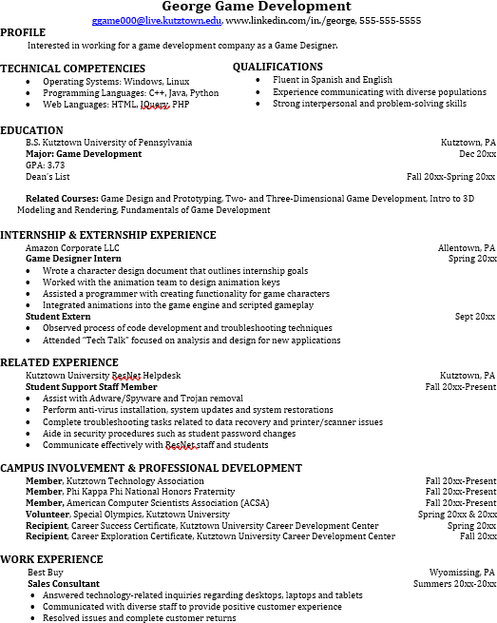
Learn more about your field and develop the necessary skills for employment by gaining hands-on experience through internships.

Utilize summer breaks to acquire valuable experience via volunteer or employment opportunities related to your major.

Develop professionally through campus involvement and professional memberships.
This illustrates responsibility, leadership abilities and time management skills.

For More Information on Game Development careers or to speak to a Career Counselor, contact KU Career Development Center 113 Stratton Administration Center * 610-683-4067 * careerhelp@kutztown.edu * www.kutztown.edu/careercenter

