

Bachelor of Arts: Geography
Bachelor of Arts: Geography/Global and Regional Studies Bachelor of Arts: Geography/Environment and Planning Bachelor of Science: Environmental Science/Geography
Minors: Cultural Geography, Geography, Environmental Geography, Planning Geography Certification: Geospatial Information Technology

Geography is the study of the interrelationships between the earth and its people. As both a social and natural science, geography focuses on climate, land, water, space, mineral resources, population, changes in the environment, and how people adapt to them. Numerous tools and techniques are employed in geographic research including cartography (the art and science of map making and use), geographic information systems (GIS), satellite imagery and air photo interpretation, surveys, mathematical modeling, and statistical analysis.
Graduates can find employment in business, government agencies, research, management, non-profits, and education fields. Employers recommend one or more internships to be successful and competitive when entering this field.

Career types associated with Geography
(Is this a good fit for you? Are you a…)
- Investigative - “Thinker”
- Realistic - “Doer”
- Enterprising - “Persuader”

Related skills, values, and qualities
- Spatial thinking
- Abilities in GIS science and cartography
- Data analysis and presentation
- Sense of complex interactions between humans and the environment
- Sensitivity to the distinctiveness of places
- A global and interdisciplinary perspective

Courses Geography majors typically enjoy
- Physical Science
- Economics
- Business
- Geography (Physical/Cultural)
- Social Science
- Sociology
- History
- Political Science
- Transportation
- Criminal Justice

Common interests of Environmental Science majors
- Visiting natural science museums
- Participating in outdoor activities
- Solving analytical and logical problems
- Hiking, camping, and backpacking
- Exploring and traveling
- Participating in Geography or science clubs
- Reading professional publications
- Environmental conservation and advocacy

For more information about the major Contact the Department of Society, History & Culture 2 Old Main or visit www.kutztown.edu/Geography

KU Majors related to Geography
Environmental Science, Geology

Investigative students may also be interested in: Anthropology, Biochemistry, Biology, Chemistry, Computer Science, Criminal Justice, Economics*, German Studies, History, International Studies*, Mathematics, Multicultural Studies*, German Studies, Physics, Political Science, Psychology, Sec Edu- Math/ Science, Sociology, Spanish, and Women’s Studies*
* minor only

For More Information on Geography careers or to speak to a Career Counselor, contact KU Career Development Center 113 Stratton Administration Center * 610-683-4067 * careerhelp@kutztown.edu * www.kutztown.edu/careercenter



- Enroll in the Career Exploration Certificate.
- Attend info sessions to learn about career development and personal branding.
- Take a career assessment to
identify and confirm interests.
- Get involved in campus clubs and organizations.
- Develop basic workplace skills through jobs or volunteer work.
- Talk with professors, family, and friends about career ideas.
- Conduct informational interviews with professionals working in fields of interest.
- Develop a relationship with your professors and faculty advisor.
- Meet with CDC career coach.
- Attend info sessions to learn about resume writing, and externships.
- Confirm your choice of major and consider options for double major or minor.
- Research careers of interest.
- Complete a job shadowing (externship) experience.
- Seek meaningful employ-ment or volunteer work in a field related to your major.
- Explore options for under-graduate research and study abroad.
- Write a resume and have it reviewed by the CDC.
- Manage your online presence.
- Enroll in the Career Success Certificate.
- Complete an internship and/or undergraduate research.
- Attend info sessions about internships, interviewing, job search strategies, and grad school.
- Build a LinkedIn profile and continue to monitor your online presence.
- Complete a mock interview.
- Build skills through research projects, part-time employment, and volunteer work.
- Participate in employment panels, site visits & networking events.
- Attend internship & job fairs.
- Take on a leadership role in a student organization or work.
- Consider graduate school
options and prepare for
- Attend your Senior Kick-off and other info sessions to prepare for job search/grad school.
- Update your resume and LinkedIn profile.
- Create cover letter drafts.
- Gain experience through internships and/or undergraduate research.
- Secure references for job/grad school applications.
- Create your “30 second”
commercial/elevator pitch.
- Meet with CDC to develop job search strategies.
- Research employers.
- Network with professionals through events and social media.
- Join a professional organization in your discipline.
- Attend the senior etiquette or
luncheon dinner.
- Participate in job fairs and on-campus interviewing.

Sample Career Titles
Geography majors can be found working in a wide variety of career fields. Here are just some career titles that may be of interest. Please note that some jobs may require further education and training.
To learn more about these careers, visit http://online.onetcenter.org or www.bls.gov/oco.

  - Aerial Photo Interpreter
  - Agricultural Extension Agent
  - Air/Water Quality Control Manager
  - Aviation designer
  - Cartographer
  - Climatologist
  - Coastal Zone Manager
  - Community Developer
  - Computer Mapper
  - Computer Programmer
  - Diplomat
  - Earth Scientist
  - Ecologist
  - Editor
  - Environmental Consultant
  - Environmental Impact Analyst
  - Environmental Quality Specialist
  - Environmental Technician
  - Facilities Planner
  - Forestry Technician
  - Geographic Area Specialist
  - Geographic Information Systems (GIS)
Specialist/Analyst
  - GIS Program Manager
  - Geophysics Assistant
  - Hazardous-Waste Planner
  - Health Services Organization
  - Health Services Planner
  - Hydrologist
  - Industrial Developer
  - Industrial Planner
  - Intelligence Agent
  - International Business Representative
  - International Investment Analyst
  - Land Developer
  - Land Economist
  - Land-Use Analyst
  - Location Expert
  - Map Analyst
  - Map Curator/Librarian
  - Market Research Analyst
  - Natural Resource Specialist
  - Operations Manager
  - Outdoor Guide
    - Park Ranger
    - Peace Corps Volunteer
    - Planner
    - Property Manager
    - Public Utilities Specialist
    - Remote Sensing Analyst
    - Rural Resource Planner/preservation
    - Site Researcher
    - Soil Conservationist
    - Surveyor
    - Sustainability Director
    - Systems Analyst
    - Teacher/Professor
    - Traffic Manager
    - Transportation Analyst
    - Transportation Manager
    - Travel Agent/Specialist
    - Urban/Regional Planner
    - Weather Forecaster
    - Wildlife Manager
    - Zoning Investigator

Common Internship Sites and Employers
Geography majors often find internships and employment in the following fields/industries.

- Colleges/Universities
- Construction/Building Companies
- Engineering Companies
- Environmental Protection Organizations
- Fuel Companies
- Greenhouses/arboretums
- Heritage Sites
- Museums
- Science/discovery Centers
- Research Laboratories
- Railroads
- Local/State/Federal Government
- Urban/Regional/County Planners
- Wildlands conservancy



Handshake is the primary online resource
for preparing and connecting students and alumni with employers.
www.kutztown.edu/handshake

Useful Websites for Geography Majors
Whether you are researching related career fields, applying for internships or jobs, or planning to join a professional association, these websites are for you!

Industry/Employment Information

Bureau of Land Management www.blm.gov Environmental

Careers World Job Bank www.environmentaljobs.com

Environmental Protection Agency
www.epa.gov

Environmental Systems Research Institute
www.esri.com

GIS Jobs Clearinghouse www.gjc.org

Geography.com http://geography.com
New Scientist Jobs www.newscientistjobs.com

Pennsylvania Spatial Data Access
www.pasda.psu.edu

US Geological Survey www.usgs.gov/ohr
LinkedIn Job Search www.linkedin.com/jobs

GIS Lounge www.gislounge.com/gis-job-listings

Professional Associations
American Congress on Surveying and Mapping http://landsurveyorsunited.com/acsm

American Geographical Society www.amergeog.org
American Planning Association
www.planning.org

American Society for Photogrammetry & Remote Sensing
www.asprs.org

American Association of Geographers www.aag.org
GIS Certification Institute www.gisci.org
Geospatial Info & Techno Association www.gita.org

Imaging and Geospatial Information Society
www.asprs.org

Pennsylvania Geographical Society www.thepgs.org

Society of Women Geographers www.iswg.org
Urban and Regional Information Systems Assoc. www.urisa.org

Related Area Employers
Babcock and Wilcox Company BEI Engineering
Berks County Planning Commission Berks Nature
Blue Marsh Lake Borough of Emmaus Borough of Lansdale City of Reading
Chester County Planning Commission Element Environmental Solutions
ESRI
Hawk Mountain Bird Sanctuary Lancaster Area Sewer Authority Langan Engineering
Lehigh Valley Planning Commission Lower Macungie Township
PA Department of Conservation and Natural Resources
Pennoni
Perkiomen Watershed
Schuylkill County Municipal Authority Tilden Township
Upper Milford Township
Wildlands Conservancy

Building Your Resume for a Career in Geography

Building a strong resume for your career field starts long before you ever start your job search. Employers want to hire graduates who not only have the necessary educational background but also have experience applying that knowledge.

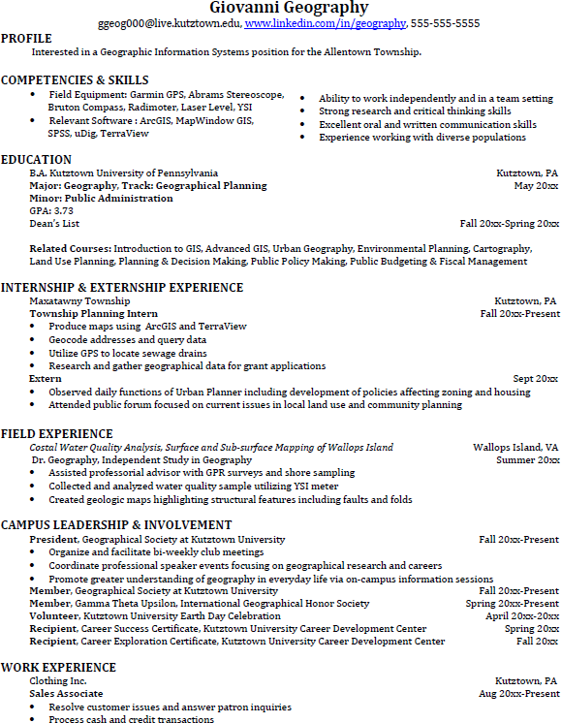
Learn more about your field and develop the necessary skills for employment by gaining hands-on experience through internships.

Utilize summer breaks to acquire valuable experience via volunteer or employment opportunities related to your major.

Develop professionally through campus involvement and professional memberships.
This illustrates responsibility, leadership abilities and time management skills.

For More Information on Geography careers or to speak to a Career Counselor, contact KU Career Development Center 113 Stratton Administration Center * 610-683-4067 * careerhelp@kutztown.edu * www.kutztown.edu/careercenter

