Bachelor of Science in Education: Library Science Bachelor of Science: Library Science
The Library Science program prepares students to serve as professional librarians evaluating, selecting, collecting, organizing, storing, retrieving and disseminating information. The various program tracks have been designed to include the traditional roles of librarianship as well as the standard and emerging technologies. Additionally, the program balances theoretical foundation with practical implementation.

Career types associated with Library Science
(Is this a good fit for you? Are you…)
Social - “Helper” Enterprising - ”Persuader” Artistic - “Creator”

Related skills, values, and qualities
- Strong interpersonal skills and ability to interact with
people of diverse backgrounds and personalities
- Desire and ability to work with people of all ages
- Ability to speak and write clearly
- Ability to organize, collect, and classify different types of materials
- Aptitude for accuracy, detail and memorization
- Ability to use and incorporate technology into curriculum and instruction
- Ability to critically think, solve problems and make sound decisions

Courses Library Science majors typically enjoy
- Children and Young Adult Literature
- English
- Language Arts
- Computer Information Systems
- Instructional Technology
- Emerging Technologies
- Video Production
- Archiving

Common interests of Library Science majors:
- Working part-time or as a volunteer in a library, bookstore, law office, or research firm
- Exploring new technologies for information sharing and learning.
- Visiting book stores, libraries and museums
- Belonging to a book club, literary society, or professional organization, such as the American Library Association
- Attending lectures, workshops, and conferences related to library and information sciences
- Participating in activities that involve research
- Creating blogs and websites

For more information
Contact the Elementary, Middle Level, Library and Technologies Education Department
11 Rohrbach, 610-683-4300
KU Majors related to Library Science Elementary Education, Secondary Education, English, Computer Science
Social students may also be interested in: Advertising *, Economics *, German Studies, History, Human Resource Mgt. (cert), International Studies *, Sport Management, Literature *, Marketing, Multicultural Studies *, PA German Studies *, Philosophy/Religious Studies, Political Science, Psychology, Public Administration, Public Relations *, Spanish, Social Work, Sociology, Speech
Communication, Women’s Studies *, Writing*
* minor only


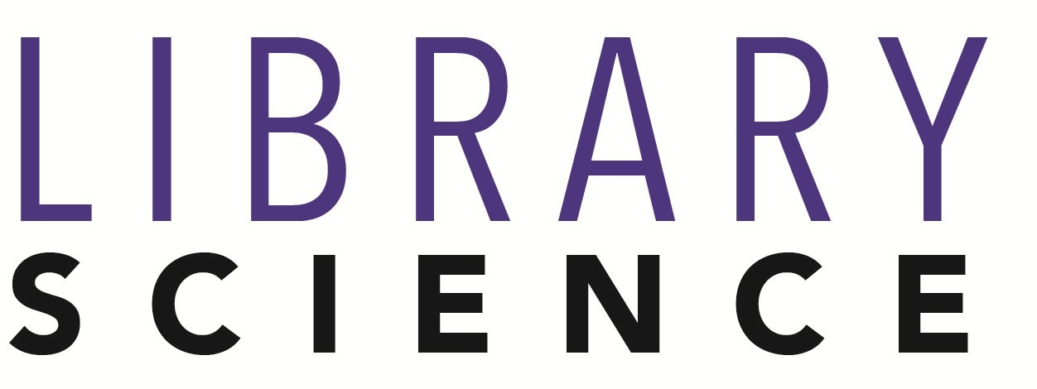
For More Information on Library Science Careers or to speak to a Career Counseling, contact KU Career Development Center 113 Stratton Administration Center * 610-683-4067 * careerhelp@kutztown.edu * www.kutztown.edu/careercenter

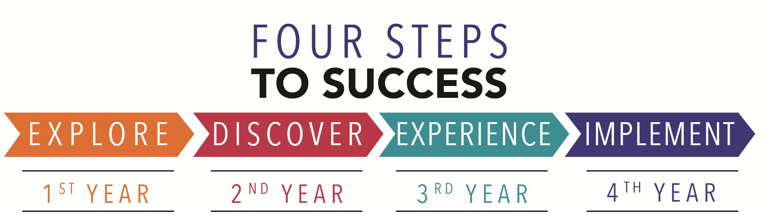

- Enroll in the Career Exploration Certificate.
- Attend info sessions to learn about career development and personal branding.
- Take a career assessment to
identify and confirm interests.
- Get involved in campus clubs and organizations.
- Develop basic workplace skills through jobs or volunteer work.
- Talk with professors, family, and friends about career ideas.
- Conduct informational interviews with professionals working in fields of interest.
- Develop a relationship with your professors and faculty advisor.
- Meet with CDC career coach.
- Attend info sessions to learn about resume writing, and externships.
- Confirm your choice of major and consider options for double major or minor.
- Research careers of interest.
- Complete a job shadowing (externship) experience.
- Seek meaningful employ-ment or volunteer work in a field related to your major.
- Explore options for under-graduate research and study abroad.
- Write a resume and have it reviewed by the CDC.
- Manage your online presence.
  - Enroll in the Career Success Certificate.
  - Complete an internship and/or undergraduate research.
  - Attend info sessions about internships, interviewing, job search strategies, and grad school.
  - Build a LinkedIn profile and continue to monitor your online presence.
  - Complete a mock interview.
  - Build skills through research projects, part-time employ-ment, and volunteer work.
  - Participate in Careers Cafe & networking programs.
  - Attend internship & job fairs.
  - Take on a leadership role in a student organization or work.
  - Consider graduate school options and prepare for admissions tests.
  - Attend your senior kick-off and other info sessions to prepare for job search/grad school.
  - Update your resume and LinkedIn profile.
  - Create cover letter drafts.
  - Gain experience through internships and/or undergraduate research.
  - Secure references for job/grad school applications.
  - Create your “30 second”
commercial.
  - Meet with CDC to develop job search strategies.
  - Research employers.
  - Network with professionals through events and social media.
  - Join a professional organization in your discipline.
  - Attend the senior etiquette dinner.
  - Participate in job fairs and on-campus interviewing.

Sample Career Titles
Library Science majors can be found working in a wide variety of career fields. Here are just some career titles that may be of interest. Please note that some jobs may require further education and training.

    - Adult Education Teacher
    - Alumni Relations Coordinator
    - Assistant Principal
    - Child Life Specialist
    - College Professor/Dean
    - Community Librarian
    - Community/Public Service
Administrator
    - Counselor
    - Day Care Administrator
    - Education and Training Administrator
    - Education Management Specialist
    - Educational Administrator
    - Education Consultant
    - Educational Materials Sales Rep
    - Educational Researcher
    - Educational Resource Coordinator
  - Elementary School Teacher
  - Employee Training Instructor
  - Grant Writer
  - Guidance Counselor
  - Historic Site Administrator
  - Instructor, College/University
  - Kindergarten Teacher
  - Librarian
  - Library Consultant
  - Media Center Specialist
  - Missionary Worker
  - Peace Corps/VISTA Volunteer
  - Personnel Director
  - Preschool Administrator/Teacher
  - Preschool Principal
    - Registrar
    - Religious Education Teacher
    - Religious Education Coordinator
    - Resource Teacher
    - School Social Worker
    - School Superintendent
    - Secondary School Teacher
    - Social Services Volunteer
    - Student Admissions Administrator
    - Curriculum Specialist
    - Technology Specialist
    - Textbook Writer
    - Training Specialist
    - Tutor
    - Vocational Rehab Counselor
    - Vocational/Technical Teacher

To learn more about these careers, visit http://online.onetcenter.org or www.bls.gov/oco.

Common Internship Sites and Employers
Library Science majors often find internships and employment in the following fields/industries:

      - Business and Industry
      - Camps
      - Public and Private Schools
      - Churches
      - Colleges and Universities
      - Youth Services
      - Community Centers/Non Profits
      - Educational Publishers
      - Day Care Agencies
      - Hospitals
      - Libraries
      - State and Federal Government


Handshake is the primary online resource for preparing and connecting students
and alumni with employers.

Useful Websites for Library Science Majors
Whether you are researching related career fields, applying for internships or jobs, or planning to join a professional association, these websites are for you!

Industry/Employment Information
O*NET OnLine Www.onetonline.org

Occupational Outlook Handbook. www.bls.gov/ooh
PA Department of Education
www.pa.gov/agencies/education.gov

NJ Department of Education www.state.nj.us/education
Education Week www.edweek.org

Job/Internship Search Boards
PA-REAP
www.pareap.net

PA-Educator.net www.paeducator.net
Southern Teacher’s Agency
www.southernteachers.com

Education Job Page www.nationjob.com/education
School Spring www.schoolspring.com

US-REAP
www.usreap.net

School-Jobs www.school-jobs.net

LinkedIn Jobs
www.linkedin.com/jobs

Pennsylvania School Boards Assoc. www.PSBA.org

Professional Associations

PA School Librarians Association www.psla.org

PA Library Association www.palibraries.org
American Library Association
www.ala.org

Public Library Association www.ala.org/pla

PA State Education Association www.psea.org

PA School Board Association www.psba.org

National Education Association www.nea.org
Assoc. of Research Libraries
www.arl.org

Teachers of English to Speakers of Other Languages www.tesol.org
American Federation of Teachers www.aft.org
Assoc. for Library & Info. Science Edu. www.alise.org

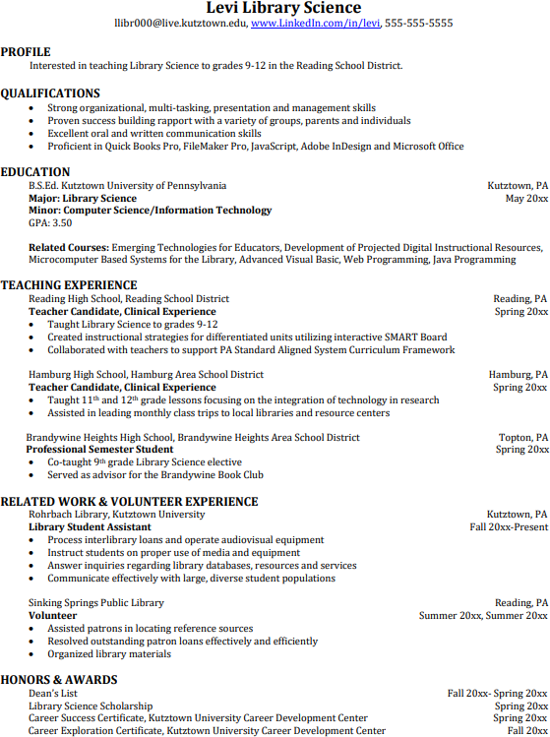
Building Your Resume for a Career in Library Science
For More Information on Library Science Careers or to speak to a Career Counseling, contact KU Career Development Center 113 Stratton Administration Center * 610-683-4067 * careerhelp@kutztown.edu * www.kutztown.edu/careercenter
Building a strong resume for your career field starts long before you ever start your job search. Employers want to hire graduates
who not only have the necessary educational background but also have experience applying that knowledge to real life situations.

Take note of the skills and knowledge obtained through your educational background and hands-on experienc-es.
Highlight transfera-ble skills such as management abili-ties and technological proficiencies.

Consider choosing a minor that will complement your major and tailor your knowledge towards specific career goals.
Learn more about your field and develop the necessary skills for employment by gaining hands-on experience through clinical practice and related work or
volunteer opportunities.

