Bachelor of Science in Business Administration with a major in Management
Management graduates are prepared to assume leadership roles in a wide variety of careers and organizations. Students pursuing a major in Management are required to complete advanced study in Organization Behavior,
Business and Social Environment, Human Resource Management, Business Strategy and Policy. Management majors have the opportunity to select from a wide offering of electives in areas including Small Business Management, International Management, and Logistics and Supply Chain Management. Employers recommend that in order to be successful and competitive when entering this field, students should complete one or more internships.

Career types associated with Management
(Is this a good fit for you? Are you a…)
- Enterprising - “Persuader”
- Realistic - “Doer”
- Social - “Helper”

Related skills, values, and qualities
- Ability to communicate ideas and concepts to others
- Proficiency in reading, writing and speaking
- Ability to solve problems and make effective decisions
- Ability to organize, plan, coordinate and direct activities
- Strong interpersonal and networking skills
- Strong sense of integrity and professionalism
- Ability to motivate and lead others
- Ability to work well under pressure

Courses Management majors typically enjoy
- Accounting
- Business
- Business Law
- Economics
- Interpersonal Communications
- Management
- Psychology
- Sociology
- Speech

Common interests of Management majors
- Working part-time in a business establishment
- Participating in oratory contests
- Planning, starting, or managing a part-time business endeavor
- Assisting in the planning of a civic or social event
- Playing games of strategy, competition, or
achievement
- Attending lectures, workshops, and conferences related to business management
- Serving as a volunteer in a social agency
- Belonging to a Junior Achievement Club or a professional business organization
For more information about the major Contact the Department of Business Administration, 233 deFrancesco, 610-683-4580,
or visit www.kutztown.edu/Management

KU Majors related to Management
Marketing, Public Administration, Sport Management
Enterprising students may also be interested in: Advertising*, Communication Studies, Criminal Justice, Economics*, Elementary Education, English-Professional Writing, Environmental Science, Finance, History, International Studies*, Literature*, Multicultural Studies*, Political Science, Psychology, Public Relations*, Secondary Education, Social Work,
Women’s Studies*.
*minor only




For More Information on Management Careers or to speak to a Career Counseling, contact KU Career Development Center 113 Stratton Administration Center * 610-683-4067 * careerhelp@kutztown.edu * www.kutztown.edu/careercenter

  - Enroll in the Career Exploration Certificate.
  - Attend info sessions to learn about career development and personal branding.
  - Take a career assessment to identify and confirm interests.
  - Get involved in campus clubs
and organizations.
  - Develop basic workplace skills through jobs or volunteer work.
  - Talk with professors, family, and friends about career ideas.
  - Conduct informational interviews with professionals working in fields of interest.
  - Develop a relationship with your professors and faculty advisor.

- Meet with CDC career coach.
- Attend info sessions to learn about resume writing, and externships.
- Confirm your choice of major and consider options for double major or minor.
- Research careers of interest.
- Complete a job shadowing (externship) experience.
- Seek meaningful employ-ment or volunteer work in a field related to your major.
- Explore options for under-graduate research and study abroad.
- Write a resume and have it reviewed by the CDC.
- Manage your online presence.
  - Enroll in the Career Success Certificate.

  - Complete an internship and/ or undergraduate research.
  - Attend info sessions about internships, interviewing, job search strategies, and grad school.
  - Build a LinkedIn profile and continue to monitor your online presence.
  - Complete a mock interview.
  - Build skills through research projects, part-time employ-ment, and volunteer work.
  - Participate in employment panels, site visits & networking events.
  - Attend internship & job fairs.
  - Take on a leadership role in a student organization or work.
  - Consider graduate school options and prepare for admissions tests.

- Attend your Senior Kick-off and other info sessions to prepare for job search/grad school.
- Update your resume and LinkedIn profile.
- Create cover letter drafts.
- Gain experience through internships and/or undergraduate research.
- Secure references for job/grad school applications.
- Create your “30 second”
commercial/elevator pitch.
- Meet with CDC to develop job search strategies.
- Research employers.
- Network with professionals through events and social media.
- Join a professional organization in your discipline.
- Attend the senior etiquette luncheon or dinner.
- Participate in job fairs and
on-campus interviewing.

Sample Career Titles
Management majors can be found working in a wide variety of career fields. Here are just some career titles that may be of interest. Please note that some jobs may require further education and training.

  - Account Executive
  - Advertising Executive
  - Airport Manager
  - Bank Manager
  - Benefits Manager
  - Branch Manager-Any Industry
  - Budget Officer
  - Business Owner
  - Chief Executive Officer
  - City Manager
  - Commodity – Industry Analyst
  - Communications Officer
  - Compensation Manager
  - Computer Operations Supervisor
  - Construction Supervisor
  - Consultant
  - Convention Manager
  - Credit and Collections Manager
  - Department Store Manager
  - Entrepreneur
  - Foreign-Exchange Trader
  - Government Services Administrator
  - Human Resources Manager
  - Industrial Relations Director
  - Information Systems Manager
  - Insurance Agent
  - International Business Manager
  - Investment Banker
  - Job Analyst
  - Labor Relations Manager
  - Logistics Specialist
  - Management Analyst
  - Management Trainee
  - Manufacturing Supervisor
  - Market Information Specialist
  - Market Research Analyst
  - Media Planner
  - Occupational Analyst
  - Operations Manager
  - Production Superintendent
  - Promotions Manager
  - Public Utilities Manager
  - Purchasing Agent
  - Quality Control Auditor
  - Real Estate Agent/Broker
  - Recreation Manager
  - Reports Analyst
  - Restaurant/Food Manager
  - Retail Sales Manager
  - Sales Manager
  - Securities Trader
  - Service Organization Manager
  - Stock Broker
  - System Coordinator
  - Traffic Manager
  - Training Manager
  - Transportation Director
  - Wholesale Sales Representative

Common Internship Sites and Employers

Management majors often find internships and employment in the following fields/industries:

    - Insurance Agencies
    - Federal/State Government
    - Manufacturers
    - Schools/Universities
    - Real Estate Agencies
    - Health Care Industry
    - Entertainment Industry
    - Banks/Financial Institutions
    - Nonprofit Organizations
    - Service Industries
    - Retail & Hospitality


Handshake is the primary online resource for preparing and connecting students and alumni
with employers.

Useful Websites for Management Majors:
Whether you are researching related career fields, applying for internships or jobs, or planning to join a professional association, these websites are for you!

Industry/Employment Information

Small Business Administration (SBA) (Tips on starting your business from the US Government)
www.sba.gov
LaSalle Non-Profit Center www.lasallenonprofitcenter.org

KU Small Business Development Center
www.pasbdc.org
Executive and Management Job List www.nationjob.com/management

Marketing/Management Jobs www.marketingjobs.com
LinkedIn Jobs
www.linkedin.com/jobs

Professional Associations

American Business Women’s Association
www.abwa.org

American Small Business Association
www.asbaonline.org

American Management Association www.amanet.org

Black Business Association www.bbala.org
Business Professionals of America www.bpa.org

Professional Managers Association www.promanager.org

Project Management Institute
www.pmi.org

Related Area Employers
ADP
Amazon
Clark Associates DHL
East Penn Manufacturing Enterprise Holdings FedEx
Fidelity Investments Kohl's Corporation
Kutztown University: Small Business Development Center
NFI Industries
Olympus Corporation of the Americas Penske Truck Leasing
Sherwin Williams Company Uline
Volvo Group

To learn more about these careers, visit http://online.onetcenter.org or www.bls.gov/oco.

Building Your Resume for a Career in Business Management
Building a strong resume for your career field starts long before you ever start your job search. Employers want to hire graduates who not only have the necessary educational background but also have experience applying that knowledge to real life situations.

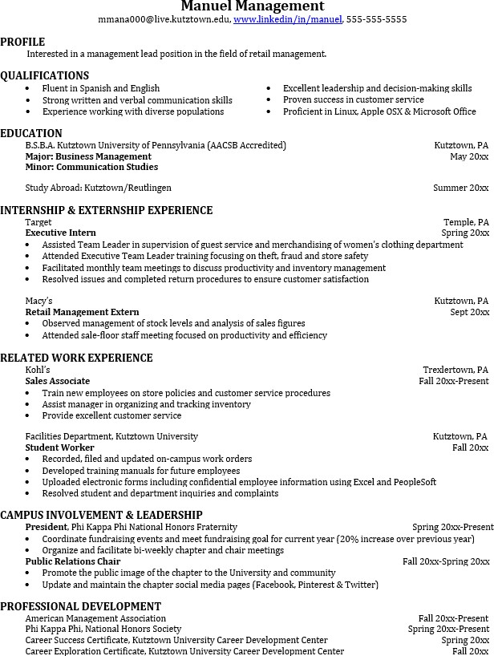
Take note of the skills and knowledge obtained through your educational background and hands-on
experiences.
Highlight transferable skills such as fluency and technological proficiencies.

Learn more about your field and develop the necessary skills for employment by gaining hands-on experience through externships, internships, part-time jobs and related volunteer positions.

Develop profession-ally through campus involvement and professional memberships.
This illustrates responsibility, leadership abilities and time management skills.

For More Information on Management Careers or to speak to a Career Counseling, contact KU Career Development Center 113 Stratton Administration Center * 610-683-4067 * careerhelp@kutztown.edu * www.kutztown.edu/careercenter

