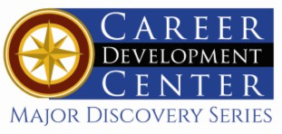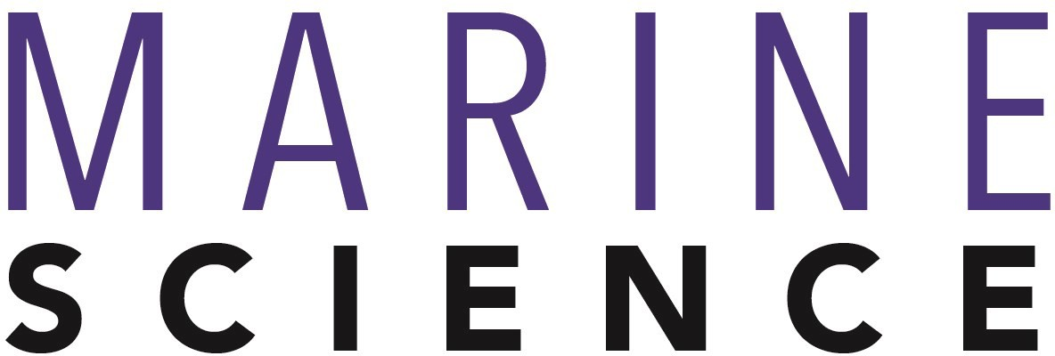

Bachelor of Science: Marine Science Concentrations: Marine Biology, Oceanography Minor: Marine Science

Marine science is a multidisciplinary approach to studying the nature of the oceans. Marine scientists must be expert at biology, chemistry, geology, and physics so they can see how the living creatures are affected by the chemistry of their environment and the physics of ocean circulation. The geology of the ocean floors affects the chemistry/physics/biology of the oceans, and geological phenomena record ancient oceanic conditions. A true marine scientist can synthesize concepts from all of these disciplines with this holistic approach to science.

The Marine Science degree at Kutztown University is designed to prepare students for life as a multidisciplinary scientist. Marine scientists are also simultaneously generalists and specialists. The Marine Science degree at Kutztown University offers a choice of two specializations called tracks: Oceanography Track for students who wish to primarily explore questions about the chemistry, physics, and geology of the oceans, and Biology Track for students who want to look at how marine life interacts with its environment.

Career types associated with Marine Science
(Is this a good fit for you? Are you a…)
- Investigative - “Thinker”
- Realistic - “Doer”
- Enterprising - “Leader”

Related skills, values, and qualities
- Proficiency in reading, writing, thinking, questioning,
analyzing and problem solving
- Ability to make critical observations and appropriate decisions
- Good manual dexterity and ability to operate scientific equipment
- Aptitude for accuracy and detail
- Ability to organize and maintain accurate records
- Ability to conduct and explain scientific research
- Ability to concentrate for long periods of time

Courses Marine Science majors typically enjoy
- Biology
- Chemistry
- Environmental Science
- Geology
- Geography
- Health
- Physics
- Zoology

Common interests of Marine Science majors
  - Attending science exhibits and visiting aquariums, nature centers, zoos or museums
  - Participating in science fairs and competitions
  - Conducting research and presenting at conference
  - Participating in science or conservation-related
clubs and organizations
  - Spending time near water and participating in outdoor activities
  - Reading science and environmental articles, blogs, magazines and books
For more information about the major Contact the Physical Sciences Department, 425 Boehm, 610-683-4447 or visit www.kutztown.edu/Marine Science

KU Majors related to Marine Science
Biology, Environmental Science, Geography, Geology

Investigative students may also be interested in: Anthropology, Biochemistry, Chemistry, Computer Science, Criminal Justice, Economics*, German Studies, History, International Studies*, Mathematics, Multicultural Studies*, PA German Studies*, Physics, Political Science, Psychology, Sec Edu- Math/Science, and Sociology
* minor only

For More Information on Marine Science careers or to speak to a Career Counselor, contact KU Career Development Center 113 Stratton Administration Center * 610-683-4067 * careerhelp@kutztown.edu * www.kutztown.edu/careercenter



- Enroll in the Career Exploration Certificate.
- Attend info sessions to learn about career development and personal branding.
- Take a career assessment to
identify and confirm interests.
- Get involved in campus clubs and organizations.
- Develop basic workplace skills through jobs or volunteer work.
- Talk with professors, family, and friends about career ideas.
- Conduct informational interviews with professionals working in fields of interest.
- Develop a relationship with your professors and faculty advisor.
- Meet with CDC career coach.
- Attend info sessions to learn about resume writing, and externships.
- Confirm your choice of major and consider options for double major or minor.
- Research careers of interest.
- Complete a job shadowing (externship) experience.
- Seek meaningful employ-ment or volunteer work in a field related to your major.
- Explore options for under-graduate research and study abroad.
- Write a resume and have it reviewed by the CDC.
- Manage your online presence.
- Enroll in the Career Success Certificate.
- Complete an internship and/or undergraduate research.
- Attend info sessions about internships, interviewing, job search strategies, and grad school.
- Build a LinkedIn profile and continue to monitor your online presence.
- Complete a mock interview.
- Build skills through research projects, part-time employment, and volunteer work.
- Participate in employer panels, site visits & networking events.
- Attend internship & job fairs.
- Take on a leadership role in a student organization or work.
- Consider graduate school options and prepare for admissions tests.
- Attend your Senior Kick-off and other info sessions to prepare for job search/grad school.
- Update your resume and LinkedIn profile.
- Create cover letter drafts.
- Gain experience through internships and/or undergraduate research.
- Secure references for job/grad school applications.
- Create your “30 second”
commercial/elevator speech.
- Meet with CDC to develop job search strategies.
- Research employers.
- Network with professionals through events and social media.
- Join a professional organization in your discipline.
- Attend the senior etiquette
luncheon or dinner.
- Participate in job fairs and on-campus interviewing.

Sample Career Titles
Marine Science majors can be found working in a wide variety of career fields. Here are just some career titles that may be of interest. Please note that some jobs may require further education and training.
To learn more about these careers, visit http://online.onetcenter.org or www.bls.gov/oco.

  - Agronomist
  - Animal Scientist
  - Aquaculture Farmer
  - Aquaculturist
  - Aquarium & Museum Worker
  - Aquatic Biologist
  - Barrier Beach Manager
  - Bio-Engineer
  - Bio-Technologist
  - Botanist
  - Chemical Oceanographer
  - Coastal Resources Worker
  - Commercial Fishing Engineer
  - Coroner
  - Ecologist
  - Environmental Engineer
  - Environmental Protection Worker
  - Ergonomist
  - Fish Hatchery Technician
  - Fish Processor
  - Fisheries Conservationist
  - Forester
  - Genetic Engineering
  - Geographer
  - Horticulturist
  - Hydrographic Survey Technician
  - Industrial Marine Economist
  - Limnological Technician
  - Marina Worker
  - Marine & Coastal Consultant
  - Marine Bacteriologist
  - Marine Biologist
  - Marine Ecologist
  - Marine Engineering Technician
  - Marine Geologist/Geophysicist/ Physicist
  - Marine Sales
  - Marine Tourist Worker
  - Marine/Fisheries Worker
  - Meteorologist
  - Microbiologist
  - Molecular Biologist
  - Mycologist
  - Naval Architect
  - Net Designer
  - Oceanographer
  - Parasitologist
  - Pharmaceutical Salesperson
  - Port & Harbor Facilities Worker
  - Science Illustrator/Writer/FilmMaker
  - Science Laboratory Technician
  - Science Teacher
  - Seafood Processor-Researcher
  - Soil Conservationist
  - Test & Inspection Technician
  - Toxicologist
  - Underwater Technician
  - Veterinarian
  - Water Quality Technician
  - Water Transportation Worker
  - Wildlife Biologist
  - Zoologist

Common Internship Sites and Employers
Marine Science majors often find internships and employment in the following fields/industries.

- Biomedicine & Pharmaceuticals
- Business and Industry
- Colleges/Universities
- Defense Contractors
- Local/State/Federal Government
- Marine Engineering
- Non-Profit Organizations
- Park Systems/Nature Preserves
- U.S. Coast Guard
- Zoos and Aquariums



Handshake is the primary online resource
for preparing and connecting students and alumni with employers.
www.kutztown.edu/handshake

Useful Websites for Marine Science Majors
Whether you are researching related career fields, applying for internships or jobs, or planning to join a professional association, these websites are for you!

Industry/Employment Information

American Institute of Biological Sciences www.aibs.org

Dolphin Research Center www.dolphins.org
Environmental Careers World Job Bank
www.environmentaljobs.com

Marine Careers www.marinecareers.net

New Scientist Jobs www.newscientistjobs.com
Science Careers http://sciencemag.org
Association of Zoos and Aquariums www.aza.org

American Geophysical Union www.agu.org

LinkedIn Jobs www.linkedin.com/jobs

Professional Associations
American Society of Limnology and Oceanography
http://aslo.org
Association for Environmental Studies and Sciences
www.aess.info
International Marine Animal Trainers’
Association www.imata.org
National Association of Environmental Professionals
www.naep.org

National Marine Educators Association www.marine-ed.org
National Oceanic and Atmospheric Association
www.noaa.gov
North American Association for Environmental Education www.naaee.org

The Oceanography Society www.tos.org
The Society for Ocean Sciences www.societyoceansciences.org

Related Area Employers

Adventure Aquarium Baltimore Aquarium Calvert Marine Museum
Chincoteague Bay Field Station Institute of Marine Mammal Studies Lehigh Valley Zoo
Li'l - Le - Hi Trout Nursery
New Logic Marine Science Camp MATE
MERR Institute
New York Aquarium
VA Dept of Game & Inland Fisheries
The Washington Center Wildlands Conservatory ZooAmerica

Building Your Resume for a Career in Marine Science

Building a strong resume for your career field starts long before you ever start your job search. Employers want to hire graduates who not only have the necessary educational background but also have experience applying that knowledge.

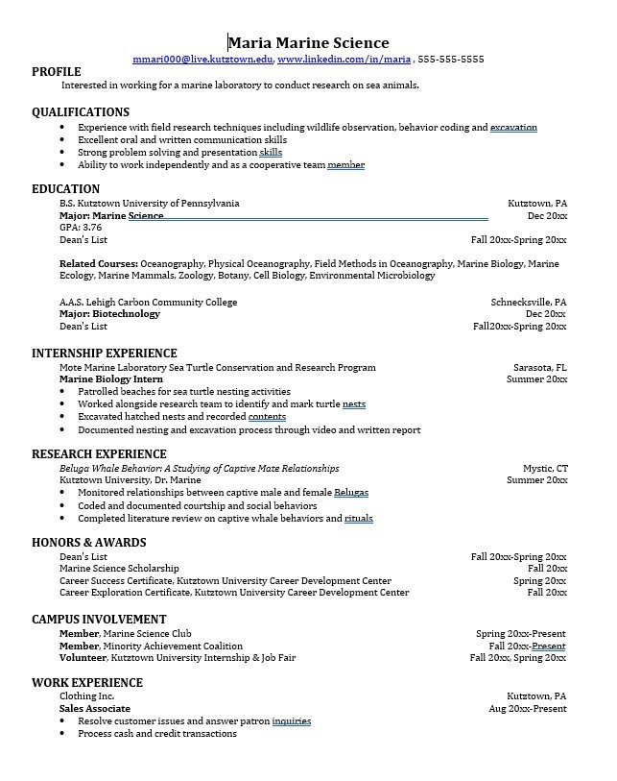
Learn more about your field and develop the necessary skills for employment by gaining hands-on experience through internships.

Utilize summer breaks to acquire valuable experience via volunteer or employment opportunities related to your major.

Develop professionally through campus involvement and professional memberships.
This illustrates responsibility, leadership abilities and time management skills.

For More Information on Marine Science careers or to speak to a Career Counselor, contact KU Career Development Center 113 Stratton Administration Center * 610-683-4067 * careerhelp@kutztown.edu * www.kutztown.edu/careercenter

