

Bachelor of Science: Mathematics Minor: Mathematics

Mathematics is the study of quantitative relationships expressed in numbers and symbols. Mathematics majors develop the ability to explore, conjecture, reason logically, and use mathematical methods to solve problems.

The Bachelor of Science in Mathematics is ideal for students who wish to pursue graduate study in mathematics or prepare for careers in mathematics or mathematically-related areas such as operations research, statistics, actuarial science, physical sciences, and computer sciences. Employers recommend one or more internships to be successful and competitive when entering this field.

Career types associated with Mathematics
(Is this a good fit for you? Are you a…)
- Investigative - “Thinker”
- Realistic - “Doer”
- Enterprising - “Leader”

Related skills, values, and qualities
- Ability to make appropriate decisions and solve
quantitative problems
- Ability to concentrate for long periods of time
- Proficiency in reading, writing, thinking, questioning, analyzing and problem solving
- Ability to understand concrete & abstract mathematical concepts
- Aptitude for accuracy and detail
- Ability to organize, analyze & interpret numerical data
- Proficiency with a scientific calculator and computers
- Aptitude for accuracy and detail
- Ability to conduct and explain scientific research

Courses Mathematics majors typically enjoy
  - Accounting
  - Computer Programming
  - Mathematics (Algebra/Trigonometry/Calculus)
  - Physics
  - Statistics

Common interests of Mathematics majors
  - Completing puzzles or playing games of strategy
  - Solving logic problems
  - Participating in quiz bowls and other competitions
  - Serving as treasurer or statistician for an organization
  - Participating in math, science, or investment clubs
  - Reading computer publications

For more information about the major
Contact the Mathematics Department, 227 Lytle, 610-683-4410, or visit www.kutztown.edu/Mathematics

KU Majors related to Mathematics Accounting, Computer Science, Finance, Physics, Secondary Education-Mathematics

Investigative students may also be interested in: Anthropology, Biology, Biochemistry, Chemistry, Criminal Justice, Economics*, Environmental Science, Geography, Geology, German Studies, History, International Studies*, Marine Science, Multicultural Studies*, PA German Studies*, Political Science, Psychology, Sociology, and Spanish
* minor only

For More Information on Mathematics careers or to speak to a Career Counselor, contact KU Career Development Center 113 Stratton Administration Center * 610-683-4067 * careerhelp@kutztown.edu * www.kutztown.edu/careercenter

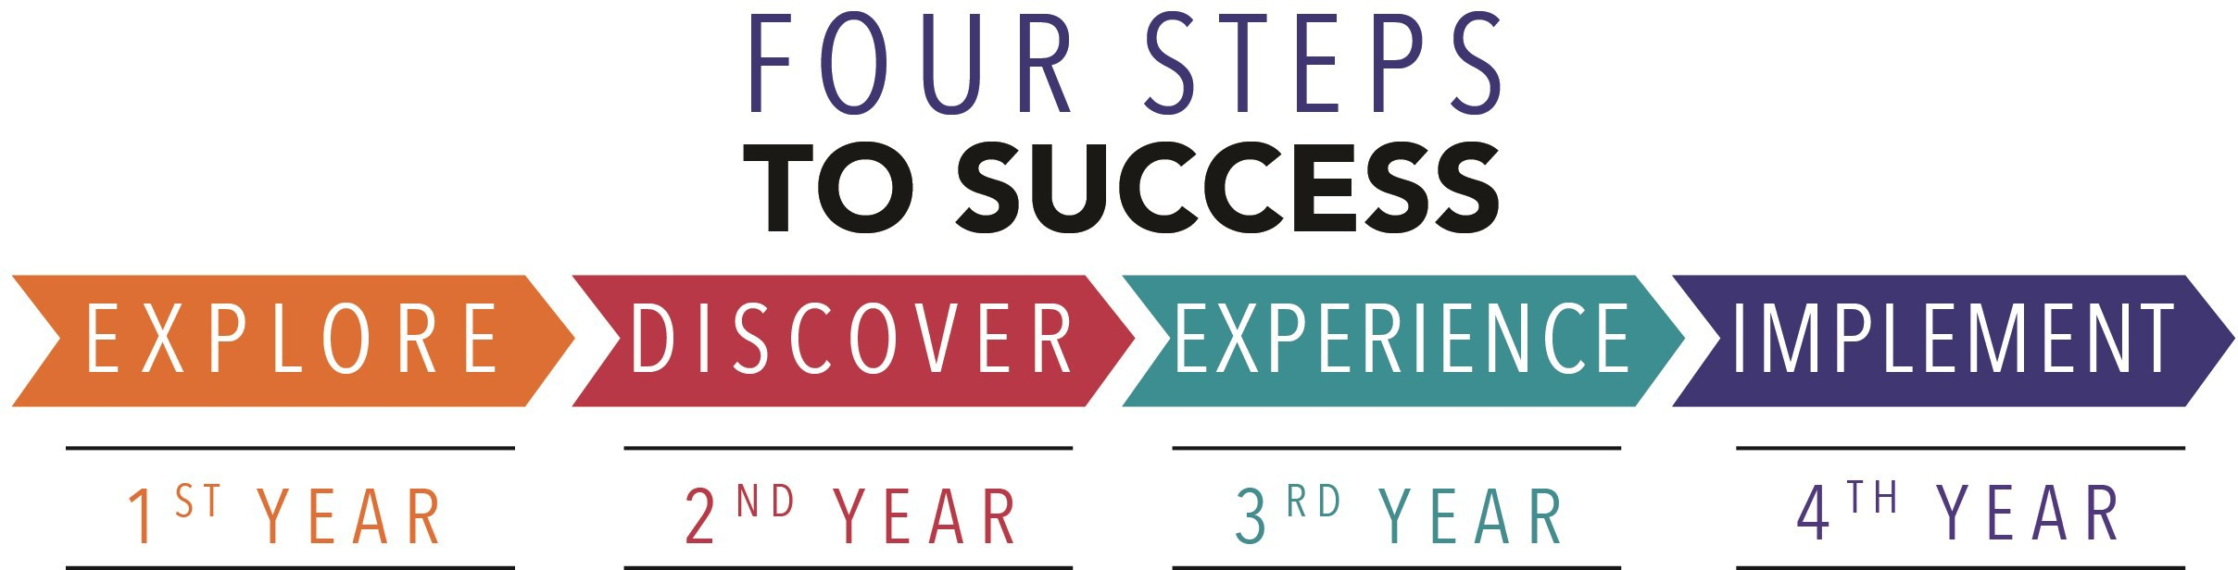

  - Enroll in the Career Exploration Certificate.
  - Attend info sessions to learn about career development and personal branding.
  - Take a career assessment to
identify and confirm interests.
  - Get involved in campus clubs and organizations.
  - Develop basic workplace skills through jobs or volunteer work.
  - Talk with professors, family, and friends about career ideas.
  - Conduct informational interviews with professionals working in fields of interest.
  - Develop a relationship with your professors and faculty advisor.
- Meet with CDC career coach.
- Attend info sessions to learn about resume writing, and externships.
- Confirm your choice of major and consider options for double major or minor.
- Research careers of interest.
- Complete a job shadowing (externship) experience.
- Seek meaningful employ-ment or volunteer work in a field related to your major.
- Explore options for under-graduate research and study abroad.
- Write a resume and have it reviewed by the CDC.
- Manage your online presence.
- Enroll in the Career Success Certificate.
- Complete an internship and/or undergraduate research.
- Attend info sessions about internships, interviewing, job search strategies, and grad school.
- Build a LinkedIn profile and continue to monitor your online presence.
- Complete a mock interview.
- Build skills through research projects, part-time employment, and volunteer work.
- Participate in employer panels, site visits & networking events.
- Attend internship & job fairs.
- Take on a leadership role in a student organization or work.
- Consider graduate school options and prepare for admissions tests.
- Attend your Senior Kick-off and other info sessions to prepare for job search/grad school.
- Update your resume and LinkedIn profile.
- Create cover letter drafts.
- Gain experience through internships and/or undergraduate research.
- Secure references for job/grad school applications.
- Create your “30 second”
commercial/elevator pitch.
- Meet with CDC to develop job search strategies.
- Research employers.
- Network with professionals through events and social media.
- Join a professional organization in your discipline.
- Attend the senior etiquette
luncheon or dinner.
- Participate in job fairs and on-campus interviewing.

Sample Career Titles
Mathematics majors can be found working in a wide variety of career fields. Here are just some career titles that may be of interest. Please note that some jobs may require further education and training.
To learn more about these careers, visit http://online.onetcenter.org or www.bls.gov/oco.

  - Accountant
  - Actuary
  - Aerospace Engineer
  - Air Traffic Controller
  - Analyst
  - Applications Programmer
  - Applied Science Technologist
  - Appraiser
  - Architect
  - Artificial Intelligence Programmer
  - Astronomer
  - Banking/Credit/Investment Manager
  - Biometrician/Biostatistician
  - Cartographer
  - Commodity Manager
  - Compensation/Benefits Administrator
  - Computer Engineer
  - Computer Facilities Manager
  - Computer Marketing/Sales
  - Computer Programmer
  - Consumer Loan/Credit Officer
  - Credit Manager
  - Cryptographer/Cryptologist
  - Data Control Administrator
  - Data Processing Manager
  - Database Manager
  - Demographer
  - Econometrician
  - Economist
  - Educator
  - Engineer
  - Engineering Lab Technician
  - Environmental Technologist
  - Estate Planner
  - External Auditor
  - Financial Auditor
  - Financial Consultant/Manager
  - Geologist
  - Hydrologist
  - Information Scientist
    - Inventory Control Specialist
    - Investment Banker
    - Market Research Analyst
    - Mathematician
    - Metallurgist
    - Meteorologist
    - Mortgage Researcher
    - Nuclear Scientist
    - Operations Research Analyst
    - Pharmacologist
    - Physicist
    - Production Manager
    - Psychometrician
    - Public Health Statistician
    - Purchasing/Contract Agent
    - Quality Assurance Analyst
    - Rate & Risk Analyst
    - Risk & Insurance Specialist
    - Satellite Communications Specialist
    - Software Development Specialist

Common Internship Sites and Employers
Mathematics majors often find internships and employment in the following fields/industries.

- Aerospace Development
- Banks & Investment Firms
- Business & Industry
- Colleges/Universities
- Engineering Firms
- Insurance Agencies
- Medical Field
- Public & Private Schools
- Research & Development Firms
- State/Federal Government
- Technical Publication Companies
- Utility Companies



Handshake is the primary online resource
for preparing and connecting students and alumni with employers.
www.kutztown.edu/handshake

Useful Websites for Mathematics Majors
Whether you are researching related career fields, applying for internships or jobs, or planning to join a professional association, these websites are for you!

Industry/Employment Information

Be an Actuary www.beanactuary.org
Careers in Federal Government www.makingthedifference.org

Careers in Math
www.coolmath.com/careers.htm

Careers in Applied Mathematics www.siam.org/careers/thinking.php

DICE
www.dice.com

Math Jobs www.math-jobs.com
Sloan Career Cornerstone Center www.careercornerstone.org
TechnoCentral www.technocentral.com

We Use Math in Careers www.weusemath.org

Professional Associations

American Mathematical Society www.ams.org

American Statistical Association www.amstat.org

Association for Women in
Mathematics www.awm-math.org

Mathematical Association of America www.maa.org
Society of Actuaries www.soa.org
Society for Industrial & Applied Mathematics www.siam.org

Society of Mathematical Biology www.smb.org

Related Area Employers
Chatham Financial Clark Associates, Inc. NFI Industries
Northwestern Mutual - Eastern PA PLS Logistics Services
PPL Electric Utilities
State Farm-Shawn Leh Agency
TD Bank
Vanguard

Building Your Resume for a Career in Mathematics

Develop professionally through campus involvement and professional memberships.
This illustrates responsibility, leadership abilities and time management skills.
Utilize summer breaks to acquire valuable experience via volunteer or employment opportunities related to your major.

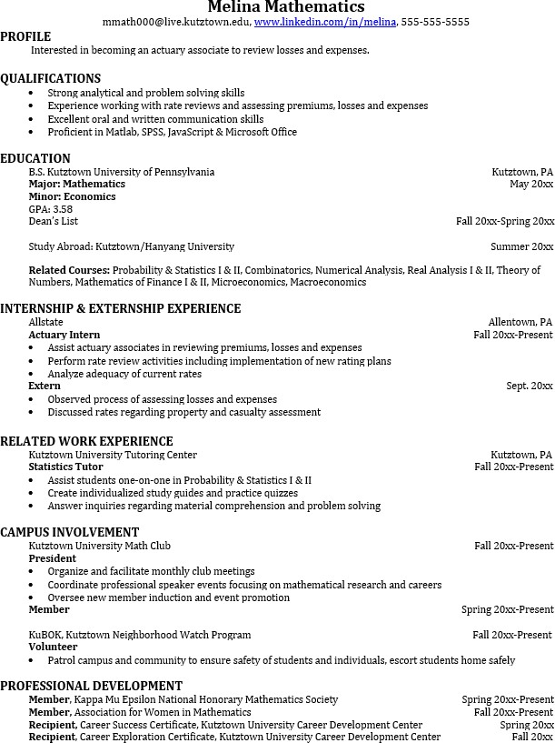
Building a strong resume for your career field starts long before you ever start your job search. Employers want to hire graduates who not only have the necessary educational background but also have experience applying that knowledge.
Learn more about your field and develop the necessary skills for employment by gaining hands-on experience through internships.

For More Information on Mathematics careers or to speak to a Career Counselor, contact KU Career Development Center 113 Stratton Administration Center * 610-683-4067 * careerhelp@kutztown.edu * www.kutztown.edu/careercenter

