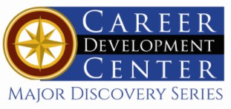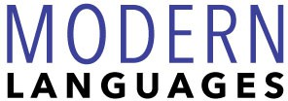

Bachelor of Arts: German Studies: Communication and Culture Bachelor of Arts: Spanish
Minors: Pennsylvania German Studies, Spanish for Modern Business

As a Modern Language major you will learn and use cross-cultural communication skills, develop a deeper appreciation for people from different cultures, experience the artistic, literary, socio-political and historical contributions of the culture, improve skills in your native language, and understand more fully your place on a global scale. Employers recommend one or more internships to be successful and competitive when entering this field.

Career types associated with Modern Languages
(Is this a good fit for you? Are you a…)
- Artistic - “Creator”
- Investigative - “Thinker”
- Enterprising - “Persuader”

Skills associated with the Modern Languages
majors
- Communicating across cultures
- Analyzing information, cultures, and complex problems
- Offering diverse perspectives and creative solutions
- Assessing cultural differences

Related courses Modern Languages majors
typically enjoy
- Anthropology
- English
- History
- Humanities
- Sociology
- Speech
- Writing

Common interests of Modern Languages majors
- Attending movies, plays, lectures, or readings
- Participating student exchanges, or pen pal experiences
- Conversing with others
- Participating in a book club or language club
- Reading essays, articles, novels, short stories, plays,
poetry, and professional journals
- Visiting libraries
- Working part-time or as a volunteer for the Red Cross, VISTA, or Peace Corps
- Traveling

For more information about this major
Contact the Department of Society, History & Culture 2 Old Main or visit www.kutztown.edu/ ModernLanguages
What do KU Graduates say about this major? "My decision to study languages has given me the opportunity to open doors that previously would have been closed to me. Now I can get to know people who don't speak my native language, and access their personal histories, points of view, and experiences. This allows me to network and open up career opportunities both in the United States and across the globe. I have used my education to live and work in Berlin for the past 5 years and would recommend learning modern languages to all with wanderlust in their hearts. The possibilities are endless."

For More Information on Modern Languages careers or to speak to a Career Counselor, contact KU Career Development Center 113 Stratton Administration Center * 610-683-4067 * careerhelp@kutztown.edu * www.kutztown.edu/careercenter



- Enroll in the Career Exploration Certificate.
- Attend info sessions to learn about career development and personal branding.
- Take a career assessment to
identify and confirm interests.
- Get involved in campus clubs and organizations.
- Develop basic workplace skills through jobs or volunteer work.
- Talk with professors, family, and friends about career ideas.
- Conduct informational interviews with professionals working in fields of interest.
- Develop a relationship with your professors and faculty advisor.
- Meet with CDC career coach.
- Attend info sessions to learn about resume writing, and externships.
- Confirm your choice of major and consider options for double major or minor.
- Research careers of interest.
- Complete a job shadowing (externship) experience.
- Seek meaningful employ-ment or volunteer work in a field related to your major.
- Explore options for under-graduate research and study abroad.
- Write a resume and have it reviewed by the CDC.
- Manage your online presence.
- Enroll in the Career Success Certificate.
- Complete an internship and/or undergraduate research.
- Attend info sessions about internships, interviewing, job search strategies, and grad school.
- Build a LinkedIn profile and continue to monitor your online presence.
- Complete a mock interview.
- Build skills through research projects, part-time employment, and volunteer work.
- Participate in employers panels, site visits & networking events.
- Attend internship & job fairs.
- Take on a leadership role in a student organization or work.
- Consider graduate school
options and prepare for
- Attend your Senior Kick-off and other info sessions to prepare for job search/grad school.
- Update your resume and LinkedIn profile.
- Create cover letter drafts.
- Gain experience through internships and/or undergraduate research.
- Secure references for job/grad school applications.
- Create your “30 second”
commercial/elevator pitch.
- Meet with CDC to develop job search strategies.
- Research employers.
- Network with professionals through events and social media.
- Join a professional organization in your discipline.
- Attend the senior etiquette
luncheon or dinner.
- Participate in job fairs and on-campus interviewing.

Sample Career Titles
Modern Languages majors can be found working in a wide variety of career fields. Here are just some career titles that may be of interest. Please note that some jobs may require further education and training.
To learn more about these careers, visit http://online.onetcenter.org or www.bls.gov/oco.

  - Anthropologist
  - Archivist
  - Art Dealer
  - Bilingual Educator
  - Bilingual Officers/Clerks/Tellers
  - Buyer
  - CIA Agent
  - Civil Service Employee
  - Commercial Loan Officer
  - Copy Editor/Proofreader/Writer
  - Court Interpreter
  - Cultural Officer
  - Customs Inspector
  - Customs/Immigration Officer
  - Diplomat
  - Drug Enforcement Agent
  - FBI Agent
  - Foreign Correspondent
  - Foreign Diplomat
  - Foreign Exchange Trader
  - Foreign Service Officer
  - Historian
  - Hotel Manager
  - Human Resources Director
  - Importer/Exporter
  - Intelligence Researcher
  - International Account Manager
  - International Banking Officer
  - International Conference Planner
  - International Consultant
  - International Trade Economist
  - Interpreter
  - Lexicographer
  - Linguist
  - Localization Project Coordinator
  - Museum Curator
  - National Security Agent
  - Negotiator
  - Overseas Personnel/Plant Mgr.
  - Peace Corps/Vista Worker
  - Pharmaceutical Representative
  - Politician
  - Producer
  - Professor
  - Public Health Administrator
  - Quality Control Supervisor
  - Radio/TV Announcer
  - Reporter
  - Salesperson
  - Scientific Linguist
  - Scientific Translator/Interpreter
  - Social Worker
  - Teacher
  - TESO/ESL Teacher
  - Textbook Publisher
  - Translation/scription Project Coord.
  - Transport Equipment Manager
  - Travel Agent/Tour Organizer

Common Internship Sites and Employers
Applied Digital Arts majors often find internships and employment in the following fields/industries.

  - Schools
  - Media
  - State/Federal Government
  - Museums
  - Colleges/Universities
  - Business & Banks
    - Airlines
    - Hotels
    - Travel/Tourism Agencies



Handshake is the primary online resource
for preparing and connecting students and alumni with employers.
www.kutztown.edu/handshake

Useful Websites for Modern Languages Majors
Whether you are researching related career fields, applying for internships or jobs, or planning to join a professional association, these websites are for you!

Industry/Employment Information
The Electronic Embassy www.embassy.org
O*NET OnLine http://online.onetcenter.org
Internships.com www.internships.com
Occupational Outlook Handbook www.bls.gov/ooh
Federal Employment Site www.usajobs.gov
United Nations www.un.org

Bilingual Jobs - Bilingual Professionals www.bilingual-jobs.com

American Council on the Teaching & Career Seekers of Foreign Languages www.actfl.org
Teachers of English to Speakers of Other Languages (TESOL) www.tesol.org

Department of State (Student Programs and Internships) www.state.gov

Professional Organizations
Modern Language Association www.mla.org

American Council on Teaching of Foreign Languages www.actfl.org

American Asso. of Teachers of Spanish & Portuguese www.aatsp.org

National Association for Bilingual Education
www.nabe.org
American Association of Teachers of German
www.aatg.org
Association for French Language Studies
www.afls.net

American Translators Association www.atanet.org

Related Area Employers
ArtsQuest
Boydell & Brewer Camden House DaVinci Science Center
Easton Area Public Library
CIEE-Council on International Educational
Exchange
FCI - The Language Experts German American Chamber of
Commerce in New York City German American Chamber of
Commerce in Philadelphia German Society of Philadelphia Lehigh County Historical Society
JR Language Translation Services Pennsylvania German Cultural
Heritage Center Valley Youth House

Building Your Resume for a Career in Modern Languages

Develop professionally through campus involvement and professional memberships.
This illustrates responsibility, leadership abilities and time management skills.
Utilize summer breaks to acquire valuable experience via volunteer or employment opportunities related to your major.

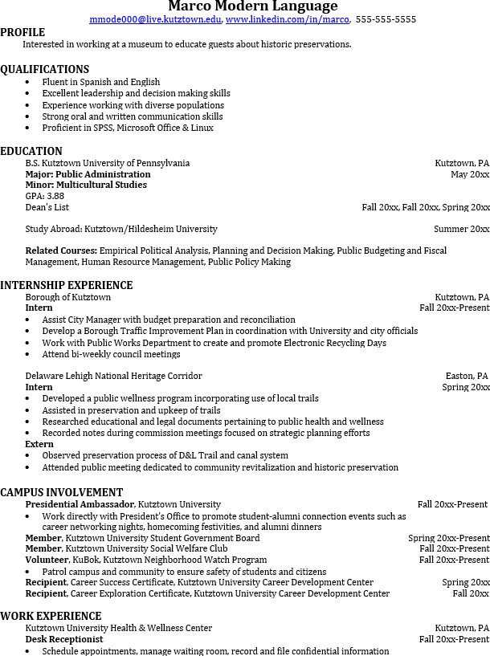
Building a strong resume for your career field starts long before you ever start your job search. Employers want to hire graduates who not only have the necessary educational background but also have experience applying that knowledge.
Learn more about your field and develop the necessary skills for employment by gaining hands-on experience through internships.

For More Information on Modern Languages careers or to speak to a Career Counselor, contact KU Career Development Center 113 Stratton Administration Center * 610-683-4067 * careerhelp@kutztown.edu * www.kutztown.edu/careercenter

