
Bachelor of Arts: Music
Bachelor of Arts: Music: Commercial Music Bachelor of Arts: Music: Performance Bachelor of Arts: Music Business
Minor: Music, Jazz, Music History, Audio Engineering, Musical Theater

Music is a phenomenon common to all societies, a richly diverse experience that is used in many ways. Music can be a form of communication, artistic expression, entertainment, therapy and worship.
As a music major, you will study music from various perspectives including historical, theoretical, pedagogical and performance. You will develop listening skills, critical thinking, and an awareness of aesthetic principles and contemporary technology. Graduates find employment in a wide variety of musical or musically related fields such as private tutoring, performing, music retailing, publishing, entertainment or music librarianship (some occupations require graduate study). Employers recommend one or more internships to be successful and competitive when entering this field.

Career types associated with Music
(Is this a good fit for you? Are you a…)
- Artistic - “Creator”
- Enterprising - “Persuader”
- Social - “Helper”

Related skills, values, and qualities
- Ability to speak articulately, listen introspectively, and make keen observations
- Ability to think creatively
- Self-discipline and perseverance
- Capacity for memorization and concentration
- Ability to meet deadlines
- Ability to withstand close scrutiny and criticism
- High degree of commitment to field of study.
- Ability to compete in a changing market that is exciting and highly competitive

Courses Music majors typically enjoy
- Arts
- Band, Orchestra, Choir
- Dance
- Debate
- Public Speaking
- Speech
- Theater

Common interests of Music majors
- Attending plays, concerts, lectures, and movies
- Participating in theater, choir, glee club, marching band, orchestra, and/or other musical groups
- Working part-time or as a volunteer for a radio/ TV station, theatre arts or communications department
- Participating in a talent or variety show, skit or play
- Joining the student council or a debate team
- Reading publications related to the performing arts

For more information about the major
Contact the Music Department, 114 Old Main, 610-683-4550,
or visit www.kutztown.edu/Music

KU Majors related to Music
Music Education, Cinema, Television and Media Production, Computer Science, Mathematics,

Artistic students may also be interested in: Advertising*, Communication Design, Elementary Education, English, German, International Studies*, Library Science, Literature*, Music Education, PA German Studies*, Philosophy, Professional Writing, Public Relations*, Secondary Education (English or Modern Languages), Spanish, Speech Communication, or Studio Art.
*minor only

For More Information on Music careers or to speak to a Career Counselor, contact KU Career Development Center 113 Stratton Administration Center * 610-683-4067 * careerhelp@kutztown.edu * www.kutztown.edu/careercenter



- Enroll in the Career Exploration Certificate.
- Attend info sessions to learn about career development and personal branding.
- Take a career assessment to
identify and confirm interests.
- Get involved in campus clubs and organizations.
- Develop basic workplace skills through jobs or volunteer work.
- Talk with professors, family, and friends about career ideas.
- Conduct informational interviews with professionals working in fields of interest.
- Develop a relationship with your professors and faculty advisor.
- Meet with CDC career coach.
- Attend info sessions to learn about resume writing, and externships.
- Confirm your choice of major and consider options for double major or minor.
- Research careers of interest.
- Complete a job shadowing (externship) experience.
- Seek meaningful employ-ment or volunteer work in a field related to your major.
- Explore options for under-graduate research and study abroad.
- Write a resume and have it reviewed by the CDC.
- Manage your online presence.
- Enroll in the Career Success Certificate.
- Complete an internship and/or undergraduate research.
- Attend info sessions about internships, interviewing, job search strategies, and grad school.
- Build a LinkedIn profile and continue to monitor your online presence.
- Complete a mock interview.
- Build skills through research projects, part-time employment, and volunteer work.
- Participate in employer panels, site visits & networking events.
- Attend internship & job fairs.
- Take on a leadership role in a student organization or work.
- Consider graduate school options and prepare for admissions tests.
- Attend your Senior Kick-off and other info sessions to prepare for job search/grad school.
- Update your resume and LinkedIn profile.
- Create cover letter drafts.
- Gain experience through internships and/or undergraduate research.
- Secure references for job/grad school applications.
- Create your “30 second”
commercial/elevator pitch.
- Meet with CDC to develop job search strategies.
- Research employers.
- Network with professionals through events and social media.
- Join a professional organization in your discipline.
- Attend the senior etiquette or luncheon dinner.

Sample Career Titles
Music majors can be found working in a wide variety of career fields. Here are just some career titles that may be of interest. Please note that some jobs may require further education and training.

  - Architectural Acoustic Monitor
  - Armed Forces Band Member
  - Artist & Repertoire (A&R) Person
  - Arts Administrator/Manager
  - Community Development Specialist
  - Community/Public Svc Administrator
  - Composer/Arranger
  - Conductor
  - Copyright Specialist
  - Copywriter
  - Cruise Social Director
  - Disc Jockey
  - Editor
  - Educator
  - Engineer/Mixer
  - Film Music Editor
  - Instrument Service Specialist
  - Journalist
  - Music Attorney
  - Music Copyist
  - Music Critic
  - Music Director
  - Music Librarian
  - Music Promoter
  - Music Publishing Specialist
  - Music Reporter
  - Music Software Programmer
  - Music Store Manager
  - Music Stringer
  - Music Teacher
  - Music Therapist
  - Musician
  - Narrator
  - Orchestra Librarian
  - Piano Tuner
  - Professional Entertainer
  - Public Relations Specialist
    - Publicist
    - Recording Engineer
    - Recording Technician
    - Recreation Director
    - Religion Music Director
    - Royalties Broadcast Monitor
    - Sales Representative
    - Singer
    - Sound Technician
    - Studio Musician
    - Synthesizer Specialist
    - Technical Writer
    - Theatre Performer
    - Tour Manager
    - Union Contractor
    - Voice Teacher

To learn more about these careers, visit http://online.onetcenter.org or www.bls.gov/oco

Common Internship Sites and Employers
Music majors often find internships and employment in the following fields/industries.

      - Public, Private, and International Schools
      - State and Federal Government Youth Services
      - Theater/Performing Groups
      - Children’s Music Programs
      - Council for the Arts
      - Radio/TV
      - Colleges and Universities
      - Community Centers/Non-Profit Organizations
      - Business and Industry
      - Magazines/Newspapers
      - Music Publishing Companies



Handshake is the primary online resource
for preparing and connecting students and alumni with employers.
www.kutztown.edu/handshake

Useful Websites for Music Majors
Whether you are researching related career fields, applying for internships or jobs, or planning to join a professional association, these websites are for you!

Industry/Employment Information
National Endowment for the Arts
www.arts.gov
Solo Performer www.soloperformer.com

Musical Chairs www.musicalchairs.info

Professional Associations

National Art Education Association www.arteducators.org

Association of Arts Admin. Educators http://artsadministration.org

American Music Conference
www.american-music.org

American Federation of Musicians www.afm.org

American Music Therapy Assoc. www.musictherapy.org

The Film Music Society www.filmmusicsociety.org

National Association of Music Merchants www.namm.org

American Musicology Society www.amsmusicology.org
Job/Internship Search Boards
Entertainment Careers
www.entertainmentcareers.net
The National Assoc. of Music Edu. www.nafme.org

LinkedIn Jobs www.linkedin.com/jobs

Production Hub www.productionhub.com/jobs

NYC Production Companies www.nyc.gov/site/mome/industries/production
-companies.page
Related Area Employers

Appel Farm Arts & Music Center
ArtsQuest
Hershey Entertainment & Resorts Kutztown University Music Department Music Choice
Reading Samba School Reda Films
Rock Lititz

Building Your Resume for a Career in Music

Develop professionally through campus involvement and professional memberships.
This illustrates responsibility, leadership abilities and time management skills.
Utilize summer breaks to acquire valuable experience via volunteer or employment opportunities related to your major.

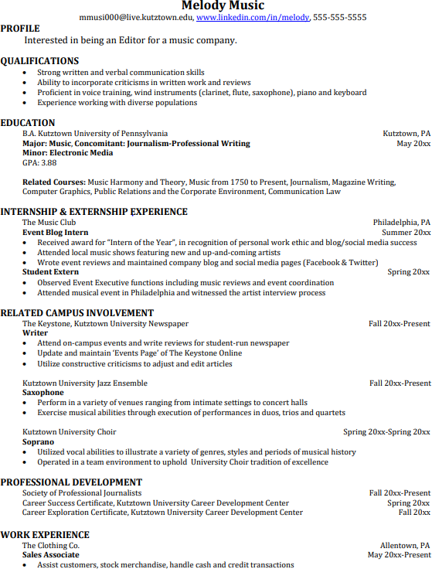
Building a strong resume for your career field starts long before you ever start your job search. Employers want to hire graduates who not only have the necessary educational background but also have experience applying that knowledge.
Learn more about your field and develop the necessary skills for employment by gaining hands-on experience through internships.

For More Information on Music careers or to speak to a Career Counselor, contact KU Career Development Center 113 Stratton Administration Center * 610-683-4067 * careerhelp@kutztown.edu * www.kutztown.edu/careercenter

