Bachelor of Science in Business Administration: Personal Financial Planning
Students completing the Personal Financial Planning (PFP) program are prepared to enter the personal financial planning profession in many different areas. They might go to work for firms that offer comprehensive financial planning services. They can also specialize in an area such as insurance and risk management, retirement planning, estate planning, private banking, mutual funds, or employee benefits. The PFP program at Kutztown University of Pennsylvania is registered with the Certified Financial Planner Board of Standards Inc. (CFP® Board).
The CFP® Board is a professional regulatory organization that fosters professional standards in personal financial planning. The Certified Financial Planner (CFP®) designation is recognized worldwide as a mark of distinction that sets individuals apart from others in the profession. The four requirements for initial certification are: Education, Examination, Experience, and Ethics. Kutztown University’s PFP program prepares students to earn the CFP® designation via a track that emphases all four of these areas. Graduates the PFP program meet the education requirement upon graduation.

Career types associated with PFP
(Is this a good fit for you? Are you a…)
- Conventional - “ Organizer”
- Enterprising - “Persuader”
- Investigative - “Thinker”

Related skills, values, and qualities
Related skills, values and qualities
- Strong quantitative and problem-solving skills
- Aptitude for accuracy and detail
- Ability to organize, analyze or interpret data
- Excellent interpersonal skills and proficiency in written and oral communications
- Strong organizational skills and ability to adapt to change
- Sense of confidence and ability to present oneself in a professional manner
- Ability to work in a team environment

Recommended elective courses include, but are not
limited to:
COM 105 - Business and Professional Presentations COM 121 - Introduction to Listening
COM 130 - Interpersonal Communication COM 201 - Storytelling I
MKT 330CM - Personal Selling
WRI 207WICT - Writing for the Workplace

Common interests of PFP majors
- Participating in investment activities (real or virtual)
- Working part-time in a bank, saving and loan, or credit union
- Serving as a treasurer for an organization
- Solving problems using analytical and logical processes
- Joining finance-related organizations such as the American Bankers Association
- Attending finance-related lectures, trade shows, or
conventions

For more information about the major:
Jonathan Kramer, Ph.D., CFP®
Professor of Finance & Program Director, PFP Program 226 deFrancesco Building
jkramer@kutztown.edu

KU Majors related to PFP
Accounting, Finance, Management.
Enterprising students may also be interested in: Advertising*, Communication Design, Communication Studies, Criminal Justice, Economics*, Education, English-Professional Writing, Environmental Science, History, International Studies*, Sport Management, Literature*, Marketing, Multicultural Studies*, Political Science, Psychology, Public Administration, Public
Relations*, Social Work, Women’s Studies*
*minor only




For More Information on PFP Careers or to speak to a Career Counseling, contact KU Career Development Center 113 Stratton Administration Center * 610-683-4067 * careerhelp@kutztown.edu * www.kutztown.edu/careercenter



  - Enroll in the Career Exploration Certificate.
  - Attend info sessions to learn about career development and personal branding.
  - Take a career assessment to
identify and confirm interests.
  - Get involved in campus clubs and organizations.
  - Develop basic workplace skills through jobs or volunteer work.
  - Talk with professors, family, and friends about career ideas.
  - Conduct informational interviews with professionals working in fields of interest.
  - Develop a relationship with your professors and faculty advisor.
- Meet with CDC career coach.
- Attend info sessions to learn about resume writing, and externships.
- Confirm your choice of major and consider options for double major or minor.
- Research careers of interest.
- Complete a job shadowing (externship) experience.
- Seek meaningful employ-ment or volunteer work in a field related to your major.
- Explore options for under-graduate research and study abroad.
- Write a resume and have it reviewed by the CDC.
- Manage your online presence.
- Enroll in the Career Success Certificate.
- Complete an internship and/or undergraduate research.
- Attend info sessions about internships, interviewing, job search strategies, and grad school.
- Build a LinkedIn profile and continue to monitor your online presence.
- Complete a mock interview.
- Build skills through research projects, part-time employment, and volunteer work.
- Participate in employer panels, site visits & networking events.
- Attend internship & job fairs.
- Take on a leadership role in a student organization or work.
- Consider graduate school options and prepare for admissions tests.
- Attend your Senior Kick-off and other info sessions to prepare for job search/grad school.
- Update your resume and LinkedIn profile.
- Create cover letter drafts.
- Gain experience through internships and/or undergraduate research.
- Secure references for job/grad school applications.
- Create your “30 second”
commercial/elevator pitch.
- Meet with CDC to develop job search strategies.
- Research employers.
- Network with professionals through events and social media.
- Join a professional organization in your discipline.
- Attend the senior etiquette
luncheon or dinner.
- Participate in job fairs and on-campus interviewing.

Sample Career Titles
PFP majors can be found working in a wide variety of career fields. Here are just some career titles that may
be of interest. Please note that some jobs may require further education and training. To learn more about these careers, visit http://online.onetcenter.org or www.bls.gov/oco

  - Account Executive
  - Actuary
  - Appraiser/Assessor
  - Audit Manager
  - Bank Economist
  - Bank Manager
  - Budget Analyst
  - Business Analyst
  - Business Loan Administrator
  - Business Manager
  - Chief Executive Officer
  - Chief Financial Officer
  - Claim Adjuster/Examiner
  - Commodities Trader
  - Consumer Loan Officer
  - Controller
  - Credit Counselor
  - Credit Manager
  - Estimator
  - External Auditor
  - Financial Aid Officer
  - Finance Writer
  - Financial Analyst
  - Financial Consultant
  - Financial Planner
  - Foreign Exchange Trader
  - Government Official
  - Industrial/Institutional Buyer
  - Insurance Agent/Broker
  - Internal Auditor
  - International Banking Officer
  - International Trade Specialist
  - Investment Banker
  - Market Research Analyst
  - Mergers Manager
  - Mutual Fund Manager
  - Mutual Fund Trader
  - Payroll Administrator
  - Portfolio Analyst
  - Property Manager
  - Purchasing Agent
  - Rate Analyst
  - Real Estate Developer
  - Sales Analyst
  - Securities Analyst/Broker
  - Statistician
  - Stockbroker
  - Systems Analyst
  - Treasurer
  - Treasury Management

Common Internship Sites and Employers
Personal Financial Planning majors often find internships and employment in the following industries:

    - Accounting Firms
    - Banks
    - Business & Industry
    - College/Universities
    - Insurance Companies
    - Non-profit organizations
    - Private Practice
    - State/Federal Government
    - Stock Brokerages



Handshake is the primary online resource
for preparing and connecting students and alumni with employers. www.kutztown.edu/handshake

Useful Websites for Personal Financial Planning Majors
Whether you are researching related career fields, applying for internships or jobs, or planning to join a professional association, these websites are for you!

Industry/Employment Information

e-Financial Careers www.efinancialcareers.com

Financial Job Bank
www.financialjobbank.com

LinkedIn Jobs www.linkedin.com/jobs
CFP Board Career Center https://www.cfp.net/career-center

Professional Associations

American Bankers Association www.aba.com
American Finance Association
www.afajof.org
CFA Institute www.cfainstitute.org
Financial Managers Association www.fma.org
The Risk Management Association www.rmahq.org
Financial Planning Association www.planetresearch.org
Certified Financial Planner Board
of Standards www.cfp.net

Related Area Employers

Charles Schwab & Co. Haas Financial Group
MassMutual Greater Philadelphia Milestone Financial
Northwestern Mutual - Eastern PA Thrivent
Travelers Univest Vanguard Wells Fargo

Building Your Resume for a Career in Personal Financial Planning
Building a strong resume for your career field starts long before you ever start your job search. Employers want to hire graduates who not only have the necessary educational background but also have experience applying that knowledge to real life situations.

Take note of the skills and knowledge obtained through your educational background and hands-on experi-ences.
Highlight transfer-able skills such as organization and communication.
Learn more about your field and develop the necessary skills for employment by gaining hands-on experience through extern-ships,
internships, part-time jobs and re-lated
volunteer posi-tions.

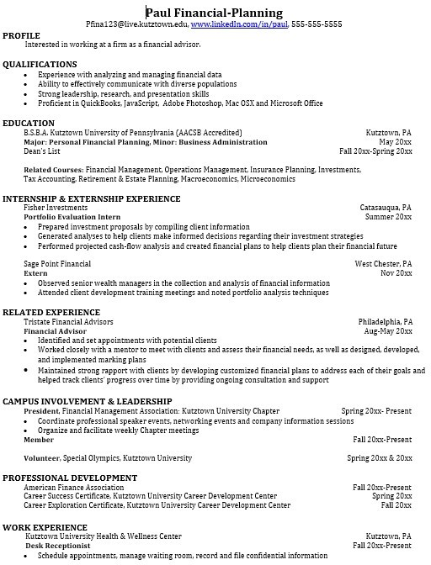
Develop professionally through campus involvement and professional mem-berships.
This illustrates responsibility, leadership abilities and time management skills.

For More Information on PFP Careers or to speak to a Career Counseling, contact KU Career Development Center 113 Stratton Administration Center * 610-683-4067 * careerhelp@kutztown.edu * www.kutztown.edu/careercenter

