

Bachelor of Science: Physics
Tracks: Engineering, Engineering Technology and Astronomy Minor: Physics
Physics is the study of the laws of nature including mechanics, sound, electricity and magnetisms, optics, heat, and quantum theory. The Bachelor of Science program at Kutztown offers three tracks: Physics, Physics-Engineering Physics, and Physics-Astronomy. Courses in these programs include Heat and Thermodynamics, Quantum Mechanics, Optics, Mathematical Physics, and Electricity and Magnetism. Additionally, Physics students have access to an on-campus observatory, planetarium and physics laboratories for course work and research projects.

A degree in Physics is ideal for students who wish to pursue graduate studies in physics, engineering, or related fields and/or careers in manufacturing, technology, and applied research.

Career types associated with Physics
(Is this a good fit for you? Are you a…)
- Investigative -“Thinker”
- Realistic - “Doer”
- Enterprising - “Leader”

Related skills, values, and qualities
- Ability to organize, analyze & interpret scientific data
- Proficiency in reading, writing, thinking, questioning, analyzing & problem solving
- Ability to make critical observations & appropriate decisions
- Ability to conduct and explain scientific research
- Strong background in mathematics
- Aptitude for accuracy and detail
- Proficiency with computers

Common interests of Physics majors
- Completing puzzles or playing games of strategy
- Troubleshooting or repairing electronic equipment
- Solving logic problems
- Working with computers
- Participating in science or math clubs
- Reading physics or science publications

For more information about the major Contact the Physical Science Department, 425 Boehm, 610-683-4447, or visit www.kutztown.edu/Physics

Courses Physics majors typically enjoy
- Computer Programming
- Earth Science
- Mathematics (Algebra/Trigonometry/Calculus)
- Physical Science
- Statistics

KU Majors related to Physics
Chemistry, Computer Science, Geology, Mathematics, Secondary Education-Science or Math, Philosophy

Investigative students may also be interested in: Anthropology, Biology, Biochemistry, Criminal Justice, Economics*, Environmental Science, Geology, Geography, German Studies, History, International Studies*, Marine Science, Multicultural Studies*, PA German Studies*, Political Science, Psychology, Sociology, and Spanish
* minor only

For More Information on Physics careers or to speak to a Career Counselor, contact KU Career Development Center 113 Stratton Administration Center * 610-683-4067 * careerhelp@kutztown.edu * www.kutztown.edu/careercenter



- Enroll in the Career Exploration Certificate.
- Attend info sessions to learn about career development and personal branding.
- Take a career assessment to
identify and confirm interests.
- Get involved in campus clubs and organizations.
- Develop basic workplace skills through jobs or volunteer work.
- Talk with professors, family, and friends about career ideas.
- Conduct informational interviews with professionals working in fields of interest.
- Develop a relationship with your professors and faculty advisor.
- Meet with CDC career coach.
- Attend info sessions to learn about resume writing, and externships.
- Confirm your choice of major and consider options for double major or minor.
- Research careers of interest.
- Complete a job shadowing (externship) experience.
- Seek meaningful employ-ment or volunteer work in a field related to your major.
- Explore options for under-graduate research and study abroad.
- Write a resume and have it reviewed by the CDC.
- Manage your online presence.
- Enroll in the Career Success Certificate.
- Complete an internship and/or undergraduate research.
- Attend info sessions about internships, interviewing, job search strategies, and grad school.
- Build a LinkedIn profile and continue to monitor your online presence.
- Complete a mock interview.
- Build skills through research projects, part-time employment, and volunteer work.
- Participate in employer panels, site visits & networking events.
- Attend internship & job fairs.
- Take on a leadership role in a student organization or work.
- Consider graduate school options and prepare for admissions tests.
- Attend your Senior Kick-off and other info sessions to prepare for job search/grad school.
- Update your resume and LinkedIn profile.
- Create cover letter drafts.
- Gain experience through internships and/or undergraduate research.
- Secure references for job/grad school applications.
- Create your “30 second”
commercial/elevator pitch.
- Meet with CDC to develop job search strategies.
- Research employers.
- Network with professionals through events and social media.
- Join a professional organization in your discipline.
- Attend the senior etiquette
luncheon or dinner.
- Participate in job fairs and on-campus interviewing.

Sample Career Titles
Physics majors can be found working in a wide variety of career fields. Here are just some career titles that may be of interest. Please note that some jobs may require further education and training.
To learn more about these careers, visit http://online.onetcenter.org or www.bls.gov/oco.

  - Acoustics Physicist Administrator
  - Aerodynamist
  - Aerospace Testing Analyst
  - Astronomer
  - Astrophysicist
  - Atomic Physicist
  - Biophysicist
  - Cardiac Imaging Researcher
  - Chemical Physicist
  - Computer Specialist
  - Computer System Engineer
  - Devices Designer Director
  - Fluids Physicist
  - Geophysicist
  - High-Tech Designer, Oil Industry
  - Hydrologist
  - Industrial Hygienist
  - Laboratory Tech/Director
  - Lawyer, Technology Specialty
  - Mathematician
  - Mathematics and Physics Teacher
  - Medical Physicist
  - Medical Products Designer
  - Meteorologist
  - Molecular Physicist
  - National Laboratory Research
  - Nuclear Magnetic Resonance
  - Nuclear Physicist
  - Nuclear Power Plant Manager
  - Operations Analyst
  - Physicist
  - Physics Researcher
  - Physiognomist
  - Plasma Physicist
  - Process Engineer
  - Project Manager
  - Radiological Researcher & Developer
  - Research Assistant
  - Satellite Data Analyst
  - Satellite Missions Analyst
  - Science Teacher
  - Science Writer Scientist
  - Seismologist
  - Solid Earth/State Physicist
  - Stratigrapher
  - Technical Consultant
  - Technical Salesperson
  - Technical Writer
  - Test Engineer

Common Internship Sites and Employers
Physics majors often find internships and employment in the following fields/industries.

- Aerospace Development
- Airports
- Business and Industry
- High Schools & Higher Education
- Medical Field
- Mining and Petroleum
- Research & Development Firms
- Scientific Publication Companies
- State/Federal Government
- Utility Companies
- Weather Bureaus



Handshake is the primary online resource
for preparing and connecting students and alumni with employers.
www.kutztown.edu/handshake

Useful Websites for Physics Majors
Whether you are researching related career fields, applying for internships or jobs, or planning to join a professional association, these websites are for you!

Industry/Employment Information

Careers in Applied Mathematics www.siam.org/careers/thinking.php

DICE
www.dice.com
Institute of Physics
www.iop.org

Math Jobs www.math-jobs.com
Physics World http://physicsworld.com

Science Careers http://sciencecareers.sciencemag.org
Sloan Career Cornerstone Center www.careercornerstone.org
We Use Math in Careers
www.weusemath.org

LinkedIn Job Search www.linkedin.com/jobs

Professional Associations

Advanced Laboratory Physics Association http://advlab.org

American Association of Physicists In Medicine
www.aapm.org

American Astronomical Society http://aas.org
American Center for Physics http://acp.org

American Institute of Physics www.aip.org
American Mathematical Society www.ams.org
American Physical Society
www.aps.org

American Geoscience Www.americangeosciences.org/ workforce
International Society of Physics Students
www.iaps.info
Society for Industrial & Applied Mathematics www.siam.org
Society of Physics Students www.spsnational.org

Related Area Employers

Actalent Amcor
Bosch-Robert Bosch LLC Brentwood Industries Crayola
East Penn Manufacturing EnerSys
FedChem LLC
Fedegari Technologies Inc HCL Technologies Inc Knoll Inc.
Morgan Corporation Radian Group Volvo Group

Building Your Resume for a Career in Physics

Building a strong resume for your career field starts long before you ever start your job search. Employers want to hire graduates who not only have the necessary educational background but also have experience applying that knowledge.

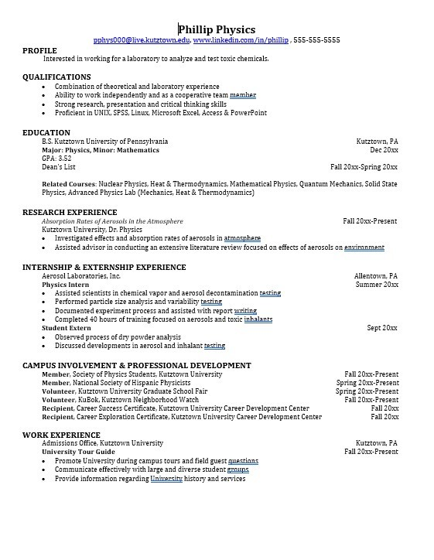
Learn more about your field and develop the necessary skills for employment by gaining hands-on experience through internships.

Utilize summer breaks to acquire valuable experience via volunteer or employment opportunities related to your major.

Develop professionally through campus involvement and professional memberships.
This illustrates responsibility, leadership abilities and time management skills.

For More Information on Physics careers or to speak to a Career Counselor, contact KU Career Development Center 113 Stratton Administration Center * 610-683-4067 * careerhelp@kutztown.edu * www.kutztown.edu/careercenter

