

Bachelor of Arts: Political Science
Bachelor of Arts: Political Science with Paralegal Studies Minor: Political Science
Political Science is the study of government and explores the origins, historical developments and function of government and political power. Political Science majors study American government, political theory, international relations, and comparative politics among their core courses and are exposed to all the subfields of the discipline.

A degree in Political Science is ideal for students who wish to pursue entrance into graduate programs or law schools and/or careers in public affairs, business, education and the media. Employers recommend one or more internships to be successful and competitive when entering this field.

Career types associated with Political Science
(Is this a good fit for you? Are you a…)
- Enterprising - “Leader”
- Social - “Helper”
- Investigative - “Thinker”

Related skills, values, and qualities
- Strong oral and written communication skills
- Ability to relate to people from varying backgrounds
- Ability to conduct research and explain research
- Proficiency in reading comprehension, writing, and speaking
- Ability to organize and interpret social, economic, and political data
- Understanding and sensitivity to community needs
- Ability to evaluate problems and make appropriate decisions
- Aptitude for leadership

Courses Political Science majors typically enjoy
- Civics/Government
- Debate
- Economics
- English
- History
- Psychology
- Public Speaking
- Social Studies
- Sociology

Common interests of Political Science majors
- Attending political rallies or lectures
- Serving as a part-time worker or volunteer precinct clerk, poll watcher, or in news media
- Running for a public school or municipal office
- Joining a debate or forensics team
- Participating in fundraising or writing promotional materials for a political campaign
- Participating in student government
- Joining a school newspaper staff, freelance writing, or reading political publications
For more information about the major Contact the Political Science Department, 318 Old Main, 610-683-4449 or visit www.kutztown.edu/Political Science
KU Majors related to Political Science English– Professional Writing, Geography, History, Secondary Education-Social Studies

Enterprising students may also be interested in: Accounting, Advertising*, Communication Design, Communication Studies, Criminal Justice, Economics*, Elementary Education, Environmental Science, Finance, International Studies*, Library Science, Literature*, Psychology, Management, Marketing, Multicultural Studies*, Public Relations*, Social Work, Special Education, Women’s Studies*, Writing*
* minor only

For More Information on Political Science careers or to speak to a Career Counselor, contact KU Career Development Center 113 Stratton Administration Center * 610-683-4067 * careerhelp@kutztown.edu * www.kutztown.edu/careercenter



- Enroll in the Career Exploration Certificate.
- Attend info sessions to learn about career development and personal branding.
- Take a career assessment to
identify and confirm interests.
- Get involved in campus clubs and organizations.
- Develop basic workplace skills through jobs or volunteer work.
- Talk with professors, family, and friends about career ideas.
- Conduct informational interviews with professionals working in fields of interest.
- Develop a relationship with your professors and faculty advisor.
- Meet with CDC career coach.
- Attend info sessions to learn about resume writing, and externships.
- Confirm your choice of major and consider options for double major or minor.
- Research careers of interest.
- Complete a job shadowing (externship) experience.
- Seek meaningful employ-ment or volunteer work in a field related to your major.
- Explore options for under-graduate research and study abroad.
- Write a resume and have it reviewed by the CDC.
- Manage your online presence.
- Enroll in the Career Success Certificate.
- Complete an internship and/or undergraduate research.
- Attend info sessions about internships, interviewing, job search strategies, and grad school.
- Build a LinkedIn profile and continue to monitor your online presence.
- Complete a mock interview.
- Build skills through research projects, part-time employment, and volunteer work.
- Participate in employers panels, site visits & networking events.
- Attend internship & job fairs.
- Take on a leadership role in a student organization or work.
- Consider graduate school
options and prepare for
- Attend your Senior Kick-off and other info sessions to prepare for job search/grad school.
- Update your resume and LinkedIn profile.
- Create cover letter drafts.
- Gain experience through internships and/or undergraduate research.
- Secure references for job/grad school applications.
- Create your “30 second”
commercial/elevator pitch.
- Meet with CDC to develop job search strategies.
- Research employers.
- Network with professionals through events and social media.
- Join a professional organization in your discipline.
- Attend the senior etiquette
luncheon or dinner.
- Participate in job fairs and on-campus interviewing.

Sample Career Titles
Political Science majors can be found working in a wide variety of career fields. Here are just some career titles that may be of interest. Please note that some jobs may require further education and training.
To learn more about these careers, visit http://online.onetcenter.org or www.bls.gov/oco.

  - Account Executive
  - Advocate
  - Archivist
  - Anthropologist
  - Association Manager
  - Attorney
  - Broadcast Journalist
  - Business Development Officer
  - Buyer
  - Campaign Manager
  - Chamber of Commerce Manager
  - City Manager
  - Community Relations Director
  - Congressional Aide
  - Congressional Research Consultant
  - Consumer Advocate
  - Diplomat
  - Editor
  - Environmental Policy Analyst
  - FBI/CIA Agent
  - Foreign Correspondent
  - Foreign Service Officer
  - Government Intelligence Analyst
  - Historic Preservationist
  - International Business Specialist
  - International Organization Official
  - International Trade Specialist
  - Interpreter
  - Judge
  - Labor Relations Specialist
  - Law Enforcement Officer
  - Legal Assistant
  - Legislative Analyst
  - Lobbyist
  - Management Analyst
  - Mayor
  - Market Research Analyst
  - Media Analyst
  - Military Officer
  - Paralegal
  - Parole/Probation Officer
  - Peace Corps/Vista Worker
  - Political Pollster
  - Penologist
  - Politician
  - Political Consultant
  - Political Scientist
  - Professor: Political Science/History
  - Public Administrator/Manager
  - Public Health Official
  - Public Opinion Interviewer
  - Public Recreation Director
  - Public Relations Specialist
  - Radio/TV Announcer/Producer
  - Real Estate Agent/Broker
  - Researcher
  - Sales Manager
  - School Administrator
  - Social Services Administrator
  - Special Interest Group Director
  - Survey Worker
  - Teacher: Humanities/Social Sciences
  - Writer/Author

Common Internship Sites and Employers
Political Science majors often find internships and employment in the following fields/industries.

- Business & Industry
- Campaign Management Firms
- Communications Media
- Consulting Firms
- Courts and Law Offices
- Educational Institutions
- Military and Para-Military Groups
- Non-Profit Organizations
- Public/International Affairs Offices
- Political Parties
- Private/Public Interest Groups



Handshake is the primary online resource
for preparing and connecting students and alumni with employers.
www.kutztown.edu/handshake

Useful Websites for Political Science Majors
Whether you are researching related career fields, applying for internships or jobs, or planning to join a professional association, these websites are for you!

Industry/Employment Information

American Enterprise Institute for Public Policy Research
www.aei.org
Careers in Government www.careersingovernment.com
Federal Jobs
www.federaljobs.net

Government Jobs www.governmentjobs.com

Law Student Center www.hg.org/students.html
National Nonprofit Job Opportunities www.opportunitynocs.org
Public Service Careers www.publicservicecareers.org

USA Jobs
www.usajobs.gov

PolyCorner www.polycorner.org

Professional Associations

The American Academy of Political & Social Science
www.aapss.org
American Assoc. for State & Local History www.aaslh.org
American Political Science Association
www.apsanet.org

Association for Public Policy Analysis & Management
www.appam.org

Association for Political Science Students
http://www.iapss.org

National Council on Public History http://ncph.org
National Federation of Paralegal Associations
www.paralegals.org

Northeaster Political Science Association
www.northeasternpsa.org

U.S. Naval Institute www.usni.org

Related Area Employers

Commonwealth of Pennsylvania Ford Law Office LLC
Grant Street Group Greenlee Partners, LLC Martson Law Offices
Mission Kids Child Advocacy Center Ostroff Injury Law, P.C.
Pennsylvania State Employees Credit Union
The Republican National Committee
The Washington Center
U.S. Census Bureau
U.S. Department of the Treasury United Way of Pennsylvania

Building Your Resume for a Career in Political Science

Develop professionally through campus involvement and professional memberships.
This illustrates responsibility, leadership abilities and time management skills.
Utilize summer breaks to acquire valuable experience via volunteer or employment opportunities related to your major.

Building a strong resume for your career field starts long before you ever start your job search. Employers want to hire graduates who not only have the necessary educational background
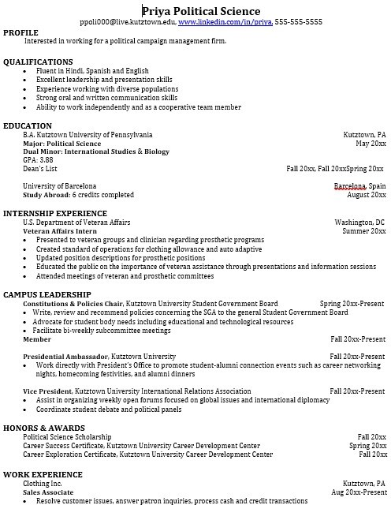
but also have experience applying that knowledge.
Learn more about your field and develop the necessary skills for employment by gaining hands-on experience through internships.

For More Information on Political Science careers or to speak to a Career Counselor, contact KU Career Development Center 113 Stratton Administration Center * 610-683-4067 * careerhelp@kutztown.edu * www.kutztown.edu/careercenter

