

Bachelor of Science: Psychology/ Paralegal Studies Bachelor of Science: Psychology/General
Minor: Psychology

Psychologists study human and animal behavior and related mental, physiological and social processes in an attempt to understand the dynamics of behavior. They apply this knowledge to the prevention and solution of both individual and social problems. Students can choose one of four tracks: Clinical-Counseling, Industrial-Organizational, Paralegal, and General. The facilities for psychology majors include computer labs for teaching statistics and research methods, a small library, and specialized research labs in visual perception and cognition.

A degree in psychology is ideal for students who wish to pursue graduate studies and/or careers in business, government, non-profits organizations, social service and criminal justice agencies, and community development and action groups. Employers recommend one or more internships to be successful and competitive when entering this field.

Career types associated with Psychology
(Is this a good fit for you? Are you a…)
- Investigative - “Thinker”
- Social - “Helper”
- Enterprising - “Leader”

Related skills, values, and qualities
- Strong interpersonal communication skills
- Proficiency in reading comprehension, writing and speaking
- Ability to interpret and explain psychological research
- Ability to interact with people of diverse backgrounds and in a variety of situations
- Ability to observe and analyze situations
- Ability to evaluate problems and make appropriate decisions

Courses Psychology majors typically enjoy
- Biology
- Criminal Justice
- Health
- History
- Philosophy/Religious Studies
- Psychology
- Social Studies
- Sociology
- Social Work

Common interests of Psychology majors
- Participating in charitable outreach efforts and raising funds for social concerns
- Joining school clubs and organizations
- Serving as a peer counselor, tutor, or hotline
assistant
- Working part-time or volunteering in a community service agency/group
- Reading about social issues and attending lectures and conferences related to psychology

For more information about the major
Contact the Psychology Department, 384 Old Main, 610-683-4455, or visit www.kutztown.edu/Psychology

KU Majors related to Psychology Anthropology, Biology, Business Management, Marketing, Criminal Justice, Philosophy, Sociology, Social Work

Investigative students may also be interested in: Biochemistry, Biology, Chemistry, Computer Science, Economics*, German Studies, International Studies*, Mathematics, Multicultural Studies*, PA German Studies*, Physics, Sec Edu- Math/Science, Spanish, and Women’s Studies*
* minor only

For More Information on Psychology careers or to speak to a Career Counselor, contact KU Career Development Center 113 Stratton Administration Center * 610-683-4067 * careerhelp@kutztown.edu * www.kutztown.edu/careercenter



- Enroll in the Career Exploration Certificate.
- Attend info sessions to learn about career development and personal branding.
- Take a career assessment to
identify and confirm interests.
- Get involved in campus clubs and organizations.
- Develop basic workplace skills through jobs or volunteer work.
- Talk with professors, family, and friends about career ideas.
- Conduct informational interviews with professionals working in fields of interest.
- Develop a relationship with your professors and faculty advisor.
- Meet with CDC career coach.
- Attend info sessions to learn about resume writing, and externships.
- Confirm your choice of major and consider options for double major or minor.
- Research careers of interest.
- Complete a job shadowing (externship) experience.
- Seek meaningful employ-ment or volunteer work in a field related to your major.
- Explore options for under-graduate research and study abroad.
- Write a resume and have it reviewed by the CDC.
- Manage your online presence.
- Enroll in the Career Success Certificate.
- Complete an internship and/or undergraduate research.
- Attend info sessions about internships, interviewing, job search strategies, and grad school.
- Build a LinkedIn profile and continue to monitor your online presence.
- Complete a mock interview.
- Build skills through research projects, part-time employment, and volunteer work.
- Participate in employers panels, site visits & networking events.
- Attend internship & job fairs.
- Take on a leadership role in a student organization or work.
- Consider graduate school
options and prepare for
- Attend your Senior Kick-off and other info sessions to prepare for job search/grad school.
- Update your resume and LinkedIn profile.
- Create cover letter drafts.
- Gain experience through internships and/or undergraduate research.
- Secure references for job/grad school applications.
- Create your “30 second”
commercial/elevator pitch.
- Meet with CDC to develop job search strategies.
- Research employers.
- Network with professionals through events and social media.
- Join a professional organization in your discipline.
- Attend the senior etiquette
luncheon or dinner.
- Participate in job fairs and on-campus interviewing.

Sample Career Titles
Psychology majors can be found working in a wide variety of career fields. Here are just some career titles that may be of interest. Please note that some jobs may require further education and training.
To learn more about these careers, visit http://online.onetcenter.org or www.bls.gov/oco.

  - Activity Leader
  - Admissions Evaluator
  - Animal Trainer
  - Art Therapist
  - Career Planning Professional
  - Child Psychologist
  - Community & Social Service Worker
  - Community Relations Director
  - Correctional Caseworker/Officer
  - Counselor: Alcohol/Drug
  - Counselor: Career
  - Counselor: Crisis Intervention
  - Counselor: Employment Agency
  - Counselor: Occupational
  - Counselor: School
  - Counselor: Vocational/Voc. Rehab
  - Criminologist
  - Employee Assistance Director
  - Employee/Labor Relations Mgr.
  - EEO/AA Specialist
  - Financial Advisor
  - Financial Aid Director
  - Forensic Psychologist
  - Halfway House Parent
  - Health Educator
  - Hospice Coordinator
  - Hotel Manager
  - Human Resources Administrator/Manager
  - Immigration Paralegal
  - Industrial Psychologist
  - International Student Advisor
  - Job Analyst & Developer
  - Labor Relations Specialist
  - Law Clerk
  - Lawyer
  - Market Research Analyst
  - Marketing/Sales Manager
  - Mental Health Professional
  - Minority & Race Relations Specialist
  - Motivational Speaker
  - Music Therapist
  - Neuropsychologist
  - Occupational Therapist
  - Outplacement Specialist
  - Paralegal
- Police Officer
- Probation Officer
- Psychiatric Nurse
- Psychiatric Social Worker
- Psychiatrist
- Psychologist
- Public Health Statistician
- Public Opinion Surveyor
- Public Relations Specialist
- Recreation Specialist
- School Counselor
- School Psychologist
- Social Service Administrator
- Student Affairs Professional
- Teacher/Educator/Coach
- Technical Writer/Communicator
- Television/Media Researcher
- Therapeutic Staff Support Person
- Vocational Rehabilitation Counselor
- Youth Corrections Officer

Common Internship Sites and Employers
Psychology majors often find internships and employment in the following fields/industries.

- Business & Industry
- Communications Media
- Community Agencies
- Correctional Facilities
- Educational Institutions
- Mental Health Agencies
- Non-Profit Organizations
- Private Practice
- Rehabilitation Agencies & Hospitals
- Research Foundations
- State/Federal Government Agencies



Handshake is the primary online resource
for preparing and connecting students and alumni with employers.
www.kutztown.edu/handshake

Useful Websites for Psychology Majors
Whether you are researching related career fields, applying for internships or jobs, or planning to join a professional association, these websites are for you!

Industry/Employment Information

All Psychology Schools www.allpsychologyschools.com

Careers in Federal Government www.usajobs.gov

Explore Health Careers http://explorehealthcareers.org

Psychology Jobs www.psychologyjobs.com

Online Psychology Career Center www.socialpsychology.org

Opportunity Knocks www.opportunitynocs.org

PsychWeb www.psywww.com

Psychology—Online Resource Center http://psychcentral.com

Public Service Jobs Directory
www.psjd.org
Social Service Jobs www.socialservice.com
Graduate Schools https://www.psychology.org/resources/ graduate-application-guide

Professional Associations

Academy of Medical Psychology www.academyofmedicalpsychology.com

American Association for Marriage & Family Therapy
www.aamft.org
American Board of Sport Psychology
www.americanboardofsportpsychology.org

American Counseling Association www.counseling.org

American Psychological Association www.apa.org

Association for Psychological Science www.psychologicalscience.org

Association of Black Psychologists www.abpsi.org

Association of Women in Psychology www.awpsych.org

National Association of School Psychologists
www.nasponline.org

Society for Industrial & Org. Psychology www.siop.org

Society for Human Resource Management www.shrm.org

Related Area Employers

Abraxas Youth & Family Services
Berks County Children & Youth Services CCRES - Educational and Behavioral Health
Services Central Behavioral Health
Children's Crisis Treatment Center Community Services Group (CSG) Creative Health Services
Lehigh County
Lehigh Country Paralegal Association Lehigh Valley Health Network KidsPeace
MCC Warwick Family Services Northern Tier Counseling
Pennsylvania Department of Human Services Safe Berks
The National Alliance of Paralegal Assoc. Threshold Rehabilitation Services, Inc.
T.W. Ponessa & Associates Counseling Services Valley Youth House
Paralegal Track Cambria & Kline PC Clark Associates, Inc.
Hershey Entertainment & Resorts Fox Rothschild LLP

Building Your Resume for a Career in Psychology

Building a strong resume for your career field starts long before you ever start your job search. Employers want to hire graduates who not only have the necessary educational background but also have experience applying that knowledge.

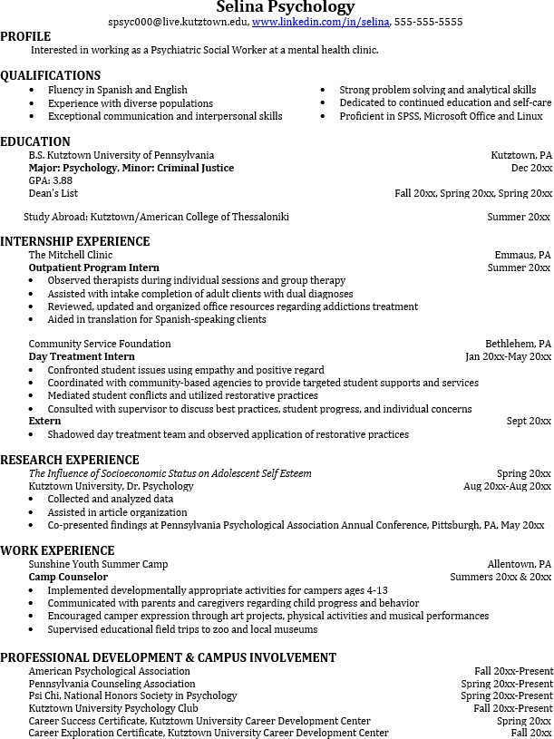
Learn more about your field and develop the necessary skills for employment by gaining hands-on experience through internships.

Utilize summer breaks to acquire valuable experience via volunteer or employment opportunities related to your major.

Develop professionally through campus involvement and professional memberships.
This illustrates responsibility, leadership abilities and time management skills.

For More Information on Psychology careers or to speak to a Career Counselor, contact KU Career Development Center 113 Stratton Administration Center * 610-683-4067 * careerhelp@kutztown.edu * www.kutztown.edu/careercenter

