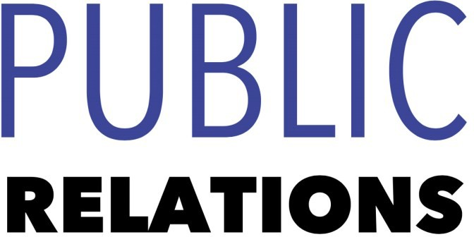

Bachelor of Science: Public Relations

Public Relations encompasses the professional management of communication between any organization or individual and its audiences. This communication can come in the form of events, media relations, or complex strategic campaigns.

The bachelor of science in public relations at Kutztown University features an innovative approach to prepare its graduates for successful careers in the field, including in public relations and social media, or to pursue graduate/advanced study. Employers recommend one or more internships to be successful and competitive when entering this field.

Career types associated with Public Relations
(Is this a good fit for you? Are you a…)
- Artistic - “Creator”
- Social - “Helper”
- Enterprising - “Leader”

Skills associated with the Public Relations major
- Proficiency in reading, writing, and speaking
- Comprehensive command of grammar and
vocabulary
- Good listening, clarifying, questioning, and responding skills
- Ability to conduct and explain research results
- Ability read analytically
- Ability to make observations and appropriate decisions
- Ability to concentrate for long periods of time
- Ability to respond appropriately to various rhetorical situations orally or in written form

Common interests of Public Relations majors
- Attending movies, plays, lectures, or readings
- Participating in theatre productions
- Writing short stories, poetry, or news articles
- Conversing and/or debating with others
- Participating in a book club, student newspaper, or yearbook club
- Reading essays, articles, novels, short stories, plays, poetry, and professional journals
- Visiting libraries
- Working part-time or as a volunteer for a library, high school/college radio or TV station, or nonprofit organization

For more information about the major
Contact the English Department, 135 Lytle,
610-683-4353, or visit www.kutztown.edu/English

Courses Public Relations majors typically enjoy
- Communications
- English
- History
- Humanities
- Sociology
- Public Speaking
- Writing
KU Majors related to Public Relations Communication Studies, English, History, Philosophy, Secondary Education

Artistic students may also be interested in: Advertising*, Art Education, Communication Design, Crafts, Elementary Education, German Studies, International Studies*, Library Science, Music, Music Education, Spanish, Studio Art.

*minor only

For More Information on Public Relations careers or to speak to a Career Counselor, contact KU Career Development Center 113 Stratton Administration Center * 610-683-4067 * careerhelp@kutztown.edu * www.kutztown.edu/careercenter



- Enroll in the Career Exploration Certificate.
- Attend info sessions to learn about career development and personal branding.
- Take a career assessment to
identify and confirm interests.
- Get involved in campus clubs and organizations.
- Develop basic workplace skills through jobs or volunteer work.
- Talk with professors, family, and friends about career ideas.
- Conduct informational interviews with professionals working in fields of interest.
- Develop a relationship with your professors and faculty advisor.
- Meet with CDC career coach.
- Attend info sessions to learn about resume writing, and externships.
- Confirm your choice of major and consider options for double major or minor.
- Research careers of interest.
- Complete a job shadowing (externship) experience.
- Seek meaningful employ-ment or volunteer work in a field related to your major.
- Explore options for under-graduate research and study abroad.
- Write a resume and have it reviewed by the CDC.
- Manage your online presence.
- Enroll in the Career Success Certificate.
- Complete an internship and/or undergraduate research.
- Attend info sessions about internships, interviewing, job search strategies, and grad school.
- Build a LinkedIn profile and continue to monitor your online presence.
- Complete a mock interview.
- Build skills through research projects, part-time employment, and volunteer work.
- Participate in employers panels, site visits & networking events.
- Attend internship & job fairs.
- Take on a leadership role in a student organization or work.
- Consider graduate school
options and prepare for
- Attend your Senior Kick-off and other info sessions to prepare for job search/grad school.
- Update your resume and LinkedIn profile.
- Create cover letter drafts.
- Gain experience through internships and/or undergraduate research.
- Secure references for job/grad school applications.
- Create your “30 second”
commercial/elevator pitch.
- Meet with CDC to develop job search strategies.
- Research employers.
- Network with professionals through events and social media.
- Join a professional organization in your discipline.
- Attend the senior etiquette
luncheon or dinner.
- Participate in job fairs and on-campus interviewing.

Sample Career Titles
Public Relations majors can be found working in a wide variety of career fields. Here are just some career titles that may be of interest. Please note that some jobs may require further education and training.
To learn more about these careers, visit http://online.onetcenter.org or www.bls.gov/oco.

  - Advertising Copywriter
  - Advertising Executive
  - Bibliographer
  - Biographer
  - Book Critic
  - Bookstore Manager
  - Columnist/Commentator
  - Comedy Writer
  - Communications Manager
  - Copywriter
  - Critic, Art/Book
  - Crossword Puzzle Developer
  - Documentation Specialist
  - Editor, Film/Video/Magazine
  - Editor, News
  - Educational Program Specialist
  - Entertainment Agent
  - ESL Teacher
  - Freelance Writer/Consultant
  - Information Abstractor/Indexer
  - Labor Relations Specialist
  - Lawyer
  - Librarian
  - Linguist
  - Literary Agent
  - Lobbyist
  - Magazine Writer
  - Manuscript Reader
  - Market Research Analyst
  - Marketing Specialist
  - Mass Media Script Reader
  - Media Planner/Spokesperson
  - Narrator
  - Paralegal
  - Playwright/Poet
  - Product Manager
  - Proofreader
  - Public Relations Specialist
  - Public Speaker
  - Publicity Assistant
  - Publisher
  - Reading Consultant
  - Reading Specialist
  - Reporter
  - Research Assistant Analyst
  - Researcher/Pollster
  - Reviewer
  - Sales Representative
  - Teacher/Educator
  - Technical Writer/Consultant
  - Training Specialist
  - Translator
  - Underwriter
  - Video Scriptwriter/Producer

Common Internship Sites and Employers
Public Relations majors often find internships and employment in the following fields/industries.

    - News Outlets, Newspapers and Magazines
    - Book Publishers
    - Colleges/Universities
    - Consulting Firms
    - Public Relations Firms
    - Marketing
    - Communications Organizations
    - Non-profit Organizations
    - Radio/Media Stations
    - Libraries



Handshake is the primary online resource
for preparing and connecting students and alumni with employers.
www.kutztown.edu/handshake

Useful Websites for Public Relations Majors
Whether you are researching related career fields, applying for internships or jobs, or planning to join a professional association, these websites are for you!

Industry/Employment Information
Book Jobs http://bookjobs.com

Journalism Jobs www.journalismjobs.com

Magazine Publishers of America www.magazine.org/careers

Pennsylvania Newspaper Association
http://panewsmedia.org
Poets & Writers http://www.pw.org

PRSA Job Center www.prsa.org/jobcenter

Public Relations www.nationjob.com/publicrelations

The Write Jobs www.writerswrite.com/jobs

Work in Public Relations www.marketingjobs.com

LinkedIn Jobs
www.linkedin.com/jobs

Professional Associations

American Society of Journalists & Authors www.asja.org

Association of Writers & Writing Programs www.awpwriter.org

Association for Education in Journalism & Mass Communications
www.aejmc.org
Modern Language Association www.mla.org

National Council for Teachers of English www.ncte.org

Public Relations Society of America www.prsa.org

The Association of Magazine Media http://www.magazine.org

Related Area Employers

Alliance for Sustainable Communities Altitude Marketing
ArtsQuest APSCUF
Dorney Park & Wildwater Kingdom Hawk Mountain Sanctuary
Hershey Entertainment & Resorts Historic Bethlehem Museums & Sites Kutztown University: Small Business
Development Center Kutztown University: University Relations Lehigh Valley Zoo
Olympus Sorrelli Jewelry
Volvo Group North America webCemeteries
WebFX

Building Your Resume for a Career in Public Relations

Develop professionally through campus involvement and professional memberships.
This illustrates responsibility, leadership abilities and time management skills.
Utilize summer breaks to acquire valuable experience via volunteer or employment opportunities related to your major.

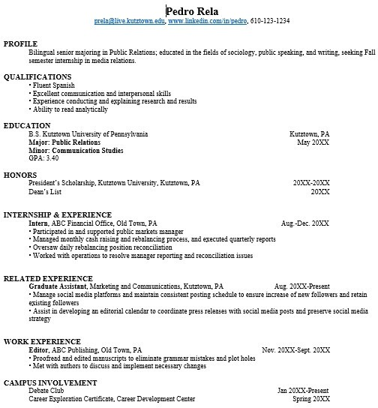
Building a strong resume for your career field starts long before you ever start your job search. Employers want to hire graduates who not only have the necessary educational background but also have experience applying that knowledge.

Learn more about your field and develop the necessary skills for employment by gaining hands-on experience through internships.

For More Information on Public Relations careers or to speak to a Career Counselor, contact KU Career Development Center 113 Stratton Administration Center * 610-683-4067 * careerhelp@kutztown.edu * www.kutztown.edu/careercenter

