


Bachelor of Science in Social Media Theory and Strategy (SMS)
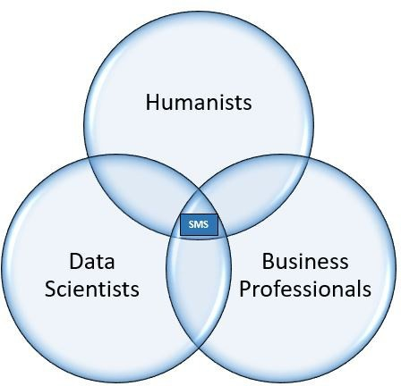
The B.S. in Social Media Theory and Strategy (SMS) enables students to design and implement social media strategies as a key component of larger communications and marketing plans, manage and monitor an organization’s presence across various social media platforms, track and analyze campaign metrics and assess results, develop social media guidelines and advise staff writers and citizen bloggers on social media best practices, create and track content marketing, publish regular multimodal content across multiple social media platforms, and conduct research on innovations and emerging platforms in social media. Students learn to apply social media knowledge to endeavors such as lead generation, public advocacy, digital marketing management, concept promotion, e-commerce, digital content marketing, pay per click (PPC) ad construction and evaluation, and content marketing. In short, students will be strong critical thinkers, problem solvers and hands-on producers who analyze and create a variety of digital content necessary to a range of fields.

Common interests of Social Media majors
- Social media, blogging
- Marketing, advertising plans, branding, and designs
- Problem solving
- Digital writing and image creation
- Puzzles
- Pattern recognition
- Exploring (new digital space, data, etc.)
- Impression management

For more information about the major Contact the Communication Studies Department CommunicationStudies@kutztown.edu
214 Rickenbach Learning Center, 610-683-4560

Courses Social Media majors typically enjoy
Interpersonal Communication Website Design Mass Communication Graphic Design
Marketing Marketing
English Debate
Journalism Psychology
Media Studies Sociology
Current Affairs Business

KU Majors related to Social Media
Business Administration-Marketing, Communication Design, Communication Studies, Computer Science, Electronic Media, English, Professional Writing, Psychology, Sociology

Students may also be interested in: Advertising*, Library Science, Literature*, Philosophy, Public Relations*, Secondary Education English or Modern Languages, or Studio Art. (*minor)

For More Information on Social Media careers or to speak to a Career Counselor, contact KU Career Development Center 113 Stratton Administration Center * 610-683-4067 * careerhelp@kutztown.edu * www.kutztown.edu/careercenter



- Enroll in the Career Exploration Certificate.
- Attend info sessions to learn about career development and personal branding.
- Take a career assessment to
identify and confirm interests.
- Get involved in campus clubs and organizations.
- Develop basic workplace skills through jobs or volunteer work.
- Talk with professors, family, and friends about career ideas.
- Conduct informational interviews with professionals working in fields of interest.
- Develop a relationship with your professors and faculty advisor.
- Meet with CDC career coach.
- Attend info sessions to learn about resume writing, and externships.
- Confirm your choice of major and consider options for double major or minor.
- Research careers of interest.
- Complete a job shadowing (externship) experience.
- Seek meaningful employ-ment or volunteer work in a field related to your major.
- Explore options for under-graduate research and study abroad.
- Write a resume and have it reviewed by the CDC.
- Manage your online presence.
- Enroll in the Career Success Certificate.
- Complete an internship and/or undergraduate research.
- Attend info sessions about internships, interviewing, job search strategies, and grad school.
- Build a LinkedIn profile and continue to monitor your online presence.
- Complete a mock interview.
- Build skills through research projects, part-time employment, and volunteer work.
- Participate in employer panels, site visits & networking events.
- Attend internship & job fairs.
- Take on a leadership role in a student organization or work.
- Consider graduate school options and prepare for admissions tests.
- Attend your Senior Kick-off and other info sessions to prepare for job search/grad school.
- Update your resume and LinkedIn profile.
- Create cover letter drafts.
- Gain experience through internships and/or undergraduate research.
- Secure references for job/grad school applications.
- Create your “30 second”
commercial/elevator pitch.
- Meet with CDC to develop job search strategies.
- Research employers.
- Network with professionals through events and social media.
- Join a professional organization in your discipline.
- Attend the senior etiquette
luncheon or dinner.
- Participate in job fairs and on-campus interviewing.

Sample Career Titles
Social Media majors can be found working in a wide variety of career fields and industries.
Here are just some career titles that may be of interest.
Please note that some jobs may require further education and training.
To learn more about these careers, visit http://online.onetcenter.org or www.bls.gov/oco

  - Blogger
  - Brand Advocate
  - Brand Manager
  - Content & Community Manager/ Marketer
  - Communications Liaison
  - Digital Communications Specialist
  - Digital Marketing Manager
  - Digital Media Manager
  - Engagement Coordinator
  - Fan Engagement Manager
  - Media Affairs Manager
  - Official Twitter handler
  - Online Communication Manager
  - Online Promotions Specialist
  - Public Relations Specialist
  - Social Media Analyst, Coordinator, Editor, Manager, Specialist, Strategist, Writer
  - Web Content Writer


Related skills, values, and qualities
Handshake is the primary online resource for preparing and connecting students and alumni with employers. www.kutztown.edu/handshake

- Strong technical skills
- Ability to analyze, interpret and convey information to others
- Strong & concise written & verbal communication
- Strong research, questioning and responding skills
- Ability to adapt to new environments and improvise when needed
- Ability to work in a team environment
- Ability to work well with diverse populations
- Ability to strategically approach problem solving and decision making
- Strong interpersonal and networking skills

Common Internship Sites and Employers

Social Media majors often find internships and employment in all industries.

Useful Websites for Social Media Majors
Whether you are researching related career fields, applying for internships or jobs, or planning to join a professional association, these websites are for you!

Industry/Employment Information
Indeed www.indeed.com
Media Bistro www.mediabistro.com
Braintrust www.usabraintrust.com

Social Media Jobs www.socialmediajobs.org

Professional Associations
International Social Marketing
Association www.isocialmarketing.org

Public Relations Society of America www.prsa.org

Social Media Association www.aasmp.org

Social Media Marketing Society https://society.socialmediaexaminer.com

Word of Mouth and Social Media Marketing
http://womma.org

Related Area Employers
Alliance for Sustainable Communities Altitude Marketing
ArtsQuest
Celtic Cultural Alliance Clark Associates
Dorney Park & Wildwater Kingdom Elysium Marketing Group Haydenfilms Institute
Hershey Entertainment & Resorts Historic Bethlehem Museums & Sites Kutztown University: Small Business
Development Center
Kutztown University: University
Relations Lehigh Valley Zoo Olympus
Seer Interactive Sorrelli Jewelry Strunk Media Group webCemeteries WebFX
Willow Street Pictures, Inc.

Building Your Resume for a Career in Social Media

Building a strong resume for your career field starts long before you ever start your job search. Employers want to hire graduates who not only have the necessary educational background but also have experience applying that

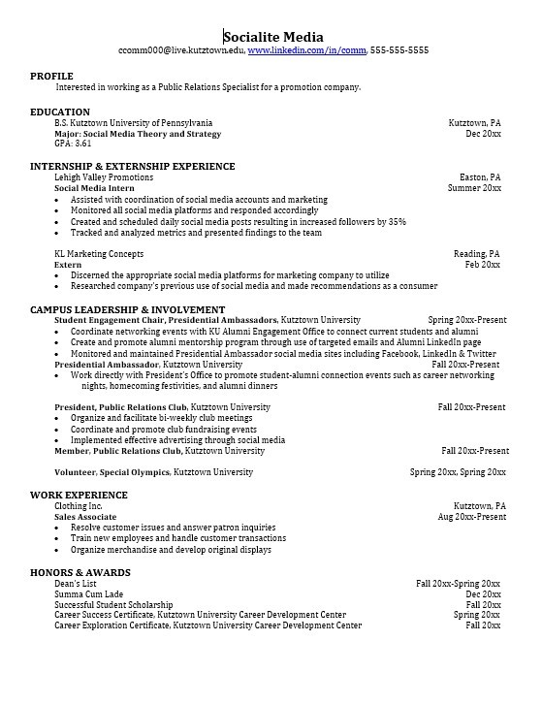
Take note of the skills and knowledge obtained through your educational background and hands-on experiences.
Highlight transfer-able skills such as organization and communication.

Learn more about your field and develop the necessary skills for employment by gaining experience through externships, internships,
part-time jobs and related
volunteer positions.

Develop professionally through campus involvement and professional memberships.
This illustrates responsibility, leadership abilities and time management skills.

For More Information on Social Media Careers or to speak to a Career Counselor contact KU Career Development Center 113 Stratton Administration Center * 610-683-4067 * careerhelp@kutztown.edu * www.kutztown.edu/careercenter

