

Bachelor of Social Work: Social Work Minor: Social Work, Case Management

Working in a myriad of settings from early intervention centers and schools to counseling centers, hospitals, and nursing homes, social workers help people achieve their highest potential. Adhering to the National Association of Social Workers Code of Ethics, social workers interact with individuals, families, groups, organizations and communities. They function as counselors, educators, advocates, case managers, policy analysts, and researchers. Social Workers initiate social change and seek social justice. Internships are required in this program.
The Bachelor of Social Work program at Kutztown University is nationally accredited by the Council on Social Work Education and is a professional program that prepares generalist social work practitioners. Those who successfully complete the Bachelor of Social Work degree, may be given Advanced Standing in any accredited Master of Social Work program. This enables them to graduate with a Master of Social Work degree in one calendar year.

Career types associated with Social Work
(Is this a good fit for you? Are you a…)
- Social - “Helper”
- Enterprising - “Persuader”
- Conventional - “Organizer”

Related skills, values, and qualities
- Ability to demonstrate empathy for others in stressful
situations
- Ability to interact with people of different backgrounds in a variety of situations
- Strong interpersonal communication skills
- Proficiency in reading comprehension, writing and speaking
- Ability to conduct and explain social research
- Ability to observe, evaluate & address social challenges & injustice
- Ability to maintain composure in stressful situations
- Ability to adapt to new environments and improvise when needed

Courses Social Work majors typically enjoy
- Sociology
- Psychology
- Civics/Government
- Communications
- Economics
- Family Studies
- Criminal Justice
- Philosophy

Common interests of Social Work majors
- Participating in charitable outreach efforts and raising funds for social concerns
- Joining school clubs and organizations
- Serving as a peer counselor, tutor, or hotline assistant
- Working part-time or volunteering in a community service agency/group
- Reading about social issues and attending lectures

For more information about the major
Contact the Social Work Department, Old Main 339, 610-683-4235, or visit www.kutztown.edu/SocialWork

KU Majors related to Social Work
Education, Psychology, Sociology, Criminal Justice

Social Work students may also be interested in: Social Work students may also be interested to minor in : Communication Studies, Criminal Justice, Economics, English, History, International Studies, Modern Language Studies, Philosophy and Government, Psychology, Women’s and Gender Studies, Special Education and Secondary Education

For More Information on Social Work careers or to speak to a Career Counselor, contact KU Career Development Center 113 Stratton Administration Center * 610-683-4067 * careerhelp@kutztown.edu * www.kutztown.edu/careercenter



- Enroll in the Career Exploration Certificate.
- Attend info sessions to learn about career development and personal branding.
- Take a career assessment to
identify and confirm interests.
- Get involved in campus clubs and organizations.
- Develop basic workplace skills through jobs or volunteer work.
- Talk with professors, family, and friends about career ideas.
- Conduct informational interviews with professionals working in fields of interest.
- Develop a relationship with your professors and faculty advisor.
- Meet with CDC career coach.
- Attend info sessions to learn about resume writing, and externships.
- Confirm your choice of major and consider options for double major or minor.
- Research careers of interest.
- Complete a job shadowing (externship) experience.
- Seek meaningful employ-ment or volunteer work in a field related to your major.
- Explore options for under-graduate research and study abroad.
- Write a resume and have it reviewed by the CDC.
- Manage your online presence.
- Enroll in the Career Success Certificate.
- Complete an internship and/or undergraduate research.
- Attend info sessions about internships, interviewing, job search strategies, and grad school.
- Build a LinkedIn profile and continue to monitor your online presence.
- Complete a mock interview.
- Build skills through research projects, part-time employment, and volunteer work.
- Participate in employer panels, site visits & networking events.
- Attend internship & job fairs.
- Take on a leadership role in a student organization or work.
- Consider graduate school options and prepare for admissions tests.
- Attend your Senior Kick-off and other info sessions to prepare for job search/grad school.
- Update your resume and LinkedIn profile.
- Create cover letter drafts.
- Gain experience through internships and/or undergraduate research.
- Secure references for job/grad school applications.
- Create your “30 second”
commercial/elevator pitch.
- Meet with CDC to develop job search strategies.
- Research employers.
- Network with professionals through events and social media.
- Join a professional organization in your discipline.
- Attend the senior etiquette
luncheon or dinner.
- Participate in job fairs and on-campus interviewing.

Sample Career Titles
Social Work majors can be found working in a wide variety of career fields. Here are just some career titles that may be of interest. Please note that some jobs may require further education and training.
To learn more about these careers, visit http://online.onetcenter.org or www.bls.gov/oco.

  - Advocate
  - Agency Director
  - Aging/Gerontology Specialist
  - Art Therapist
  - Behavior Health Technician
  - Case Worker
  - Child Welfare Worker
  - Clinical Social Worker
  - Community & Social Service Worker
  - Community Relations Director
  - Correctional Caseworker/Officer
  - Counselor: Alcohol/Drug
  - Counselor: Career
  - Counselor: Crisis Intervention
  - Counselor: Employment Agency
  - Counselor: Marriage
  - Counselor: Occupational
  - Counselor: School
  - Counselor: Vocational Rehab.
  - Criminologist
  - Developmental Disabilities Specialist
  - Employee Assistance Director
  - Employee/Labor Relations Manager
  - EEO/AA Specialist
  - Financial Aid Director
  - Group Home Parent/Director
  - Health Care Specialist
  - Health Educator
  - Human Factors Specialist
  - Human Resources Administrator
  - Intake Counselor
  - International Student Advisor
  - Job Analyst & Developer
  - Labor Relations Specialist
  - Market Research Analyst
  - Medical Social Counselor
  - Mental Health Professional
  - Minority & Race Relations Specialist
  - Mobile Therapist
  - Motivational Speaker
  - Outplacement Specialist
  - Paralegal
  - Peace Corps/VISTA Volunteer
  - Personnel Manager
  - Police Officer
  - Policy & Planning Specialist
  - Probation Officer
  - Psychiatric Nurse
  - Psychiatric Social Worker
  - Public Health Statistician
  - Public Opinion Surveyor
  - Public Relations Specialist
  - Regulatory Administrator
  - Social Service Administrator
  - Social Worker: Family Services
  - Social Worker: International
  - Social Worker: Hospital
  - Social Worker: Psychiatric
  - Social Worker: Occupational
  - Social Worker: School
  - Sociologist
  - Statistician Analyst
  - Teacher
  - Technical Writer/Communicator
  - Therapeutic Staff Support Person
  - Wage/Benefits Analyst
  - Youth Corrections Officer

Common Internship Sites and Employers
Social Work majors often find internships and employment in the following fields/industries.

- Adoption-Foster Care Agencies
- Business & Industry
- Community Agencies
- Correctional Facilities
- Educational Institutions
- Human Rights Agencies
- Medical Centers/Nursing Homes
- Mental Health Agencies
- Non-Profit Organizations
- Rehabilitation Agencies & Hospitals
- Research Foundations
- State/Federal Government



Handshake is the primary online resource
for preparing and connecting students and alumni with employers.
www.kutztown.edu/handshake

Useful Websites for Social Work Majors
Whether you are researching related career fields, applying for internships or jobs, or planning to join a professional association, these websites are for you!

Industry/Employment Information

Careers in Federal Government www.usabjobs.gov

The Chronicle of Philanthropy http://philanthropy.com
Idealist: Non-Profit Opportunities
www.idealist.org

MentalHelp.Net www.mentalhelp.net

NASW JobLink Careers.socialworkers.org
The New Social Worker Online www.socialworker.com

Non-Profit Times www.thenonproftimes.com
Saludos Hispanos Career Center www.saludos.com/cguide/cswguide.html

Social Service Jobs www.socialservice.com

Social Work Job Bank www.socialworkjobbank.com
LinkedIn Jobs www.linkedin.com/jobs

Professional Associations
Association for Community Organization & Social Administration
www.acosa.org
Clinical Social Work Association www.clinicalsocialworkassociation.org

Council on Social Work Education
www.cswe.org

National Association of Social Workers www.socialworkers.org
www.nasw-pa.org (PA Chapter)

National Assoc. of Black Social Workers www.nabsw.org
National Organization of Forensic Social Work
www.nofsw.org

North American Association of Christians in Social Work
www.nacsw.org

Society for Social Work Leadership in Health Care
www.sswlhc.org

Related Area Employers
Access Services Adoptions from the Heart Allentown School District
Bayada Home Health Care Bethlehem Health Bureau Bloom for Women Compassus Hospice Concern for Kids
Berks County CYS
Caron Treatment Center
Council on Chemical Abuse (COCA) Diakon Foster Care and Permanency Everlasting Wellness
Kids Peace Kutztown Strong
Lehigh County Aging and Adult Ser-vices
Lehigh Valley Health Network LGBT Center of Greater Berks Mind Matters
Northampton County CYS
Northampton County Juvenile Detention Center
New Vitae
Promise Neighborhoods of the Lehigh Valley
Reading School District Salvation Army Senator Judy Schwenk
Service Access & Management Inc. (SAM)
St. Luke's Hospital Valley Youth House

Building Your Resume for a Career in Social Work

Develop professionally through campus involvement and professional memberships.
This illustrates responsibility, leadership abilities and time management skills.
Utilize summer breaks to acquire valuable experience via volunteer or employment opportunities related to your major.

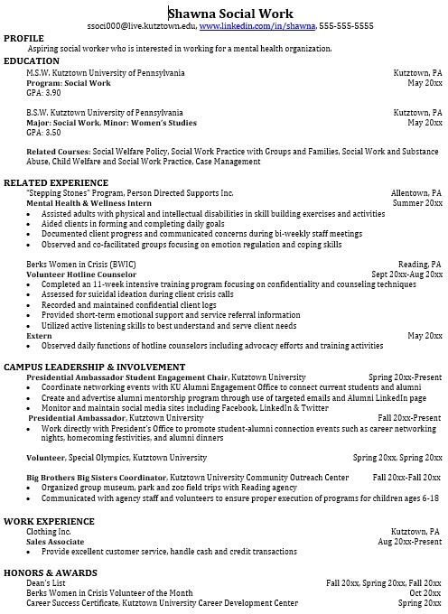
Building a strong resume for your career field starts long before you ever start your job search. Employers want to hire graduates who not only have the necessary educational background but also have experience applying that knowledge.
Learn more about your field and develop the necessary skills for employment by gaining hands-on experience through internships.

For More Information on Social Work careers or to speak to a Career Counselor, contact KU Career Development Center 113 Stratton Administration Center * 610-683-4067 * careerhelp@kutztown.edu * www.kutztown.edu/careercenter

