Bachelor of Science: Sport Management
Minor: Coaching and Athletic Administration, Fitness Administration, Leadership
The Sport Management major prepares students for administrative and operations positions in sport, athletic and recreation industries. Athletics, sport and recreation continues to provide a variety of career opportunities in the United States. 256.2 million Americans engage in some form of sporting activity creating an industry that generates revenue in excess of $160 billion annually and provides 1.9 million jobs. The popularity of sports/recreation participation, leisure activities, and spectator interest creates exciting opportunities for college graduates. Possible career paths may include community recreation programs, health and fitness club management, athletic administration, and professional athletics opportunities, to name just a few. A major in Sport Management can prepare students with the appropriate entry-level skills to meet the profession’s expanding employment opportunities and requirements. Employers recommend one or more internships to be successful and competitive when entering this field.

Career types associated with Sport Management
(Is this a good fit for you? Are you a…)
- Enterprising - “Persuader”
- Realistic - “Doer”
- Social - “Helper”

Related skills, values, and qualities
- Strong interpersonal and communication skills
- Excellent personal fitness and habits
- Ability to multitask and work accurately
- Confidence, initiative, and ability to motivate others
- Ability to relate to and interact with people of varying ages and backgrounds
- Ability to lead, supervise, and direct others
- Ability to react spontaneously and maintain emotional composure in stressful situation
- Ability to solve problems and make effective decisions
- Sensitivity to the human need for recreation and balance

Courses Sport Management majors typically enjoy
- Sport
- Coaching
- Fitness
- Leadership
- Health
- Management
- Business
- Social Media

Common interests of Sport Management majors
- Working at a fitness club or other recreational facility
- Engaging in physical and outdoor activities
- Serving as a part-time coach, official, or scorer
- Reading research and journals related to sport business, coaching or physical fitness
- Volunteering at sport venues
- Attending lectures and workshops related to leisure, health, and sports
For more information about the major Contact the Department of Sport Management, 207 DeFrancesco Building, 610-683-4370,
or visit www.kutztown.edu/SportManagement

KU Majors related to Sport Management
Communication Studies, Management, Marketing


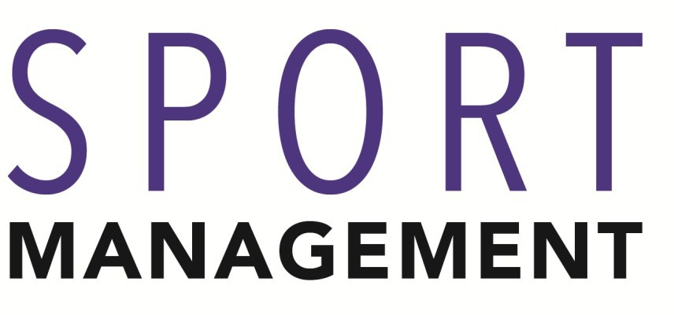
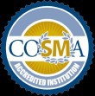

For More Information on Sport Management Careers or to speak to a Career Counseling, contact KU Career Development Center 113 Stratton Administration Center * 610-683-4067 * careerhelp@kutztown.edu * www.kutztown.edu/careercenter



  - Enroll in the Career Exploration Certificate.
  - Attend info sessions to learn about career development and personal branding.
  - Take a career assessment to
identify and confirm interests.
  - Get involved in campus clubs and organizations.
  - Develop basic workplace skills through jobs or volunteer work.
  - Talk with professors, family, and friends about career
- Meet with CDC career coach.
- Attend info sessions to learn about resume writing, and externships.
- Confirm your choice of major and consider options for double major or minor.
- Research careers of interest.
- Complete a job shadowing (externship) experience.
- Seek meaningful employ-ment or volunteer work in a
  - Enroll in the Career Success Certificate.
  - Complete an internship and/or undergraduate research.
  - Attend info sessions about internships, interviewing, job search strategies, and grad school.
  - Build a LinkedIn profile and continue to monitor your online presence.
  - Complete a mock interview.
  - Build skills through research
- Attend your Senior Kick-off and other info sessions to prepare for job search/grad school.
- Update your resume and LinkedIn profile.
- Create cover letter drafts.
- Gain experience through internships and/or undergraduate research.
- Secure references for job/grad school applications.
- Create your “30 second”
commercial/elevators pitch.

ideas.
field related to your major.
projects, part-time employment, • Meet with CDC to develop

  - Conduct informational interviews with professionals working in fields of interest.
  - Develop a relationship with your professors and faculty advisor.
  - Explore options for under-graduate research and study abroad.
  - Write a resume and have it reviewed by the CDC.
  - Manage your online presence.
and volunteer work.
  - Participate in employer panels, site visits & networking events.
  - Attend internship & job fairs.
  - Take on a leadership role in a student organization or work.
  - Consider graduate school options and prepare for admissions tests.
job search strategies.
- Research employers.
- Network with professionals through events and social media.
- Join a professional organization in your discipline.
- Attend the senior etiquette
luncheon or dinner.
- Participate in job fairs and on-campus interviewing.

Sample Career Titles
Sport Management majors can be found working in a wide variety of career fields. Here are just some career titles that may be of interest. Please note that some jobs may require further education and training.

  - Agent/Sports Representative
  - Athletic Coach/Director
  - Fitness Trainer
  - Commissioner/League Director
  - Equipment Manager
  - Event Coordinator
  - General Manager
  - Marketing Director
  - Player Engagement
  - Public Relations Manager
  - Recreation & Activities Director
  - Sports Information Director
  - Sportscaster/Journalist
  - Statistician/Historian
  - Team Manager
  - Ticket Manager
  - Wholesale/Retail Salesperson
  - Youth Sports Director

To learn more about these careers, visit http://online.onetcenter.org or www.bls.gov/oco.

Common Internship Sites and Employers

- Travel & tourism agencies
- Colleges & universities
- State/federal government
- Hospitals/schools
- Fitness clubs/resorts/spas/cruise lines
- Professional and semi-professional sports teams
- Community organizations
- Parks & recreation offices
- Campgrounds
- Media
- YMCA/YWCA
- Sporting good/exercise equipment stores/manufacturers


Handshake is the primary online resource
for preparing and connecting students and alumni with employers. www.kutztown.edu/handshake

Useful Websites for Sport Management Majors
Whether you are researching related career fields, applying for internships or jobs, or planning to join a professional association, these websites are for you!

Industry/Employment Information

Special Olympics www.specialolympics.org

Human Kinetics www.humankinetics.com

National Wellness Institute
www.nationalwellness.org

Therapeutic Recreation Directory www.recreationtherapy.com
Society of Health & Physical Educators www.shapeamerica.org
Athletic Business www.athleticbusiness.com

Front Office Sports www.frontofficesports.com

The Gist Sports
www.thegistsports.com

Job/Internship Search Sites
Work in Sports www.workinsports.com
ExerciseJobs.com www.exercisejobs.com

Sports & Live Event Jobs
www.teamworkonline.com

Cool Works www.coolworks.com
On-Line Sports www.onlinesports.com/career-center

Professional Associations
National Intramural-Recreational Sports Association
www.nirsa.org
National Recreation & Park Association www.nrpa.org

The National Academy of Kinesiology
americankinesiology.org

American Therapeutic Recreation Association
www.atra-online.com

North American Society for Sport Management
www.nassm.com

National Strength & Conditioning Association
www.nsca.com

The National Committee for Accreditation of Coaching Education www.qualitycoachingeducation.org

Related Area Employers
All Star Baseball Academy, Athletic Clubs, Body Zone, Ed Snider Youth Hockey Foundation, Area Children’s Camps, Area School Districts, Area University Athletic Departments, In The Net Sports Complex, Kutztown University Athletic Department and Recreation Center, Lancaster Barnstormers, Lehigh Valley IronPigs, Lehigh Valley Phantoms, Liven Up Health and Fitness, Martial Arts Training Centers, Miracle League of the Lehigh Valley, National Flag Football, Penn National Gaming, Philadelphia Eagles, Philadelphia Freedom, Philadelphia PGA, Philadelphia Phillies, Pocono Raceway, Reading Fightin Phils, Scranton/Wilkes-Barre RailRiders, Rugby New Jersey, Ski Resorts, Special Olympics, Spooky Nook Sports, Soccer Shots, The 422 Sportsplex, United Sports, Valley Preferred Cycling Center, York Revolution, YMCAs/YWCAs

Building Your Resume for a Career in Sport Management
Building a strong resume for your career field starts long before you ever start your job search. Employers want to hire graduates who not only have the necessary educational background but also have experience applying that knowledge to real life situations.

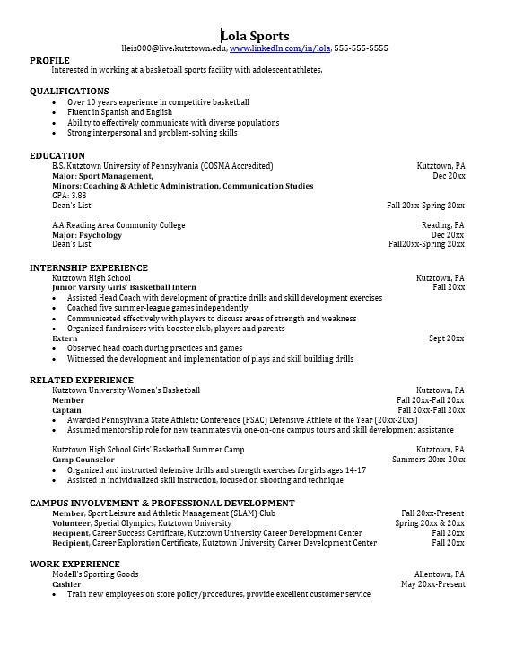
Take note of the skills and knowledge obtained through your educational background and hands-on experiences.
Highlight transferable skills such as
problem-solving abilities and communication.

Learn more about your field and develop the necessary skills for employment by gaining hands-on experience through externships, internships
part-time jobs and related volunteer positions.

Develop professionally through campus involvement and professional memberships.
This illustrates responsibility, leadership abilities and time management skills.

For More Information on Sport Management Careers or to speak to a Career Counseling, contact KU Career Development Center 113 Stratton Administration Center * 610-683-4067 * careerhelp@kutztown.edu * www.kutztown.edu/careercenter

