Bachelor of Science in Business Administration with a major in Supply Chain Management

Supply Chain Management graduates are prepared to assume leadership roles in a wide variety of careers in logistics, supply chain, transportation and warehousing areas. Students pursuing a major in Supply Chain Management are required to complete advanced study in Supply Chain Management, Business Logistics, Supply Chain Analytics, and Global Transportation Management. These majors have the opportunity to select from a wide offering of electives in the areas of Business Intelligence, Advanced Supply Chain Management, and Retail Management. Employers recommend that in order to be successful and competitive when entering this field, students should complete one or more internships.

Career types associated with SCM
- “Thinker”
- “Doer”
- “Organizer”
- “Coordinator”

Related skills, values, and qualities
  - Ability to communicate ideas and concepts to others
  - Strong verbal and written communication skills
  - Proficiency in analytical thinking, problem solving and effective decision making
  - Strong interpersonal and networking skills
  - Ability to manage data
  - Ability to understand different cultures in global supply chain environment
  - Ability to motivate and lead others

Courses SCM majors typically enjoy
  - Accounting
  - Management
  - Marketing
  - Finance
  - Computer Science
  - Communication
  - Geography

Common interests of SCM majors
- Work part time in supply chain related areas.
- Conduct informational discussions with individuals from the industry. Attend networking events.
- Develop strong analytical skills and interpersonal
communication skills.
- Explore various professional designations and
licenses relevant to SCM career paths.
- Reading publications regarding the economy & labor supply

For more information about the major Contact the Department of Business Administration, 236 deFrancesco, 610-683-4580,
or visit www.kutztown.edu

KU Majors related to SCM
Management, Marketing, Finance, Accounting,
Information Technology, Computer Science.
Enterprising students may also be interested in: Communication Studies, Economics*, Entrepreneurship*, International Studies*, Leadership*, Multicultural Studies*, Public Administration, Public Relations*, Social Media, Social Work, Sport Management.




For More Information on Management Careers or to speak to a Career Counselor, contact KU Career Development Center 113 Stratton Administration Center * 610-683-4067 * careerhelp@kutztown.edu * www.kutztown.edu/careercenter



  - Enroll in the Career Exploration Certificate.
  - Attend info sessions to learn about career development and personal branding.
  - Take a career assessment to identify and confirm interests.
  - Get involved in campus clubs
and organizations.
  - Develop basic workplace skills through students clubs, jobs, or volunteer work.
  - Talk with professors, family, and friends about career ideas.
  - Conduct informational interviews with professionals working in fields of interest.
  - Develop a relationship with your professors and faculty

  - Meet with CDC career coach.
  - Attend info sessions to learn about resume writing and externships.
  - Confirm your choice of major and consider options for double major or minor.
  - Research careers of interest.
  - Complete a job shadowing (externship) experience.
  - Seek meaningful employ-ment or volunteer work in a field related to your major.
  - Explore options for part-time work opportunity.
  - Write a resume and have it reviewed by the CDC.
  - Manage your online presence.
  - Enroll in the Career Success Certificate.
  - Complete an internship and/ or undergraduate research.
  - Attend info sessions about internships, interviewing, job search strategies, and grad school.
  - Build a LinkedIn profile and continue to monitor your online presence.
  - Complete a mock interview.
  - Build skills through research projects, part-time employ-ment, and volunteer work.
  - Participate in employer pan-els, site visits & networking events.
  - Attend internship & job fairs.
  - Take on a leadership role in a student organization or work.
  - Consider graduate school options and prepare for admissions tests.
  - Attend your Senior Kick-off and other info sessions to prepare for job search/grad school.
  - Update your resume and LinkedIn profile.
  - Create cover letter drafts.
  - Gain experience through internships and/or undergraduate research.
  - Secure references for job/grad school applications.
  - Create your “30 second”
commercial.
  - Meet with CDC to develop job search strategies.
  - Research employers.
  - Network with professionals through events and social media.
  - Join a professional organization in your discipline.
  - Attend the senior etiquette
dinner.
  - Participate in job fairs and on-campus interviewing.

Sample Career Titles
Supply Chain Management majors can be found working in a wide variety of career fields. Here are just some career titles that may be of interest. Please note that some jobs may require further education and training.

    - Account Executive
    - Airport Manager
    - Branch Manager-Any Industry
    - Chief Executive Officer
    - Chief Supply Chain Officer
    - City Manager
    - Commodity – Industry Analyst
    - Communications Officer
    - Construction Supervisor
    - Consultant
    - Convention Manager
    - Customer Success Specialist
    - Department Store Manager
    - Director, Logistics
    - Director, Supply Chain Management
    - Government Services Administrator
    - Hospital Administrator
    - Industrial Relations Director
    - Information Systems Manager
    - International Business Manager
    - Inventory Controller
    - Job Analyst
    - Load Planner
    - Logistics Manager
    - Logistics Specialist
    - Management Analyst
    - Manufacturing Supervisor
    - Market Information Specialist
    - Occupational Analyst
    - Operational Excellence Analyst
    - Operations Manager
    - Planner
    - Procurement Specialist
    - Procurement Management
    - Production Superintendent
    - Product Manager
    - Public Utilities Manager
    - Purchasing Agent
    - Quality Control Auditor
    - Real Estate Agent/Broker
    - Report Analyst
    - Retail Sales Manager
    - Sales Manager
    - Service Organization Manager
    - Sourcing Manager
    - Supply Chain Analyst
    - Supply Chain Coordinator
    - Supply Chain Manager
    - System Coordinator
    - Traffic Manager
    - Training Manager
    - Transportation Director
    - Wholesale Sales Representative
    - Warehouse Manager

Common Internship Sites and Employers

Supply Chain Management majors often find internships and employment in the following fields/industries:

      - Warehousing
      - Transportation Company
      - Federal/State Government
      - Manufacturing
      - Schools/Universities
      - Health Care Industry
      - Entertainment Industry
      - Business Solution Companies
      - Nonprofit Organizations
      - Service Industries


Handshake is the primary online resource for preparing and connecting students and alumni
with employers.

Useful Websites for Supply Chain Management Majors:
Whether you are researching related career fields, applying for internships or jobs, or planning to join
a professional association, these websites are for you!

Industry/Employment Information

KU Small Business Development Center https://www.pasbdc.org

Executive and Management Job List www.nationjob.com/management
Marketing/Management Jobs www.marketingjobs.com

LinkedIn Jobs www.linkedin.com/jobs

Professional Associations

Association for Supply Chain Management
www.ascm.org

Council of Supply Chain Management Professionals
www.cscmp.org

Institute for Supply Management www.ismworld.org
Warehousing Education and Research Council
www.werc.org

The Traffic Club of the Lehigh Valley www.trafficcluboflv.org

Related Area Employers
Clark Associates DHL Supply Chain DSC Logistics
East Penn Manufacturing
J.B. Hunt Transport
LeverX
Mondelez International Penske Truck Leasing

To learn more about these careers, visit http://online.onetcenter.org or www.bls.gov/oco

Building Your Resume for a Career in Supply Chain Management
For More Information on Management Careers or to speak to a Career Counselor, contact KU Career Development Center 113 Stratton Administration Center * 610-683-4067 * careerhelp@kutztown.edu * www.kutztown.edu/careercenter
Learn more about your field and develop the necessary skills for employment by gaining hands-on experience through externships, internships, part-time jobs and related volunteer positions.
Develop profession-ally through campus involvement and professional memberships.
This illustrates responsibility, leadership abilities and time management skills.
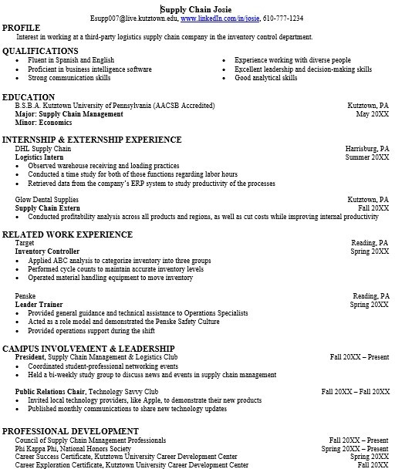
Building a strong resume for your career field starts long before you ever start your job search. Employers want to hire graduates who not only have the necessary educational background but also have experience applying that knowledge to real life situations.
Take note of the skills and knowledge obtained through your educational background and hands-on
experiences.
Highlight transferable skills such as fluency and technological proficiencies.

