

Bachelor of Science: Music Education
Music is a phenomenon common to all societies, a richly diverse experience that is used in many ways. Music can be a form of communication, artistic expression, entertainment, therapy and worship.
As a Music Education major, you will study music from various perspectives including historical, theoretical, pedagogical and performance. You will develop listening skills, critical thinking, an awareness of aesthetic principles and contemporary technology as well as the knowledge and tools you need to be a successful music teacher.
Employers recommend one or more internships to be successful and competitive when entering this field.

Career types associated with Music Education
(Is this a good fit for you? Are you a…)
- Social - “Helper”
- Artistic - “Creator”
- Enterprising - “Persuader”

Related skills, values, and qualities
- Ability to speak articulately, listen introspectively,
and make keen observations
- Ability to think creatively
- Self-discipline and perseverance
- Capacity for memorization and concentration
- Ability to meet deadlines
- Ability to teach, assess, plan and evaluate
- Desire and ability to work with children
- Ability to adjust to close public scrutiny and criticism
- High degree of commitment to field of study.

Courses Music Education majors typically enjoy
- Art
- Band, Orchestra, Choir
- Dance
- Debate
- Theater
- Public Speaking
- Interpersonal Communication
- Psychology and Sociology

Common interests of Music Education majors
- Attending plays, concerts, lectures, and movies
- Participating in theater, choir, glee club, marching band, orchestra, and/or other musical groups
- Working part-time or as a volunteer for a theatre arts or communications department, preschool or camp setting
- Serving as a tutor, peer counselor, or youth group leader
- Participating in a talent or variety show, skit or play
- Joining the student council or a debate team
- Reading publications related to the performing arts

For more information about the major
Contact the Music Department, 114 Old Main, 610-683-4550,
or visit www.kutztown.edu/MusicEducation

KU Majors related to Music Education Music, Cinema, Television and Media Production, Computer Science, Mathematics, Elementary Education, Library Science, Secondary Education, Special Education
Artistic students may also be interested in: Advertising*, Communication Design, English, German, International Studies*, Literature*, PA German Studies*, Philosophy, Professional Writing, Public Relations*, Spanish, Speech Communication, or Studio Art.
*minor only

For More Information on Music Education careers or to speak to a Career Counselor, contact KU Career Development Center 113 Stratton Administration Center * 610-683-4067 * careerhelp@kutztown.edu * www.kutztown.edu/careercenter



- Enroll in the Career Exploration Certificate.
- Attend info sessions to learn about career development and personal branding.
- Take a career assessment to identify and confirm interests.
- Get involved in campus clubs
and organizations.
- Develop basic workplace skills through jobs or volunteer work.
- Talk with professors, family, and friends about career ideas.
- Conduct informational interviews with professionals working in fields of interest.
- Develop a relationship with your professors and faculty advisor.
- Meet with CDC career coach.
- Attend info sessions to learn about resume writing, and externships.
- Confirm your choice of major and consider options for double major or minor.
- Research careers of interest.
- Complete a job shadowing (externship) experience.
- Seek meaningful employ-ment or volunteer work in a field related to your major.
- Explore options for under-graduate research and study abroad.
- Write a resume and have it reviewed by the CDC.
- Manage your online presence.
- Enroll in the Career Success Certificate.
- Complete an internship and/or undergraduate research.
- Attend info sessions about internships, interviewing, job search strategies, and grad school.
- Build a LinkedIn profile and continue to monitor your online presence.
- Complete a mock interview.
- Build skills through research projects, part-time employment, and volunteer work.
- Participate in employer panels, site visits & networking events.
- Attend internship & job fairs.
- Take on a leadership role in a student organization or work.
- Consider graduate school options and prepare for admissions tests.
- Attend your senior kick-off and other info sessions to prepare for job search/grad school.
- Update your resume and LinkedIn profile.
- Create cover letter drafts.
- Gain experience through internships and/or undergraduate research.
- Secure references for job/grad school applications.
- Create your “30 second”
commercial.
- Meet with CDC to develop job search strategies.
- Research employers.
- Network with professionals through events and social media.
- Join a professional organization in your discipline.
- Attend the senior etiquette
dinner.
- Participate in job fairs and on-campus interviewing.

Sample Career Titles
Music Education majors can be found working in a wide variety of career fields. Here are just some career titles that may be of interest. Please note that some jobs may require further education and training.

  - Adult Education Teacher
  - Antiquarian Book Trader
  - Assistant Principal
  - Audio Visual Production Professional
  - College Professor
  - Day Care Administrator
  - Educational Programmer
  - Education & Training Administrator
  - Education Management Specialist
  - Educational Administrator
  - Education Consultant
  - Elementary School Teacher
  - Financial Aid Counselor
  - Guidance Counselor
  - Music Attorney
  - Music Copyist
  - Music Critic
  - Music Director
  - Music Librarian
  - Music Promoter
  - Music Publishing Specialist
  - Music Reporter
  - Music Software Programmer
  - Music Store Manager
  - Music Stringer
  - Music Teacher
  - Music Therapist
  - Musician
  - Narrator
  - Orchestra Librarian
  - Peace Corps/VISTA Worker
  - Piano Tuner
  - Preschool Administrator
  - Preschool Teacher
  - Principal
  - Professional Entertainer
  - Publicist
  - Recording Engineer
  - Recording Technician
  - Recreation Director
  - Religion Music Director
  - Royalties Broadcast Monitor
  - Secondary School Teacher
  - Singer
  - Sound Technician
  - Student Affairs Administrator
  - Studio Musician
  - Synthesizer Specialist
  - Technical Writer
  - Theatre Performer
  - Tour Manager
  - Union Contractor

To learn more about these careers, visit http://online.onetcenter.org or www.bls.gov/oco

Common Internship Sites and Employers
Music Education majors often find internships and employment in the following fields/industries.

    - Public and Private Schools
    - International Schools
    - State and Federal Government Youth Services
    - Theater
    - Council for the Arts
    - Entertainment
    - Colleges and Universities
    - Community Centers/Non-Profit Organizations
    - Business and Industry
    - Music Publishing Companies
    - Restaurants


Handshake is the primary online resource
for preparing and connecting students and alumni with em-
ployers.
www.kutztown.edu/handshake

Useful Websites for Music Education Majors
Whether you are researching related career fields, applying for internships or jobs, or planning to join a professional association, these websites are for you!

Industry/Employment Information

PA Department of Education
www.pa.gov/agencies/education.html
NJ Department of Education www.state.nj.us/education

Education Week www.edweek.org

Teachers Support Network http://teacherssupportnetwork.net

LinkedIn Jobs www.linkedin.com/jobs

Job/Internship Search Boards
PA-REAP
www.pareap.net

PA-Educator.net www.pa-educator.net

Teachers-Teachers www.teachers-teachers.com

Southern Teacher’s Agency
www.southernteachers.com
K-12jobs.com www.k12jobs.com

Education Job Page www.nationjob.com/education

The National Assoc. of Music Edu.
www.menc.org/careers

Professional Associations
PA School Board Association
www.psba.org

American Federation of Teachers www.aft.org

PA State Education Association www.psea.org

National Education Association www.nea.org

American Music Conference www.american-music.org

International Society for Music Edu. www.isme.org

Music Teachers National Association
www.mtna.org

Employers
Appel Farm Arts & Music Center, ArtsQuest, Hershey Entertainment & Resorts, Kutztown University Mu-sic Department, Music Choice, Reading Samba School, Reda Films

Building Your Resume for a Career in Music Education

Develop professionally through campus involvement and professional memberships.
This illustrates responsibility, leadership abilities and time management skills.
Utilize summer breaks to acquire valuable experience via volunteer or employment opportunities related to your major.

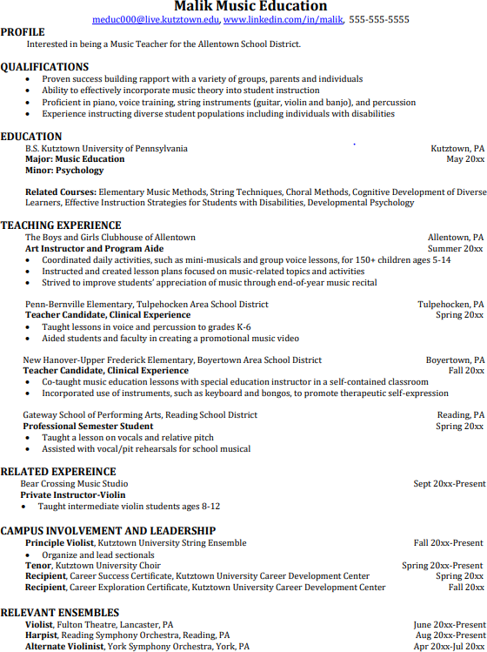
Building a strong resume for your career field starts long before you ever start your job search. Employers want to hire graduates who not only have the necessary educational background but also have experience applying that knowledge.
Learn more about your field and develop the necessary skills for employment by gaining hands-on experience through internships.

For More Information on Music Education careers or to speak to a Career Counselor, contact KU Career Development Center 113 Stratton Administration Center * 610-683-4067 * careerhelp@kutztown.edu * www.kutztown.edu/careercenter

